Hydrogen Storage in Carbon Nanotubes (CNTs)---A Review Paper
Quanyan Wu

Abstract:
The area of hydrogen storage in carbon nanotubes (CNTs) is really a tricky one: on one aspect, there have been numerous reports of progress and achievements on their promise to give possible solutions to the challenges of future hydrogen-driven vehicles, but on the other side, scientists are still experiencing so much that remains illusive on this new technology. In this report, we will try to look different work that has been done in this sphere since the first reported case in 1997, mainly focusing on the SWNTs and MWNTs, which are receiving more attention than other CNTs, and try to present the ideas that were supported by experimental data and accepted theory.

Key words: Hydrogen storage, CNT, SWNT, and MWNT.

Introduction:
There has been huge excitement and enthusiasm in the efforts to get a better understanding in the hydrogen storage in carbon nanostructures since Dillon et al. first reported that single-walled carbon nanotubes (SWNTs) had the potential of taking up to 5-10% hydrogen at moderate temperatures and pressures [1]. Commercialization of fuel cell vehicles thus can be readily expected once an adequate hydrogen storage device could be found in the near future [2]. In that work, it was experimentally proved that reversible hydrogen storage only for SWNTs and, an opening of the SWNTs is essential to reach high storage capacities. We will also look that in this review paper. The reason for the activities to be favoring carbon nanotubes (CNTs) is their superior properties such as: chemical stability, large surface area, hollowness, and light mass [3].
Hydrogen could be stored in bundles in single-walled nanotubes, where H₂ molecules are physisorbed at the exterior surfaces of CNTs or interstitial spaces between CNTs separating the intertube distances, provided a high pressure of hydrogen gas. It was reported that storage capacity can reach 8 wt % under 77K, while under room temperature it varies according to different research groups [3]. Those high values of hydrogen storage under room temperature still remain doubtful in the society. Early Monte Carlo simulations predicted about 1 wt % at 10 MPa, whereas some recent calculations predicted large values up to 10-14 wt % at low temperature. Thus there are still disagreements between experiments and theoretical predictions [3]. It has also been demonstrated that CNTs could also store hydrogen electrochemically, but at less than 1 wt % which is far from the useful amount of 6.5 wt %, even though the electrochemical method is more practical for the application to the secondary hydrogen battery. In electrochemical mechanism, hydrogen ions (or hydrated hydrogen ions), not hydrogen molecules, exists in an electrolyte, leading to a different adsorption mechanism from the previously described physisorption process, where the H₂ molecule plays an important role for adsorption. So an efficient method of hydrogen storage, maximum storage capacity, a form of hydrogen adsorption, and reversibility, especially in an electrochemical storage method, are still far from being clearly understood, despite so much work has been published. That is also a reason why some work has been done to find something that is breaking this stalemate: by trying the multiwalled nanotubes (MWNTs) [4]. It found that hydrogen storage on multiwalled nanotubes (MWNTs) was dependent on the degree of catalyst removal; meanly there is a need for interactions by metal-support to generate spillover. But that was also criticized by other work that claimed only SWNTs show reversible hydrogen storage capacity [2]. Currently work is still being carried out to reproduce and verify the results both theoretically and experimentally [4,5].

CNTs storage patterns with experimental observations: Absorption and Desorption
There are thermodynamic parameters that describe the absorption of hydrogen: the amount of hydrogen in mole, the hydrogen partial pressure and the temperature [6]. When the temperature is constant in an isothermal absorption, the amount of hydrogen absorbed is a function of the hydrogen pressure. Experimentally we can use a mass flow controller in order to measure the amount of hydrogen gas applied to the sample cylinder. At the same time, the gas pressure in the cylinder is measured. The quantity of adsorbed hydrogen is calculated from the difference of a measurement with the carbon sample in the cylinder and the empty cylinder at a certain pressure. Then the carbon samples were placed in a steel cylinder connected to a vacuum pump and heated to 550ºC for 2 h. Then the samples were slowly cooled to room temperature. A constant hydrogen gas flow of 1 cm³ min⁻¹ (under STP conditions) was applied and the gas pressure was recorded. Afterwards, the samples were removed from the cylinder and the experiment was repeated. The difference between the two measurements leads to a negative volume, i.e. the volume of the samples. This is due to the fact that the absorbed volume of hydrogen at room temperature is negligible as compared to the volume of the samples. The same measurements were carried out at T =78 K (liquid nitrogen). Fig. 1 shows the result of the measurement on an SWNT sample purchased from MER [6].

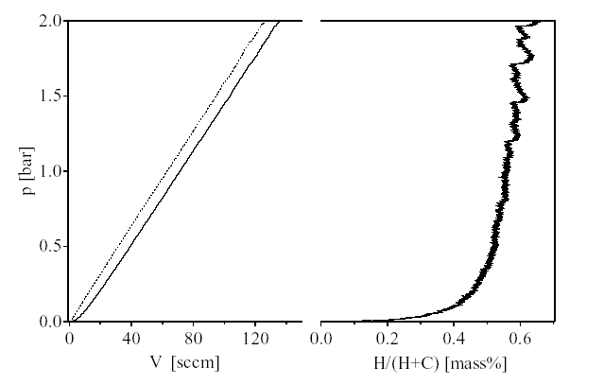
Fig. 1. Isothermal volumetric measurement of the hydrogen gas absorption on an SWNT sample purchased from MER [28] at liquid nitrogen temperature (78 K). Difference between the volumes expressed as mass% on the right-hand side.

0.4 mass% below a pressure of 0.01 Mpa was observed. With the increase of pressure the absorption saturates at approximately 0.6 mass%. And, we noticed that all the other nanostructured carbon samples tested absorbed a much smaller amount of hydrogen, which also proved [2].
The desorption process was investigated by means of TPD. The samples were immersed in high pressure hydrogen gas at room temperature for ½ hr. prior to desorption, then the sample was cooled down with liquid nitrogen, and the residual hydrogen in the gas phase was pumped off. Fig. 2 shows the hydrogen partial pressure as a function of temperature of a high surface area graphite (HSAG) sample and an SWNT sample from MER. Both samples exhibit the low temperature peak at 105 K of the physisorbed hydrogen followed by a much smaller wide peak at 136 K. Above this temperature the hydrogen pressure was continuously decreased showing only a small shoulder at 300 K. The spectra of the SWNT and the graphite are similar, however, the hydrogen partial pressure for the SWNT sample was always higher as compared to the pressure of the graphite sample. At 550 K, the spectra showed an increase in hydrogen pressure. This is an indication

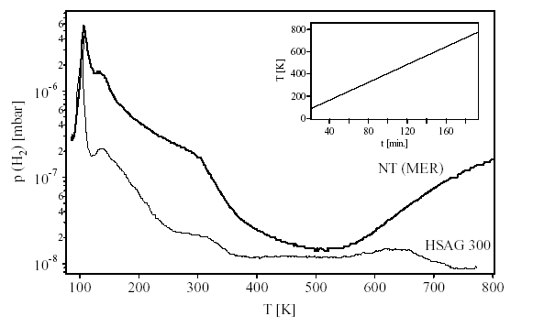
Fig. 2 Temperature programmed desorption spectra for a nanotube sample from MER (bold line) and a high surface area graphite (HSAG 300) sample from Timcal [31]. Samples were evacuated at 78 K before the desorption experiment started with a heating rate of 4 K min.1. The inset shows the temperature as a function of time.

for at least two different sites for hydrogen in the SWNT sample. The well-known physisorbed (molecular) hydrogen at the surface of the carbon desorbs around 105 K. The hydrogen desorbing at temperatures above 500 K originates from a tight bond hydrogen
similar to the hydrogen bond in hydrocarbons. We have shown that this type of hydrogen can be found even with the HSAG sample after a hydrogen absorption treatment at elevated temperature (573 K). Therefore, hydrogen desorbing at temperatures above 500 K from SWNT samples was probably incorporated during the synthesis of the nanotubes.

Multiwalled carbon nanotubes & Metal oxide catalyst effect: Some people tried MWNTs [4]. Multiwalled carbon nanotubes (MWNTs) were synthesized using a procedure similar to that developed by Chen et al. [7]. HRTEM and SEM micrographs were used to confirm the presence of MWNTs; the outer diameter of the MWNTs is well consistent at 15 nm, while the inner diameter ranges from 2 to 8 nm (Fig. 3). The metal content of the MWNTs is summarized in Table 1; room temperature acid treatment left residual catalyst (MW-H), whereas no residual metal was detected for the sample treated by acid reflux (MW-HR). SEM shows that the residual metal oxide for the MW-H sample was evenly distributed along the length of the anotube, and it also indicates the tubular carbon nanotubes remains intact after the acid treatments.
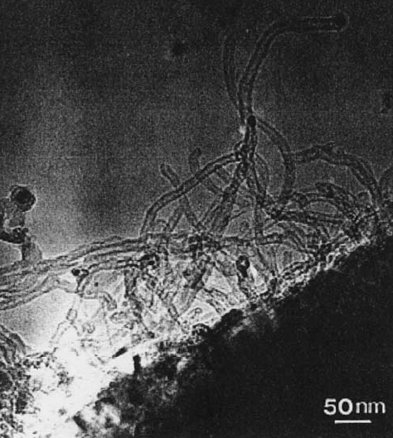
Fig. 3. Transmission electron micrograph of MWNTs as prepared.

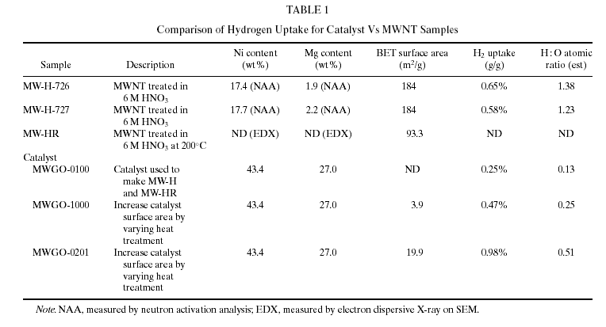

A comparison between TGA hydrogen adsorption experiments for the nanotube samples versus the original catalyst shows that the catalyst is a necessary component for hydrogen uptake under the nonequilibrium experimental conditions (Fig. 2). Removal of the catalyst by acid reflux (MW-HR) eliminates hydrogen uptake when compared to the 0.6–0.7% uptake by the nanotubes with residual catalyst (MW-H). Although the hydrogen uptake of the catalyst is not as extensive as the nanotube–catalyst sample, the two
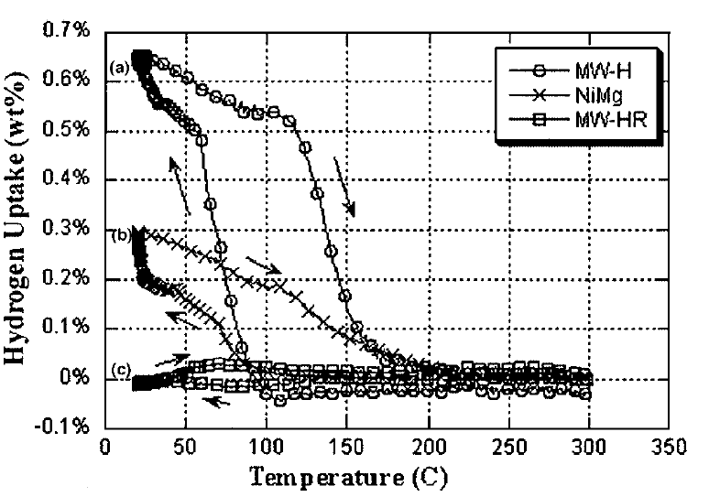
Fig. 4. TGA adsorption profile for (a) an acid-treated MWNT (MW-H), (b) the Ni0.4Mg0.6O catalyst, and (c) the MWNT with extended acid treatment to remove the residual catalyst (MW-HR). The data has been normalized by subtracting the mass of quartz blank.

sorbents have qualitatively similar behavior. It can be explained by the increase of catalyst surface area on acid-deposition on the nanotube surface, as observed in SEM micrographs. The TGA experiment was not an equilibrium measure; thus, the available surface area of the active component will affect the rate of hydrogen uptake. Varying the catalyst surface area using different calcination conditions has provided additional evidence for this: increasing the catalyst surface area fivefold doubled the hydrogen uptake (Table 1).
It is not surprising that metal oxide catalyst participates in hydrogen uptake process, as both magnesium oxides and dilute transition metal–magnesium oxides are active in hydrogen exchange reactions. It should also be pointed out that the conditions under which the samples were treated were not sufficient to reduce the bulk of the metal oxide, as evidenced by X-ray diffraction data. On the ionic crystal lattice structure of metal oxides, hydrogen molecules are thought to dissociate into a proton and a hydride, associated with the anion and cation, respectively. However, pretreatment of MgO as well as NiO–MgO solutions at elevated temperatures and/or in the presence of hydrogen atoms can form active catalytic centers corresponding to a lattice vacancy populated by an electron. These results may also provide a basis with which to reinterpret and optimize other hydrogen storage measures in light of any residual catalyst present in the system; the use of transition metals in nanotube synthesis is common, in arc-discharge as well as catalytic vapor decomposition methods.

Doping effects for electrochemical hydrogen storage:
It has been proposed that doping or additional conductive materials to the nanotube electrode is required in electrochemical hydrogen storage process, because the C-H bond formation changes the electronic structure of metallic carbon nanotubes to semiconductors [8].
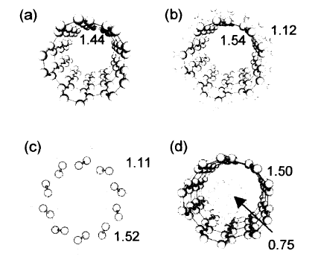
Fig 4. Top views of various hydrogen adsorptions in the nanotube with ball and stick forms: a) clean; b)arch type; c) zigzag type, and d) the molecular hydrogen inside the CNT. Bond lengths are in units of Å
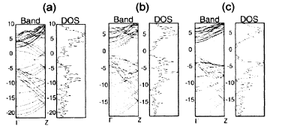
Fig 5. Band dispersions along the tube axis Z and the corresponding densities of states (DOS) for a)clean CNT and b) arch type, and c)zigzag type. The horizontal lines indicate the Fermi Level. The energies are in unit of eV.

Also, Surface treatment with gas was found to contribute to the confinement of hydrogen in these processes. The composition of gas mixtures can be influenced with the aid of microporous membranes by exploitation of the Knudsen effect [9].

Future work:
Although there has been so work in the field of hydrogen storage exploiting the CNTs, much still remains to be looked into before it can really be put into practical use. Scientists have been trying to look at these areas of breakthroughs like mass production of SWNTs, purifications and surface functionization of carbon nanotubes, and elucidation of the microstructure, expecially the pore structure and surface microstructure [5]. Hopefully they can get that done in the near future.

References:
1. Dillon, A. C., Jones K.M., Bekkedahl, T. A., Kiang, C.H., Bethune, D. S., and Heben, M. J., Nature 386-377 (1997).
2. M. Hirscher, M. Becher, M. Haluska, A. Quintel, V. Skakalova, Y. M Choi, U. Dettlaff. W., S. Roth, and J. Fink, “Hydrogen storage in carbon nanostructures”, Journal of Alloys and Compounds, 330-332 (2002) 654-658.
3.Seung Mi Lee, Kay Hyeok An, Young Hee Lee, Gotthard Seifert, and Thomas Frauenheim, “A hydrogen storage mechanism in single-walled carbon nanotubes”, Journal of American Chemistry Society, 2001,123, 5059-5063.
4. Angela Lueking and Palph T. Yang, “Hydrogen spillover from a metal oxide catalyst onto carbon nanotubes-implication for hydrogen storage”, Journal of Catalysis 206, 165-168 (2002)
5. Hui-ming Cheng, Quan-hong Yang, and Chang Liu, “Hydrogen storage in carbon nanotubes”, Carbon, 39 (2001) 1447-1454.
6. A. Zuttel, P. Sudan, Ph. Mauron, T. Kiyobayashi, Ch. Emmennegger, L. Schlapbach, “Hydrogen storage in carbon nanostructures”, International Journal of Hydrogen Energy”, 27 (2002) 203-212.
7. Chen P. , Zhang H.B., Lin, G.D., Hong Q, and Tsai K. R. Carbon,35,1495 (1997).
8. Seung Mi lee, Kay Hyunk An, Won Seok Kim, Young Hee Lee, young Soo Park, Gottard Seifert, and Thomas Frauenheim, “Hydrogen storage in carbon nanotubes”, Synthetic Metals, 121 (2001) 1189-1190
9. NEUMANN B, FUTTERER E, CHEMIE INGENIEUR TECHNIK, June 1995

