**Homework 1 Advanced Thermodynamics**

**Due Tuesday September 1, 2020**

Tombari and Johari (*Endothermic Effects on Heating Physically Aged Sucrose Glasses and the Clausius Theorem Violation in Glass Thermodynamics*, J. Phys. Chem. B 2020, 124, 2017−2028) discuss features in the calorimetry curve for sucrose that indicate an endothermic effect on heating.

1. Explain the difference between a first and a second order transition.
2. Explain how a differential scanning calorimeter works.
3. How would you expect the heat versus temperature curve to appear for a first and a second order transition? (Cooling curve for Figure 1 of Tombari 2020)
4. What is the Clausius Theorem?
5. In a calorimeter you observe the change in input heat, qH, as a function of temperature, T. For a constant heating rate, dT/dt, explain how the heat capacity Cp is obtained from this measurement. Derive the necessary relationships.
6. Tombari and Johari associate “kinetic unfreezing” of unequilibrated molecular conformations with an endotherm in the calorimetric measurement of the glass transition. Make an argument in favor of this including why relaxation of unequilibrated molecular conformations would be endothermic. In your argument use the words ergodic and non-ergodic. (you might look at G.P. Johari *Specific heat relaxation-based critique of isothermal glass transition, zero residual entropy and time-average formalism for ergodicity loss*  Thermochimica Acta **523** (2011) 97–104.)

Answers: **Homework 1 Advanced Thermodynamics**

**Due Tuesday September 1, 2020**

1. *Explain the difference between a first and a second order transition.*

A first order transition, like the melting point, involves a step change in the enthalpy, entropy, volume, heat capacity, thermal expansion coefficient, compressibility. So there is a heat of fusion for instance. The Gibbs free energy is the same for the two phases at the transition but the rate of change in temperature (the entropy) changes. The structure and order of the material changes at a first order transition. A second order transition, such as the glass transition, involves a change in the slope in temperature of the enthalpy, entropy and volume and a step change in the heat capacity, thermal expansion coefficient and the compressibility. The Gibbs free energy is continuous through a second order transition. The structure and order of a material does not change in a second order transition.

1. *Explain how a differential scanning calorimeter works.*

A DSC has two adiabatic pans, one with a small amount of material, 20 mg, and the other empty. The two pans are heated to maintain the same temperature and the amount of heat required to maintain the same temperature during a temperature ramp up or down is recorded. It can also be used isothermally to record the enthalpy of a reaction such as degradation. A plot of heat flux, dq/dt, is plotted against temperature for a fixed heating or cooling rate. This is proportional to the heat capacity, (dH/dT)p.

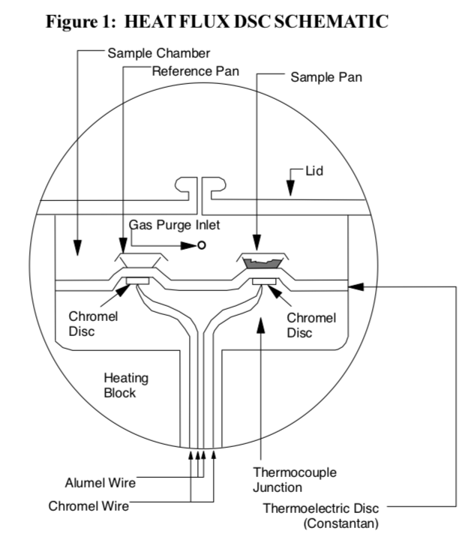

1. *How would you expect the heat versus temperature curve to appear for a first and a second order transition? (Cooling curve for Figure 1 of Tombari 2020)*

Figure 1 cooling shows the typical curve for a second order transition. Endotherm is up in this plot. To the right is the results from modulated DSC for poly(ethylene terephthalate) (PET or PETE or water bottle). At about 70°C there is a glass transition, cold crystallization at about 130°C and melting at about 260°C. Endotherm is down in this plot. The total curve is the normal trace. Nonreversing is irreversible features.

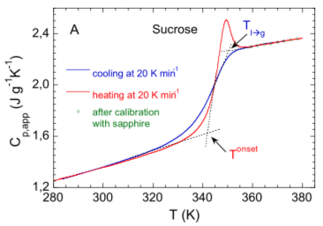 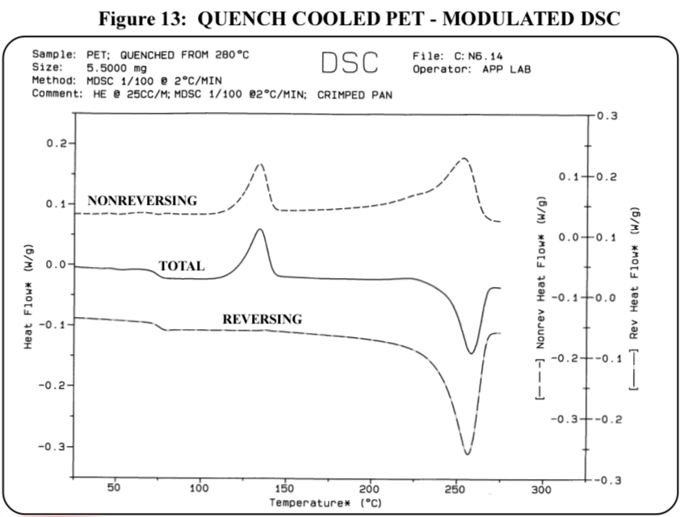

1. *What is the Clausius Theorem?*

For a perfectly efficient reversible process with no heat loss S = 0. For all other processes entropy increases. This can be construed to mean that heat flows from hot to cold.

1. *In a calorimeter you observe the change in input heat, qH, as a function of temperature, T. For a constant heating rate, dT/dt, explain how the heat capacity Cp is obtained from this measurement. Derive the necessary relationships.*

dU = dq + dw = dq – pdV (only e/c work, i.e. no shaft work)

Entropy H = U + PV so dH = dU + pdV + Vdp

(dH)p = dU + pdV for constant pressure

With only pV work (expansion/contraction), dwec = -pdV

dq = dU + pdV = (dH)p

Cp = (dH/dT)p = dq/dT

You measure dq/dt and the heating rate is constant (dT/dt) so

dq/dt ~ dq/dT = Cp

1. *Tombari and Johari associate “kinetic unfreezing” of unequilibrated molecular conformations with an endotherm in the calorimetric measurement of the glass transition. Make an argument in favor of this including why relaxation of unequilibrated molecular conformations would be endothermic. In your argument use the words ergodic and non-ergodic. (you might look at G.P. Johari Specific heat relaxation-based critique of isothermal glass transition, zero residual entropy and time-average formalism for ergodicity loss Thermochimica Acta* ***523*** *(2011) 97–104.)*

When a glass forms it locks-in a certain structure. The faster the cooling, the greater the structural lock-in. The structural lock-in would naturally relax if the system were ergodic. During heating, as the glass transition temperature is approached, the molecules have the ability to probe energy space. The motion to a lower energy, relaxed state is an endothermic process, similar to melting of a crystal.