**Homework 12 Advanced Thermodynamics**

**Due Tuesday November 17, 2020**

Super alloys are important to high temperature applications where high stress is encountered particularly in the turbine blades of jet engines and in gas turbines for electricity generation. A metal that has low creep, i.e. low defect transport, near its melting point, is desired. -phase FCC Ni is an example. Ni is subject to oxidation at high temperatures and can be stabilized by addition of Al which oxidizes at the surface forming a protective layer. Additionally, Ni3Al forms a coherent FCC precipitate '-phase that prevents defect transport.

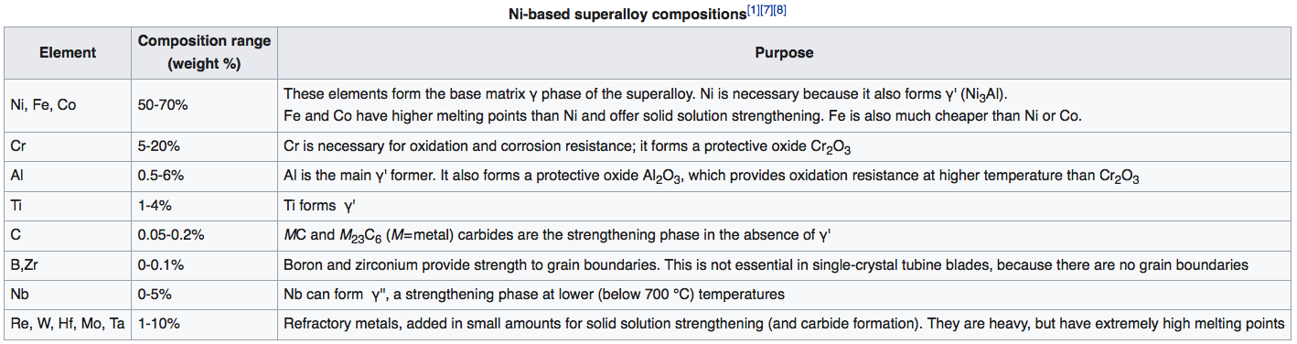

Shang S-L; Wang Y; Kim DE; Liu Z-K *First-principles thermodynamics from phonon and Debye model: Application to Ni and Ni3Al* Comp. Mat. Sci. **47** 1040-1048 (2010) calculate thermodynamic properties of Ni and Ni3Al including the thermal expansion coefficient, bulk modulus, entropy, enthalpy, and heat capacity. These properties are of interest since it is desirable to have similar thermal expansion coefficients for the two phases to prevent thermal stress, the bulk modulus is required to remain high near the melting point, the energy difference between the Ni3Al and Ni phases should be small to ensure interfacial compatibility, differences in the heat capacity can impact thermal gradients in the super alloy.

1. Shang et al. uses a quasi-harmonic approach. What is a quasi-harmonic approach? How does it differ from a harmonic approach?
2. Shang et al. use equation 1 and equation 21 to obtain the thermal expansion coefficient. Describe the components of equation 1 and explain exactly the steps Shang uses to obtain the volume and bulk modulus as a function of temperature.
3. Shang indicates “*As for the Debye model, the predicted thermal expansion coefficients depend heavily on the selected Grüneisen constant in Debye–Grüneisen model and the*  *value in Debye–Wang model*”. Explain the origin of the Grüneisen constant. (Derive the expression given in our text (equation 8.33) and compare it with what is given in this paper in the paragraph between equations 18 and 19.) The Wang-Debye model paper is linked to this homework in case you are interested in .
4. Figure 5 shows the bulk modulus as a function of temperature. “*For both Ni and Ni3Al, the measured bulk moduli are in general higher than most of the predictions, agreeing with the low temperature case of Debye–Grüneisen model and  = 1 of Debye–Wang model, instead of phonon predictions.*” Explain the difference between the Debye models and the phonon predictions. Why are the Debye models better than the phonon predictions? (In your answer explain the importance of Figure 3.)
5. In Figure 8a the experimental data displays a peak at about 600K. Explain the normal origin of a peak in a Cp versus temperature plot. Derive a function that would predict such a peak.