**Homework 3 Advanced Thermodynamics**

**Due Tuesday September 15, 2020**

The glass transition is a second order transition.

1. Show that the glass transition temperature should be linearly dependent on pressure as demonstrated by R. Casalini, T. C. Ransom, On the pressure dependence of the thermodynamical scaling exponent , Soft Matter, (2020), **16**, 4625-4631.
2. The Flory-Fox equation describes the dependence of glass transition temperature on the molecular weight of a polymer. Explain this dependence based on a free volume model.
3. The Fox equation describes the glass transition for a mixture of two materials and indicates that the parameter of interest in blends is the inverse of the glass transition temperature which is a weighted sum of the component glass transitions. The Fox equation is a harmonic mean which is usually used when you want to get an average rate. Like the average velocity on a trip, if you went 100 mph for half the trip and 10 mph for the other half your average speed would be 18.2 mph (not 55 mph). Explain the Fox equation using the idea of a harmonic mean. Refer to Casalini and Ransom (2020) who specify the rate of observation, x, for their glass transition temperature, Tx.
4. Using the concept that you developed in part “c” write a new Flory-Fox equation to describe the impact of molecular weight on the glass transition (or explain how the concept in part c is consistent with the existing Flory-Fox equation).
5. A. Stoddart, W. J. Feast, S. P. Rannard, Synthesis and thermal studies of aliphatic polyurethane dendrimers: a geometric approach to the Flory–Fox equation for dendrimer glass transition temperature, Soft Matter, (2012), **8**, 1096- 1108, describe a modified Flory-Fox equation for dendrimers. Dendrimers are highly branched polymers that follow a branching rule, say start with a three arm star, at each end-point branch two arms, and repeat for n generations. This generates a starburst molecule with many end-groups. Do you think that the Flory-Fox equation should work for this molecule? Explain Stoddart et al.’s approach and their resulting dependence shown in Figure 8.

Answers: **Homework 3 Advanced Thermodynamics**

**Due Tuesday September 15, 2020**

1. *Show that the glass transition temperature should be linearly dependent on pressure as demonstrated by R. Casalini, T. C. Ransom, On the pressure dependence of the thermodynamical scaling exponent , Soft Matter, (2020),* ***16****, 4625-4631.*

The glass transition displays continuous primary thermodynamic features, G, H, S, V, etc. For volume, dV = 0 = (dV/dT)p dTg + (dV/dp)T dpg =  dTg - T dpg, so dTg/dpg = T/. If the thermal expansion coefficient and the isothermal compressibility are constant, then the glass transition temperature is constant in pressure.

1. *The Flory-Fox equation describes the dependence of glass transition temperature on the molecular weight of a polymer. Explain this dependence based on a free volume model.*

The glass transition occurs when the free volume reaches a fixed percent of the total volume according to the iso-free volume theory. The figure below shows this value to be 11.3%. The bottom dashes line is the occupied volume of molecules, which increases with temperature due to vibration of atoms. The right solid line is the liquid line which decreases with temperature due to reduced translational and rotational motion as well as molecular vibrations. At about 10% the translational and rotational motion is locked out and the material becomes a glass. The free volume associated with these motions is locked in.

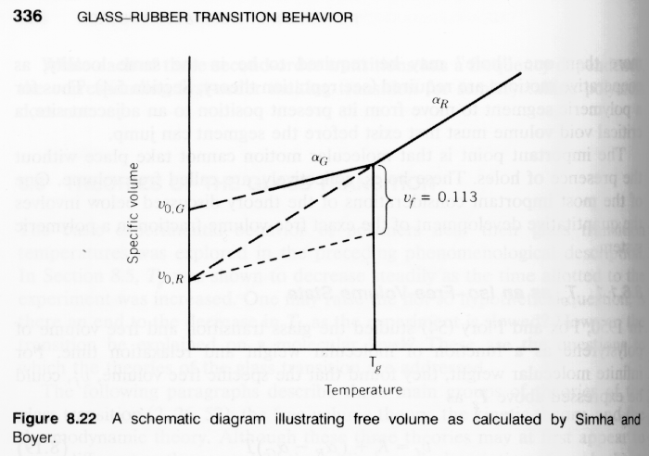

Chain ends have more flexibility so they should have more free volume compared to the main chain of a polymer. The fraction of chain ends, 2/Mn, should reflect an increased flexibility of the chains, lowering the glass transition. In the plot above, the black line to the right is shifted up by a factor proportional to 2/Mn which leads to a reduction in the glass transition following the Flory-Fox equation, Tg = Tg,∞ - 2K/Mn.

1. *The Fox equation describes the glass transition for a mixture of two materials and indicates that the parameter of interest in blends is the inverse of the glass transition temperature which is a weighted sum of the component glass transitions. The Fox equation is a harmonic mean which is usually used when you want to get an average rate. Like the average velocity on a trip, if you went 100 mph for half the trip and 10 mph for the other half your average speed would be 18.2 mph (not 55 mph). Explain the Fox equation using the idea of a harmonic mean. Refer to Casalini and Ransom (2020) who specify the rate of observation, x, for their glass transition temperature, Tx.*

The frequency of molecular vibrations is proportional to their energy, Evib = h (This is a solution from quantum mechanics for the energy difference between quantized vibrational energy states with the lowest energy state having an energy of ½ h. <https://chem.libretexts.org/Bookshelves/Physical_and_Theoretical_Chemistry_Textbook_Maps/Supplemental_Modules_(Physical_and_Theoretical_Chemistry)/Spectroscopy/Vibrational_Spectroscopy/Vibrational_Modes/Introduction_to_Vibrations> ). The thermal energy that drives the vibration is EThermal = kBT. At the glass transition the thermal energy driving a molecular vibration associated with flow is just achieved so Evib = EThermal, and Tg = (h/kB) . The glass transition temperature can be associated with a rate or a frequency of vibration. If we look for the average glass transition we should therefore look for an average rate and use the harmonic mean, 1/Tg,average = w1/Tg,1 + w2/Tg,2, which is the Fox Equation.

1. *Using the concept that you developed in part “c” write a new Flory-Fox equation to describe the impact of molecular weight on the glass transition (or explain how the concept in part c is consistent with the existing Flory-Fox equation).*

The fraction of chain ends, 2/Mn, could be used as w2 in the Fox equation leading to, 1/Tg,Mn = (1-2/Mn)/Tg,∞ + (2/Mn)/Tg,end. This can be written Tg,Mn = Tg,∞ [1/(1+(2/Mn){(Tg,∞/Tg,end) - 1})]. Then using the series expansion: 1/(1+x) = 1 – x + x2 – x3 + … the Flory-Fox equation can be obtained in this form: Tg,Mn = Tg,∞ - 2K/Mn where K = Tg,∞ ((Tg,∞/Tg,end) - 1). K should be a fairly large number and should have units of K. Mn is in number of equivalent end units. The two approaches are equivalent, the Fox approach allows an estimation of K.

1. *A. Stoddart, W. J. Feast, S. P. Rannard, Synthesis and thermal studies of aliphatic polyurethane dendrimers: a geometric approach to the Flory–Fox equation for dendrimer glass transition temperature, Soft Matter, (2012),* ***8****, 1096- 1108, describe a modified Flory-Fox equation for dendrimers. Dendrimers are highly branched polymers that follow a branching rule, say start with a three arm star, at each end-point branch two arms, and repeat for n generations. This generates a starburst molecule with many end-groups. Do you think that the Flory-Fox equation should work for this molecule? Explain Stoddart et al.’s approach and their resulting dependence shown in Figure 8.*

At face value there is a conceptual problem with dendrimers since the number of end-groups increases geometrically with molecular weight. The Flory-Fox equation is for a linear chain so it needs to be significantly modified to describe dendrimers. A new parameter, the infinite linear Tg,∞ needs to be introduced. And 2/Mn needs to be replaced with a function associated with dendrimers, probably a function that describes the increase in number of end-groups with generation, so if each end-group is doubled in each generation, then the number of end-groups would be (Original Arms in generation 0)(number of arms added per end)Number of generations. This term replaces 2 in the Flory-Fox equation.

The molecular weight of the structure also increases geometrically with the generation since for each generation the molecular weight increases by a number proportional to (number of arms added per end)Number of generations. The ratio of number of ends/molecular weight therefore reaches a constant value at a moderate number of generations.

Following the Flory-Fox equation the glass transition should also reach a plateau at moderate number of generations. In figure 10 Stoddart et al. show that this is the case:

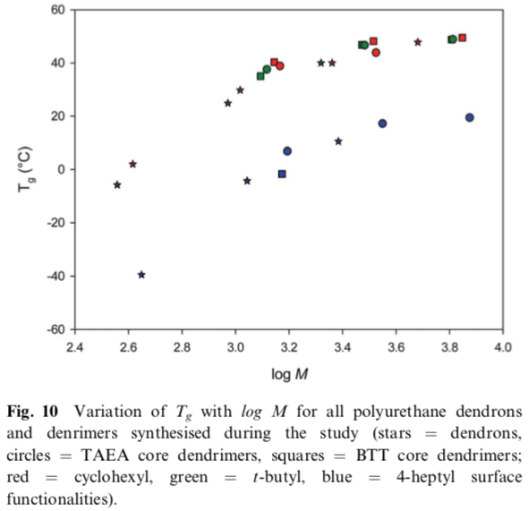

It would seem that there are many complications with dendrimers that would make the simple iso free volume approach not appropriate, but the data shown supports this model even for dendrimers.