**Homework 5 Advanced Thermodynamics**

**Due Tuesday September 29, 2020**

In class we discussed the activity coefficient as a measure of the thermodynamics of mixtures.

1. Jin, Weiliang, Qian, Xiaohong, Saijun and Jun, *Thermodynamics of Liquid Bi-Pb alloys -Experimental vs Modeling* Int. J. Electrochem. Sci., **15** 3836 – 3845 (2020), model and measure the miscibility of bismuth-lead alloys which is used as a heat transfer fluid in nuclear reactors. They used the electromotive force to measure the activity coefficients. For this case the Gibbs free energy can be expressed as



where Q = Fn is the charge (F is the Faraday constant and n is the number of electrons) and E is the potential or electromotive force dW/dQ. Figure 1 shows an electrochemical cell used to measure the open circuit voltage as a function of composition of the alloy in the right cup number 10. In equation (1) identify the entropic and enthalpic terms. Compare the equation with the Hildebrand model and explain any differences and similarities.

1. Equations (2) and (3) are polynomial models for the activity coefficient. Compare these equations with the equations presented in class. From what was done in class, what is the activity coefficient at infinite dilution? How are equations (4) and (5) obtained?
2. Explain the origin of equation (8). Use the free energy expression given above at constant temperature and pressure.
3. Luo, Chen, Wu, Cao, Luo and Shi, *Molecular Dynamics Simulation Study on Two-Component Solubility Parameters of Carbon Nanotubes and Precisely Tailoring the Thermodynamic Compatibility between Carbon Nanotubes and Polymers* Langmuir **36** 9291−9305 (2020) used the Hildebrand and Hansen solubility parameters to quantify the compatibility between polymers and carbon nanotubes. They used molecular dynamics simulations and the COMPASS force field. The solubility parameter is obtained from  = √CED = √(Ecoh/V) and Ecoh for various interactions are calculated and averaged using a quadratic mean, xm2 = xa2 + xb2 from the simulation results. The solubility parameters are compared with those obtained from the Flory-Huggins equation as described in reference 46. The smaller the R value the better the dispersion of SWNT in the polymer. Explain how the solubility parameter is related to the enthalpy of interaction. Interactions can be attractive or repulsive, how is this accounted for in the solubility parameter approach?
4. Explain the relationship between the Hildebrand, Hansen and the potentials available from the COMPASS simulations. How do these parameters relate to the Flory-Huggins interaction parameter, ?

Answers: **Homework 5 Advanced Thermodynamics**

**Due Tuesday September 29, 2020**

1. *In equation (1) identify the entropic and enthalpic terms. Compare the equation with the Hildebrand model and explain any differences and similarities.*



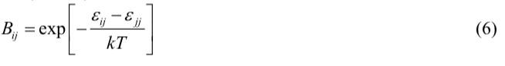

For the Hildebrand model, GmE/RT =  xA xB

For the activity coefficient model, GmE/RT = xA ln A + xB ln B

RT ln A =  xB2

Equation (1) has a mixture of enthalpic and non-combinatorial entropic terms. If we identify terms that are more or less linearly dependent on temperature as entropic, then the first two terms seem to be mostly entropic though the exponential dependence of Bij on temperature compromises that statement.

The second two terms are mostly enthalpic since ln(Bij) = ln(exp(-De/kT)) = -De/kT. This cancels with the GmE/RT temperature dependence. However, the presence of Bij in the numerator compromises this simple interpretation. It is a complicated expression.

1. *Equations (2) and (3) are polynomial models for the activity coefficient. Compare these equations with the equations presented in class. From what was done in class, what is the activity coefficient at infinite dilution? How are equations (4) and (5) obtained?*

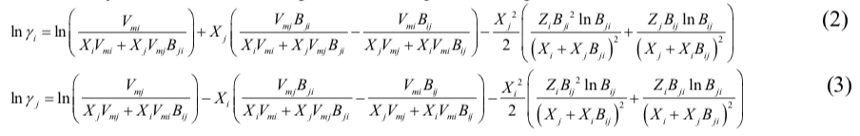

The Hildebrand regular solution model gives: RT ln A =  xB2. This has some similarity to the last term.

The polynomial model gives;

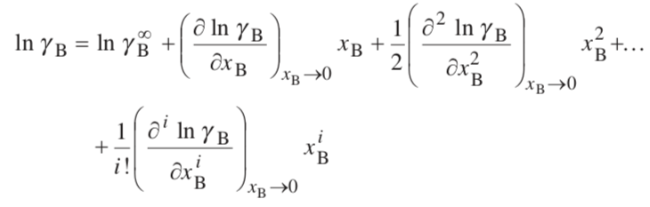

Which follows almost exactly equations (2) and (3) using the first two terms in equation (1) to define ln A, by comparison of equation (1) with GmE/RT = xA ln A + xB ln B.

1. *Explain the origin of equation (8). Use the free energy expression given above at constant temperature and pressure.*

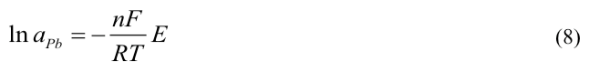

This arises directly from  with Q = nF. At constant temperature and pressure, G = E Q. If Gm/RT = xA ln aA + xB ln aB for the left electrode which is pure lead,   
G = RT ln aPb. So ln aPb = -nFE/(RT)

1. *Explain how the solubility parameter is related to the enthalpy of interaction. Interactions can be attractive or repulsive, how is this accounted for in the solubility parameter approach?*

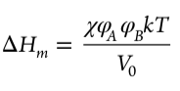

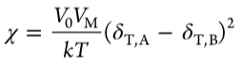

The solubility parameter is related to the cohesive energy density, that is the energy that holds a material together, 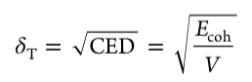. The model is based on the concept that materials that are held together with similar cohesive energies are similar materials, for instance polar molecules, molecules that hydrogen bond, molecules with high polarizability (van der Waals bonding) etc. Similar cohesive forces lead to miscibility. So there is no idea of attractive and repulsive forces in a direct way in the solubility parameter approach. It is based on the idea that like dissolves like. This idea doesn’t explicitly include these details.

1. *Explain the relationship between the Hildebrand, Hansen and the potentials available from the COMPASS simulations. How do these parameters relate to the Flory-Huggins interaction parameter, ?*

Luo explains this in some detail in the introduction section,

Hildebrand: 

Hansen: 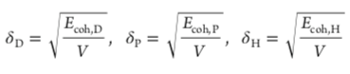 for dispersive, polar and hydrogen bonding interactions.

Related by a quadratic mean: 

COMPASS force field:  Valence is bond stretching, bending, torsion, out of plain deformations. Cross term is a fudge factor for odd “distortions” due to the presence of other atoms. Non-bond is sum of vdW and electrostatic interactions. In this paper Luo uses:  which were obtained from the COMPASS program but the details are not exactly spelled out.

The interaction parameter is obtained from:  more or less.