**Homework 6 Advanced Thermodynamics**

**Due Tuesday October 6, 2020**

This week we are looking at various types of phase diagrams.

1. Sketch a phase diagram and write the reaction that occurs at a/an: eutectic point, peritectic point, monotectic point, syntectic point. Indicate where congruent and incongruent melting occurs in your phase diagrams. Identify as many of these reactions as possible in an iron-carbon phase diagram as well as in a Bi-Zn phase diagram.
2. Septimio RS; Arenas MA; Conde A; Garcia A; Cheung N; de Damborenea J *Correlation between microstructure and corrosion behaviour of Bi-Zn solder alloys* Corr. Eng. Sci. Tech. 54 362-368 (2019). Explore the microstructure of bismuth zinc solders as a function of thermal treatment and composition. Figure 1 shows some microstructures that can result in this system. Explain the origin of the six micrographs that are shown based on your knowledge of phase diagrams and processing history.
3. Corrosion results from an electrochemical reaction, similar to a battery where an oxidation and reduction reaction occur at the anode and cathodes respectively. The microstructures of Figure 1 can influence the corrosion properties of these alloys. Briefly summarize the behavior that is observed in this paper including a comparison of Figures 2 and 3 and the micrographic evidence that is presented.
4. Feng D; Zhang J; Lib M; Chen M; Zhao B *Phase Equilibria of the SiO2–V2O5 system* present a phase diagram Cer. Int. **46** 24053–24059 (2020) present a phase diagram in Figure 6 that was partly determined from micrographic evidence presented in Figures 2 to 5. Explain the logic for each of these micrographs and how they relate to the phase diagram.
5. Anwar J; Leitold C; Peters B *Solid–solid phase equilibria in the NaCl–KCl system* J. Chem. Phys. **152**, 144109 (2020) present the phase diagram for NaCl-KCl determined using an equation of state and computer simluations in Figure 2. Explain what a solid solution is and how it is important to this paper. Explain Figures 3 and 4 and how they can be used to determine the phase diagram.

Answers: **Homework 5 Advanced Thermodynamics**

**Due Tuesday September 29, 2020**

1. *In equation (1) identify the entropic and enthalpic terms. Compare the equation with the Hildebrand model and explain any differences and similarities.*



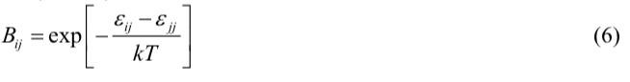

For the Hildebrand model, GmE/RT =  xA xB

For the activity coefficient model, GmE/RT = xA ln A + xB ln B

RT ln A =  xB2

Equation (1) has a mixture of enthalpic and non-combinatorial entropic terms. If we identify terms that are more or less linearly dependent on temperature as entropic, then the first two terms seem to be mostly entropic though the exponential dependence of Bij on temperature compromises that statement.

The second two terms are mostly enthalpic since ln(Bij) = ln(exp(-De/kT)) = -De/kT. This cancels with the GmE/RT temperature dependence. However, the presence of Bij in the numerator compromises this simple interpretation. It is a complicated expression.

1. *Equations (2) and (3) are polynomial models for the activity coefficient. Compare these equations with the equations presented in class. From what was done in class, what is the activity coefficient at infinite dilution? How are equations (4) and (5) obtained?*

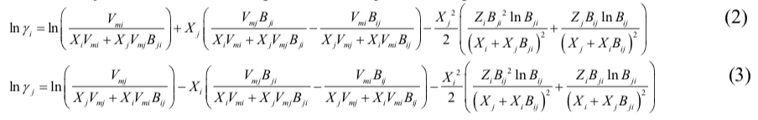

The Hildebrand regular solution model gives: RT ln A =  xB2. This has some similarity to the last term.

The polynomial model gives;

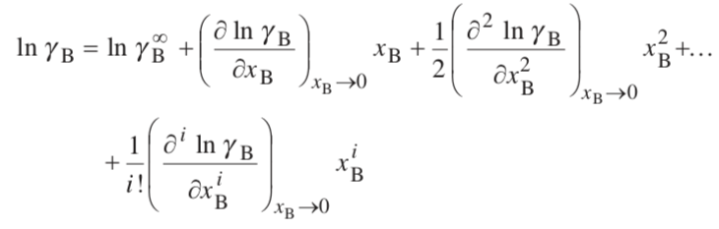

Which follows almost exactly equations (2) and (3) using the first two terms in equation (1) to define ln A, by comparison of equation (1) with GmE/RT = xA ln A + xB ln B.

1. *Explain the origin of equation (8). Use the free energy expression given above at constant temperature and pressure.*

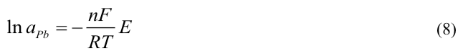

This arises directly from  with Q = nF. At constant temperature and pressure, G = E Q. If Gm/RT = xA ln aA + xB ln aB for the left electrode which is pure lead,   
G = RT ln aPb. So ln aPb = -nFE/(RT)

1. *Explain how the solubility parameter is related to the enthalpy of interaction. Interactions can be attractive or repulsive, how is this accounted for in the solubility parameter approach?*

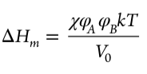

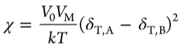

The solubility parameter is related to the cohesive energy density, that is the energy that holds a material together, 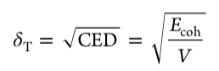. The model is based on the concept that materials that are held together with similar cohesive energies are similar materials, for instance polar molecules, molecules that hydrogen bond, molecules with high polarizability (van der Waals bonding) etc. Similar cohesive forces lead to miscibility. So there is no idea of attractive and repulsive forces in a direct way in the solubility parameter approach. It is based on the idea that like dissolves like. This idea doesn’t explicitly include these details.

1. *Explain the relationship between the Hildebrand, Hansen and the potentials available from the COMPASS simulations. How do these parameters relate to the Flory-Huggins interaction parameter, ?*

Luo explains this in some detail in the introduction section,

Hildebrand: 

Hansen: 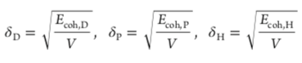 for dispersive, polar and hydrogen bonding interactions.

Related by a quadratic mean: 

COMPASS force field:  Valence is bond stretching, bending, torsion, out of plain deformations. Cross term is a fudge factor for odd “distortions” due to the presence of other atoms. Non-bond is sum of vdW and electrostatic interactions. In this paper Luo uses:  which were obtained from the COMPASS program but the details are not exactly spelled out.

The interaction parameter is obtained from:  more or less.