**Homework 7 Advanced Thermodynamics**

**Due Tuesday October 13, 2020**

The topic this week centers on the idea of fluctuations. Thermodynamics involves thermally drive fluctuations as the basis for reaching equilibrium and as the basis for change. Composition fluctuations can be visualized in spinodal decomposition since phase growth occurs on regions of high concentration related to fluctuations of composition.

1. Parsa MA, Ghiass M, Moghbeli MR *Mathematical Modelling and Phase Separation Kinetics of Polystyrene/Polyvinylmethylether Blend* Ir. Polym. J. **20** 689-696 (2011) describes simulation of spinodal decomposition in PVME/PS blends. Parsa uses the Flory-Huggins equation, (3). Compare this expression with the Hildebrand equation. Why were the differences introduced?
2. Equation (2) of Parsa is the Cahn-Hilliard (CH) equation which describes the rate of growth of concentration for domains spaced according to a balance between free energy and transport. CH theory predicts the spacing and time dependence of growth and is seen as a major theory in materials science. (Cahn was at UCLA and Hilliard was at MIT.) Explain the behavior that is seen in Figures 2 to 4 in terms of the driving force for phase separation in spinodal decomposition and in terms of Ostwald ripening.
3. Higgins JS, Cabral JT *A Thorny Problem? Spinodal Decomposition in Polymer Blends* Macromolecules **53** 4137−4140 (2020) discuss spinodal decomposition in polymers. In Fig. 3 shows a light scattering pattern that displays a peak. Explain the origin of this peak and why it shifts position to lower q as a function of time. According to Cahn-Hilliard theory how should this peak change with time?
4. Higgins mentions “uphill diffusion” at the end of her letter. Explain the difference between nucleation and growth and spinodal decomposition using the idea of uphill diffusion. (You might want to look at the Chapter from Strobl Polymer Physics linked to this section and Hashimoto T, Kumaki J, Kawai H *Time-Resolved Light Scattering Studies on Kinetics of Phase Separation and Phase Dissolution of Polymer Blends.+ 1. Kinetics of Phase Separation of a Binary Mixture of Polystyrene and Poly(viny1methyl ether)* Macromolecules **16**, 641-648 (1983))
5. Kulkarni AS, Beaucage G *Reaction induced phase-separation controlled by molecular topology* Polymer **46** 4454–4464 (2005) show that Ostwald Ripening can be prevented in systems that display complex topologies such as in polymer networks. Explain the different conditions that lead to nucleation and growth and spinodal decomposition in this system.

Answers: **Homework 5 Advanced Thermodynamics**

**Due Tuesday September 29, 2020**

1. *In equation (1) identify the entropic and enthalpic terms. Compare the equation with the Hildebrand model and explain any differences and similarities.*



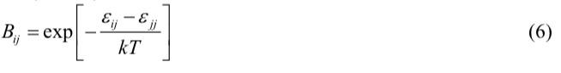

For the Hildebrand model, GmE/RT =  xA xB

For the activity coefficient model, GmE/RT = xA ln A + xB ln B

RT ln A =  xB2

Equation (1) has a mixture of enthalpic and non-combinatorial entropic terms. If we identify terms that are more or less linearly dependent on temperature as entropic, then the first two terms seem to be mostly entropic though the exponential dependence of Bij on temperature compromises that statement.

The second two terms are mostly enthalpic since ln(Bij) = ln(exp(-De/kT)) = -De/kT. This cancels with the GmE/RT temperature dependence. However, the presence of Bij in the numerator compromises this simple interpretation. It is a complicated expression.

1. *Equations (2) and (3) are polynomial models for the activity coefficient. Compare these equations with the equations presented in class. From what was done in class, what is the activity coefficient at infinite dilution? How are equations (4) and (5) obtained?*

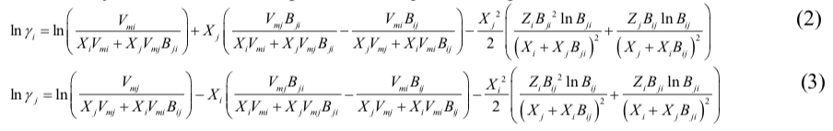

The Hildebrand regular solution model gives: RT ln A =  xB2. This has some similarity to the last term.

The polynomial model gives;

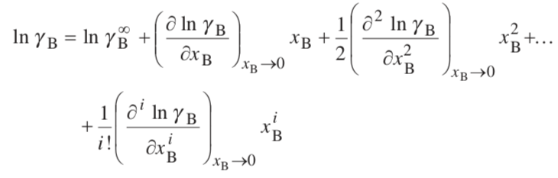

Which follows almost exactly equations (2) and (3) using the first two terms in equation (1) to define ln A, by comparison of equation (1) with GmE/RT = xA ln A + xB ln B.

1. *Explain the origin of equation (8). Use the free energy expression given above at constant temperature and pressure.*

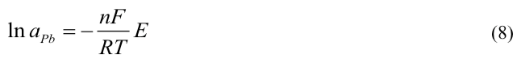

This arises directly from  with Q = nF. At constant temperature and pressure, G = E Q. If Gm/RT = xA ln aA + xB ln aB for the left electrode which is pure lead,   
G = RT ln aPb. So ln aPb = -nFE/(RT)

1. *Explain how the solubility parameter is related to the enthalpy of interaction. Interactions can be attractive or repulsive, how is this accounted for in the solubility parameter approach?*

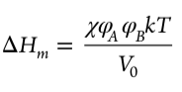

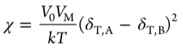

The solubility parameter is related to the cohesive energy density, that is the energy that holds a material together, 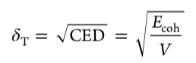. The model is based on the concept that materials that are held together with similar cohesive energies are similar materials, for instance polar molecules, molecules that hydrogen bond, molecules with high polarizability (van der Waals bonding) etc. Similar cohesive forces lead to miscibility. So there is no idea of attractive and repulsive forces in a direct way in the solubility parameter approach. It is based on the idea that like dissolves like. This idea doesn’t explicitly include these details.

1. *Explain the relationship between the Hildebrand, Hansen and the potentials available from the COMPASS simulations. How do these parameters relate to the Flory-Huggins interaction parameter, ?*

Luo explains this in some detail in the introduction section,

Hildebrand: 

Hansen: 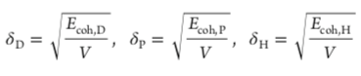 for dispersive, polar and hydrogen bonding interactions.

Related by a quadratic mean: 

COMPASS force field:  Valence is bond stretching, bending, torsion, out of plain deformations. Cross term is a fudge factor for odd “distortions” due to the presence of other atoms. Non-bond is sum of vdW and electrostatic interactions. In this paper Luo uses:  which were obtained from the COMPASS program but the details are not exactly spelled out.

The interaction parameter is obtained from:  more or less.