Homework 1
Polymer Physics
Due August 30,2022 before class

A first-order transition is characterized by a discontinuity in state functions such as the enthalpy which results in a heat of transition for example the heat of vaporization or fusion. Neophytou A, Chakrabarti D, Sciortino F Topological nature of the liquid–liquid phase transition in tetrahedral liquids Nat. Phys. https://doi.org/10.1038/s41567-022-01698-6 (2022) propose a first order transition between two liquid states for tetrahedrally associated molecules due to topological differences between the two “phases”. An example of topological difference of this type is the difference between a pile of string and a pile of string with knots, below. Where LDL is a low-density liquid with no knots and HDL is a high-density liquid with knots.
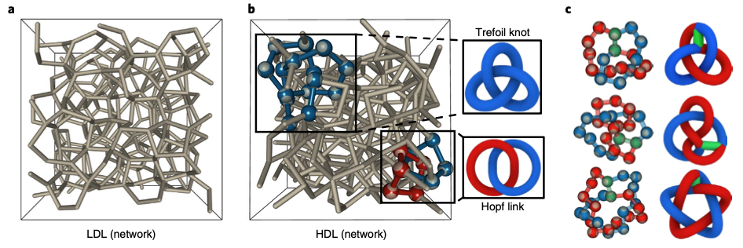
Neophytou quantifies the transition with several topological intrinsic parameters shown below.
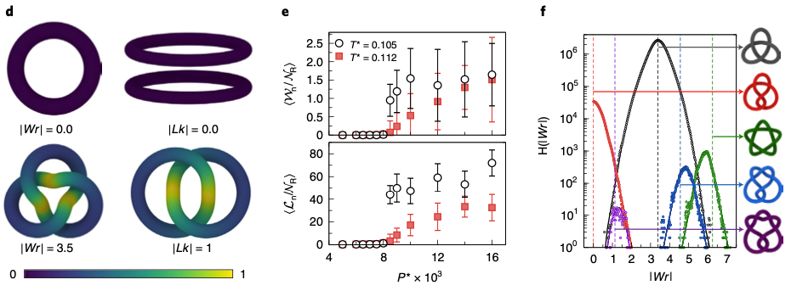
The last figure shows the distribution of various topological features.
- Define a state parameter. Is a topological feature such as a knot in a shoelace a state parameter. Would Hess’ Law apply to a topological feature such as a knot in a shoelace?
- Make an argument that the transition being observed is a second order transition. Define what parameter is considered that has a discontinuous second derivative.
- If I throw computer cables on the floor, then try to pick them up I generally find that they are entangled. It requires significant energy to disentangle the cables though the pile will appear almost identical before and after disentanglement. Is this a first-order transition? How is this different from Neophytou’s proposition for water molecules?
- Is Neophytou’s system ergotic? Has it reached equilibrium? How would you define equilibrium in this case?
- Consider the LDL and HDL “states”. Do these two states have different entropies if calculated using the Boltzman equation?

