Homework 14 Thermodynamics Due Friday December 9, 2022
(This counts at two Homework)

Thermodynamics Question 1

One form of the Gibbs-Thompson Equation (GTE) describes the shift in melting point for nano-crystals as a function of their size and can be adapted to describe the shift in melting point for confined fluids such as at an AFM tip as a function of a fluid filled gap’s height, h, Fig. 2 below. Scalfi L, Coasne B, Rotenberg B, On the Gibbs-Thomson equation for the crystallization of confined fluids. J. Chem. Phys. 154 114711 (2021) present a new derivation of the GTE for confined fluids and use the derivation to simulate crystallization in confined pores and gaps using a Monte Carlo method.

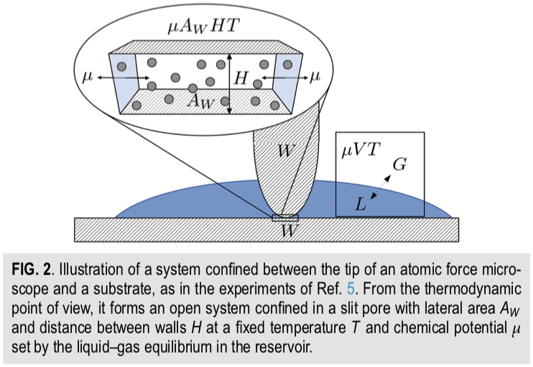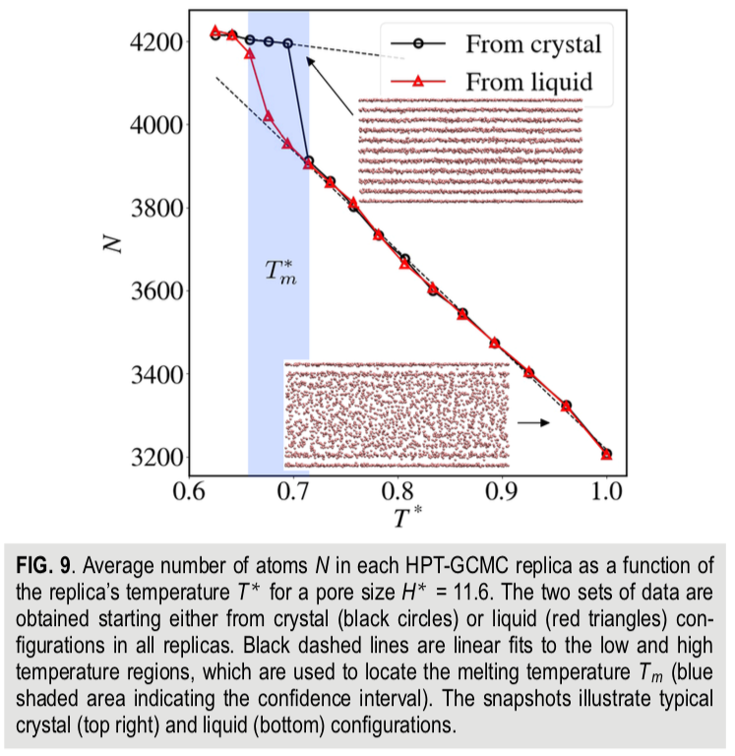

- The normal derivation of the GTE involves simply writing an expression for the Gibbs free energy that includes volumetric and surface terms, considering equilibrium for small particles (spheres) and solving for the particle size. Derive the GTE in this way for a planar crystal with infinite width and height H (Scalfi uses “h” for the enthalpy per particle). Scalfi’s GTE includes two surface energies, that of the liquid and that of the solid. How do you accommodate this in your derivation?
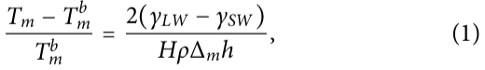
- Scalfi gives the following thermodynamic potential (2) and internal energy (3) for the fluid/solid between the gap,
Use the thermodynamic square or other means to explain the origin of these two expressions. What kind of free energy is Ω ?
- The son of Herman von Helmholtz (Robert von Helmholz) derived the Gibbs-Thompson equation from the Oswald-Freundlich Equation (OFE) using the integrated Clausius-Clapeyron Equation (CCE) for his PhD dissertation in 1885 (things were simpler then).
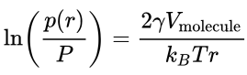 OFE
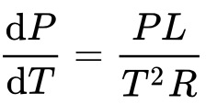 CCE
For this reason, the OFE or Kelvin Equation is sometimes referred to as the GTE. Obtain the GTE from the OFE using the integrated CCE. Also, give (don’t derive) the Ostwald-Freundlich Equation which describes the relationship between the supersaturated mole fraction, x, and nanoparticle size, r, for crystallization from solution.
- Scalfi used Monte Carlo Simulations with the Metropolis method to determine the melting point, Figure 9 where N is the density and T* is a reduced temperature. He used a 6-12 potential with a cutoff of 2.5 σ where σ is the atomic size. Monte Carlo steps involved translation, deletion or insertion. The starting state could be liquid or crystal structures and resulted in the densities shown in Figure 9. Give an algorithm for a typical Metropolis simulation of this type. How would you determine if the simulation had reached equilibrium?
- In Figure 9 Scalfi shows that the crystalline structure exists at the interface with the AFM tip and the stage (which is the same material in the simulation) even in the (bulk) amorphous state (lower structure). Derive expressions comparing the free energy barrier, ΔG*, and phase size, r*, for surface (heterogeneous) and bulk (homogeneous nucleation). Can this explain the observed behavior?

Thermodynamics Question 2

Choi J-M, Holehouse AS, Pappu RV Physical Principles Underlying the Complex Biology of Intracellular Phase Transitions Ann. Rev. Biophy. 49 107-133 (2020) discuss phase separation in cellular biology. Choi’s discussion is largely based on the Flory-Huggins mean-field, regular-solution model. They include some aspects of “stickers”, ”spacers”, and ”linkers” that can be used to describe complex folding phenomena.

- Choi gives the following definition of the Flory-Huggins chi-parameter,
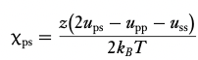
He further states:
“In a theta solvent, also known as an indifferent solvent, χ_{ps} = 0, and the polymer–solvent, polymer–polymer, and solvent–solvent interactions are perfectly counterbalanced. Accordingly, the entropy of mixing is the only relevant term, and this favors the formation of an ideal, one-phase mixture in a theta solvent.”
For polymers the “theta” point is the critical temperature for phase separation. A “theta solvent” is a solution exactly at the theta temperature. Write the Flory-Huggins (FH) regular-solution equation for the Helmholtz free energy and indicate how you would obtain the critical point (theta-temperature). Is Choi’s statement correct? What is an “athermal” solvent?
- Choi indicates that FH theory is for mean-field interactions while biological polymers have specific interactions. What is the different between these two types of interaction? How are specific interactions generally dealt with, that is, what are the equations that might be used to describe specific interactions?
- Something that isn’t considered by Choi is molecular convolution, that is, for polyelectrolytes with charged side groups the chains tend to be extended due to Coulombic repulsion of charge groups. How would rod-like chains impact miscibility in a solvent?
- Choi determines a mean-field Helmholtz free energy, equation 6, from the partition function, Z. Explain the origin (derive) of equation 3 that relates the Helmholtz free energy to the partition function. What ground state is this free energy relative to?
- Choi discusses an “associative mean-field” model. Critique this model. Are binary interactions such as used in the regular solution model, sufficient to describe associations of the type in this paper? Can a mean-field model describe protein/nucleic acid folding?

