Homework 14 Thermodynamics Due Friday December 8, 2023
(This counts at two Homework)

Question 1

Fenton SM, Padmanabhan P, Ryu BK, Nguyen TTD, Zia RN, Helgeson ME Minimal conditions for solidification and thermal processing of colloidal gels PNAS 120 e2215922120 (2023) explore the formation of gels based on three mechanisms: percolation, phase separation, and glassy arrest. Fenton determines a gelation point at the slowest extrapolated rate of gelation. Fenton states: “the minimal gel line is set by a complex interplay of percolation, phase separation, and glassy arrest, which dissects the phase diagram into a number of regions with differing time-dependent gelation behavior that is conserved across interaction potentials of differing range.”.

- Gels involve formation of a network of particles or molecules in a solvent. Explain the pathway for formation of this network based on 1) percolation, 2) phase separation and 3) glassy arrest. How would the thermal dependence of gelation differ for these three mechanisms? Under each of these three mechanisms, is gelation a thermodynamic transition? What role would kinetics play in each of these three mechanisms? What is the difference between a “state diagram” discussed by Fenton, and a phase diagram discussed in class?
- Michael Cates is somewhat seen as the next potential Nobel Laureate for soft matter physics. Fenton’s paper is premised on a paper by Cates “For example, Cates and coworkers (13) posited that quenches at different rates could be used as a means of controlling gelation behavior when the time scales of phase separation intersect with the time scales of the quench.” Explain this text. Explain the “minimal gel point” described by Fenton on page 4 at the top of the second column.
- Fenton’s equation 1 relates an interparticle potential obtained from neutron scattering to the second virial coefficient (see
https://chem.libretexts.org/Bookshelves/Physical_and_Theoretical_Chemistry_Textbook_Maps/Physical_Chemistry_(LibreTexts)/16%3A_The_Properties_of_Gases/16.05%3A_The_Second_Virial_Coefficient). Explain how the second virial coefficient for non-interaction hard spheres of radius σ is estimated from the van der Waals equation (a = 0). How is this used in equation 1?
- In oscillatory rheometry the strain is oscillated, and the stress is measured as a function of time. The in-phase stress defines the storage modulus G’ (solid-gel behavior). The out-of-phase stress defines the loss modulus G” (liquid-sol) behavior. When G” > G‘, the material is a liquid sol. When G’ > G” the material is a solid gel. Measurements are usually made at different frequencies of oscillation, high frequency (short time) leads to solid, low frequency (long time) to liquid. Fenton measures at a fixed frequency and observes the G’ and G” as a function of gelation time with G”/G’ (or tan δ where δ is the phase angle) dropping. The gel point is defined by Fenton as the time where G’ = G” (or tan δ = 1 and phase angle = 45°). This cross over time is the “gel time”, τ_{gel}. B₂* from equation 1, as measured by scattering or simulation, is plotted against τ_{gel}⁻¹ to determine the infinite time B₂* (where 1/τ_{gel} => 0). (In the van der Waals model B₂ = b - a/kT so the B₂* axis is effectively a 1/T axis.)
How would Fenton’s figure 3A be used to predict phase behavior? Explain the three regimes, red, green, and blue in Fenton’s figure 3A.
- Fenton discusses a time-scale dependence to gelation. There is also a size-scale dependence to gelation, considering, for instance, a percolation model or an Ising model. Explain a size-scale dependence (not discussed by Fenton) and how it could impact comparisons between simulation, scattering, and rheology (typically rheology probes macroscopic sizes at low frequencies (long times) and atomic sizes at very high frequencies (short times) such as in Figures 3 B, C, D).

Question 2

One form of the Gibbs-Thompson Equation (GTE) describes the shift in melting point for nano-crystals as a function of their size and can be adapted to describe the shift in melting point for confined fluids such as at an AFM tip as a function of a fluid filled gap’s height, h, Fig. 2 below. Scalfi L, Coasne B, Rotenberg B, On the Gibbs-Thomson equation for the crystallization of confined fluids. J. Chem. Phys. 154 114711 (2021) present a new derivation of the GTE for confined fluids and use the derivation to simulate crystallization in confined pores and gaps using a Monte Carlo method.

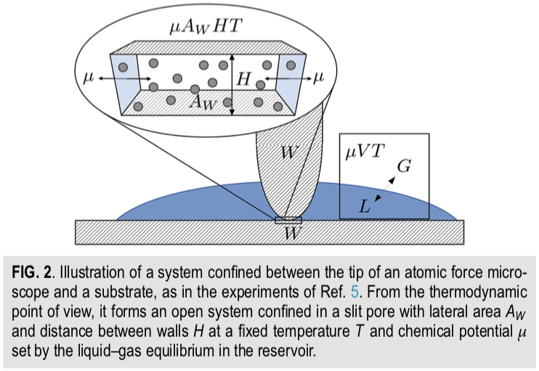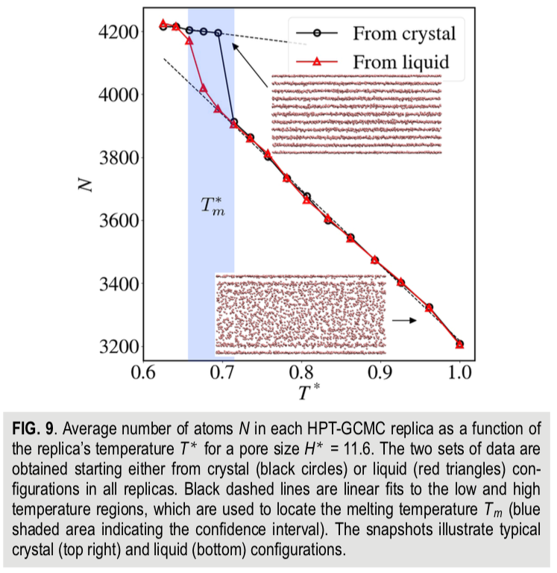

- The normal derivation of the GTE involves simply writing an expression for the Gibbs free energy that includes volumetric and surface terms, considering equilibrium for small particles (spheres) and solving for the particle size. Derive the GTE in this way for a planar crystal with infinite width and height H (Scalfi uses “h” for the enthalpy per particle). Scalfi’s GTE includes two surface energies, that of the liquid and that of the solid. How do you accommodate this in your derivation?
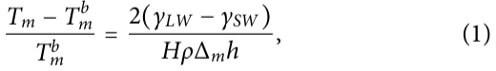
- Scalfi gives the following thermodynamic potential (2) and internal energy (3) for the fluid/solid between the gap,
Use the thermodynamic square or other means to explain the origin of these two expressions. What kind of free energy is Ω ?
- The son of Herman von Helmholtz (Robert von Helmholz) derived the Gibbs-Thompson equation from the Oswald-Freundlich Equation (OFE) using the integrated Clausius-Clapeyron Equation (CCE) for his PhD dissertation in 1885 (things were simpler then).
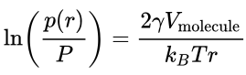 OFE
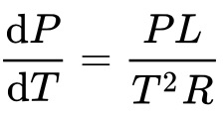 CCE
For this reason, the OFE or Kelvin Equation is sometimes referred to as the GTE. Obtain the GTE from the OFE using the integrated CCE. Also, give (don’t derive) the Ostwald-Freundlich Equation which describes the relationship between the supersaturated mole fraction, x, and nanoparticle size, r, for crystallization from solution.
- Scalfi used Monte Carlo Simulations with the Metropolis method to determine the melting point, Figure 9 where N is the density and T* is a reduced temperature. He used a 6-12 potential with a cutoff of 2.5 σ where σ is the atomic size. Monte Carlo steps involved translation, deletion or insertion. The starting state could be liquid or crystal structures and resulted in the densities shown in Figure 9. Give an algorithm for a typical Metropolis simulation of this type. How would you determine if the simulation had reached equilibrium?
- In Figure 9 Scalfi shows that the crystalline structure exists at the interface with the AFM tip and the stage (which is the same material in the simulation) even in the (bulk) amorphous state (lower structure). Derive expressions comparing the free energy barrier, ΔG*, and phase size, r*, for surface (heterogeneous) and bulk (homogeneous nucleation). Can this explain the observed behavior?

