Homework 5
Advanced Materials Thermodynamics
Due Monday September 25, 2023

Lithium-ion batteries rely on an anode, originally lithium-intercalated in graphite, and a cathode, originally lithium cobalt oxide or lithium manganese oxide or lithium nickel oxide which are also layered structures that intercalate lithium ions. An electrolyte, lithium hexaflorophosphate (LiPF₆), is used with a separator membrane between the electrodes. The low density of lithium leads to a high energy density for the Li⁺ cell. The storage capacity for lithium ions should be almost matched between the anode and cathode (10% more in the anode to prevent precipitation of lithium metal dendrites). The storage capacity of the anode can be increased by a factor of 10 by substitution of silicon for graphite, and even higher using a lithium anode. (https://www.quantumscape.com/resources/blog/energy-density-active-materials-electrode-loading/) The power density of Li+ batteries has plateaued after rapidly increasing up to about 2012. This is partly due to the need for a leap in technology such as improved cathode and anode materials (this leap must be matched) with greater storage capacity. Much of the increase in the plot below has been due to the addition of small amounts of silicon to the graphite anode. Matching dramatic enhancement of the cathode material is one need.
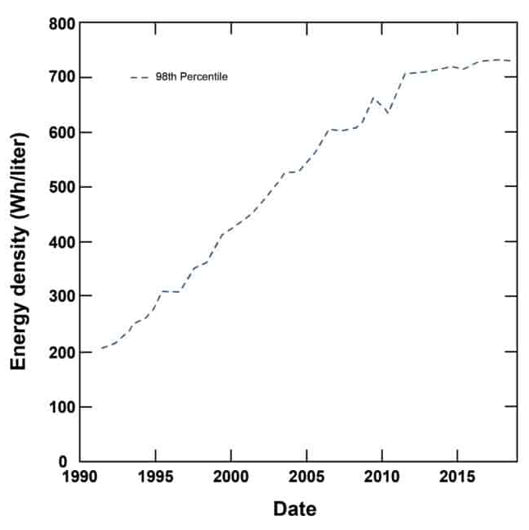
Limitations on the cathode material include, 1) cost and political problems with cobalt as a major component (mined in the DRC by child hand labor). 2) formation of rock salt crystal structure nickel oxide phases at interfaces that interfere with transport of electrons and Li⁺. 3) Brittleness of the cathode due to the micron-scale structure and processing limitations. Yoon M, Dong Y, Huang Y, Wang B, Kim J, Park J-S, Hwang J, Park J, Kang SJ, Cho J, Li J Eutectic salt-assisted planetary centrifugal deagglomeration for single-crystalline cathode synthesis Nat. Energy 8 482-491 (2023), present a process to improve the crystal structure of Li-/Mn-rich layered cathodes Li_{1.2}Mn_{0.48}Ni_{0.16}Co_{0.16}O₂ (LMR) which are spinel structure crystals. These crystals are produced by mixing the component metals in the indicated stoichiometry and calcinating the mixture at a high temperature. Yoon suggests the use of an eutectic lithium salt, Figure 2h, as a processing aid. (It is surprising that this engineering report was published in Nature but the topic is of some technical importance and some of the authors are from MIT.)

- Figure 2h shows a phase diagram for two lithium salts that are used as a processing aid for LMR cathodes. If you slowly cooled 0.5 mole fraction LiOH from 300°C to 175°C what structure and compositions would result? What about a rapid quench from 300°C to 100°C for the same composition? (Sketch the structures)
- If you rapidly cooled the salts at 0.45 mole fraction LiOH from 250°C to 187°C what structure and what compositions would you expect? What about a rapid quench from 250°C to 175°C? And a rapid quench from 250°C to 100°C? (Sketch the structures)
- If you slowly cooled the salts at 0.45 mole fraction LiOH from 250°C to 100°C, what structure and composition would you expect? (Sketch the structure)
- Yoon indicates that the red “X” compositions in the phase diagram do not lead to well dispersed LMR cathodes while the green inverse triangles lead to optimal cathodes. The cathodes are processed in a polypropylene vessel that melts at 166°C. The vessel doesn’t melt during the mixing at 6000 rpm in a plenary mixer. Explain how the two green compositions could impact the structure and dispersion of the cathode material.
- A spinel structure is of the form AB₂O₄ where A is a metal in an oxidation state +2 while B is a metal in an oxidation state +3. Rock salt is a crystal form that is similar to NaCl, two superimposed FCC structures with the second component on the center of the edge locations. In Figure 3 Yoon indicates M₃O₄ for the spinel phase and Li_{1-x}M_{x}O for the rock salt phase. Explain how this can be correct given these definitions. Why is the rock salt phase at the surface of the spinel phase and why is it thinner in the presence of the lithium salts with compositions at the inverted green triangles in Figure 4h?

