Homework 6
Advanced Materials Thermodynamics
Due Monday October 2, 2023

Spinodally-decomposed materials have been proposed for several applications such as heat shock resistant glass (Vycor), fog free windows, dust repelling surfaces, pore gradient membranes (SIPS membranes https://www.3m.com/3M/en_US/membrana-us/resources/technologies/manufacturing/sips/#:~:text=SIPS%20Processes%20for%20Hollow%2DFibre,and%20thus%20creates%20the%20lumen.), and biocompatible porous materials. In many of these applications use is made of the bi-continuous network structure which allows leaching of one of the two phases. Wang Z, Dabaja R, Chen L, Banu M Machine learning unifies flexibility and efficiency of spinodal structure generation for stochastic biomaterial design Nat. 13 5414 (2023) describe a machine learning (convolution neural network) to simulate spinodal structures with gradients in porosity and anisotropic pore structure that can be examined for mechanical strength, pore sizes and transport. The intent is to mimic the natural gradients of random porosity in human bone tissue. Machine learning involves a training data set and a weighted parametrization of features of a system, here the composition spatial distribution over a 64 cubed “voxel” grid.

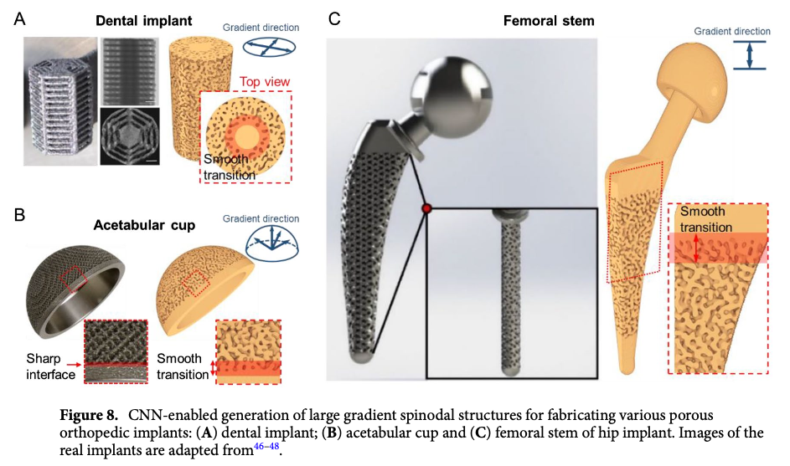

- Wang calculates the training and testing data using a phase-field simulation starting with a random distribution of phase composition on 1500 64 cubed voxel samples. A phase-field simulation involves calculation of the bulk free energy and the interface energy based on a smooth gradient. In this case these are based on equations (3) and (4). Explain how these equations are related to the Cahn-Hilliard theory for spinodal decomposition by comparison with Hashimoto T, Kumaki J, Kawai H Time-Resolved Light Scattering Studies on Kinetics of Phase Separation and Phase Dissolution of Polymer Blends. 1. Kinetics of Phase Separation of a Binary Mixture of Polystyrene and Poly(viny1methyl ether) Macromolecules 16 641-648 (1983). Wang uses “circular padding” to deal with edge effects for these 64 cubed samples. Explain what “circular padding” means by looking at Schoeters S, Dewulf W, Krutha JP, Haitjema H, Boeckmans B Description and validation of a circular padding method for linear roughness measurements of short data lengths MethodsX 7 101122 (2020).
- Spinodal decomposition results in certain signature structural features: a bicontinuous structure, a structure of constant mean curvature (Jinnai H, Koga T, Nishikawa Y, Hashimoto T, Hyde ST Curvature Determination of Spinodal Interface in a Condensed Matter System PRL 78 2248-2251 (1997).), a stochastic (“random”) structure with periodic domains of narrow size distribution, and interfacial concentration gradients that go against Fick’s law, that is reverse diffusion interfacial concentration gradients. Figure 4B on page 6 demonstrates one of these signature features from the ML structures. The initial slope of a binary correlation function is proportional to the negative of the surface to volume ratio for the phase. The peak pertains to another feature of the system as does the limiting value at large distances. Do these three features of the correlation functions for the three concentrations agree with expectations? Consider that the learning sample was a square of 64 voxels that results in Wang’s periodic structure. What do you think would have happened if Wang had shown the correlation function to the full size of his 128 voxel artificial intelligence (AI) generated structures?
- Figure 3A shows what appears to be Ostwald ripening. Explain what Ostwald ripening involves and how Figure 3A demonstrates it. What is the final result if Ostwald ripening were to run to conclusion?
- Figure 3 F and G demonstrate some of the expected behaviors of spinodal structures. Go through these two figures and explain what features are being demonstrated.
- Figures 5 and 6 compare the mechanical properties of the AI generated structures with the training samples. Explain what the C_{ij} values are and how they relate to the mechanical properties. How many independent values for C_{ij} are there? (see https://www.eng.uc.edu/~beaucag/Classes/AdvancedMaterialsThermodynamics/Books/Mechanical%20Constituitive%20Equations%20module_3_with_solutions.pdf and the Born & Huang text Dynamical Theory of Crystal Lattices.)

