Homework 1 Advanced Materials Thermodynamics
Due September 2, 2024

A first-order transition is characterized by a discontinuity in state functions such as the enthalpy which results in a heat of transition, for example the heat of vaporization or fusion. Neophytou A, Chakrabarti D, Sciortino F Topological nature of the liquid–liquid phase transition in tetrahedral liquids Nat. Phys. https://doi.org/10.1038/s41567-022-01698-6 (2022) propose a first order transition between two liquid states for tetrahedrally-associated molecules (like water or silicon) due to topological differences between the two “phases”. An example of topological difference of this type is the difference between a pile of string and a pile of string with knots, below, where LDL is a low-density liquid with no knots and HDL is a high-density liquid with knots.
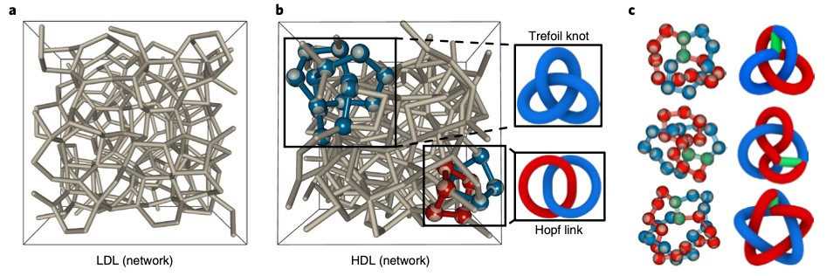
Neophytou quantifies the transition with several topological intrinsic parameters shown below.
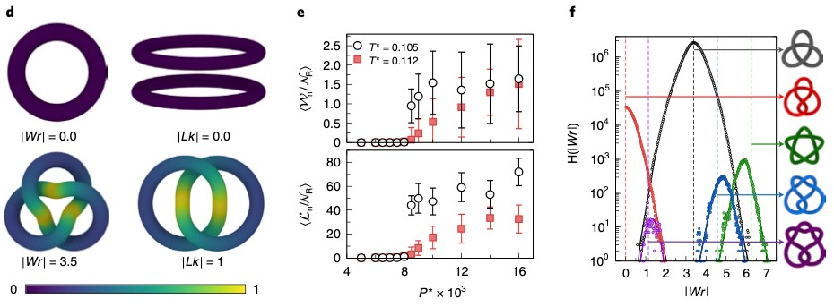
The last figure shows the distribution of various topological features.
- Define a state parameter. Is a topological feature such as a knot in a shoelace a state parameter? Would Hess’ Law (and the First Law of Thermodynamics) apply to a topological feature such as a knot in a shoelace?
- Neophytou demonstrates that the transition is first order in figures 1 c-e. Explain how each of these figures indicates a first order transition.
- Water has the strange feature that the solid state is less dense than the liquid state, allowing icebergs to float and ice to form at the top of a lake. Explain how Neophytou’s figure 1a supports the connection of his colloids to water. What is the mechanism that Neophytou proposes for this behavior (second to the last paragraph in the conclusion).
- If I throw computer cables on the floor, then try to pick them up I generally find that they are entangled. It requires significant energy to disentangle the cables though the pile will appear almost identical before and after disentanglement. Is this a first-order transition? How is this different from Neophytou’s proposition for water molecules (tetrahedrally-associated molecules)?
- Is Neophytou’s system ergotic? Has it reached equilibrium? Do the LDL and HDL states have different entropies if calculated using the Boltzmann equation?

