**Chemical Engineering Thermodynamics**

**Quiz 1**

**January 14, 2021**

***Turn in the completed Excel sheet and the PV plot***

Consider a simplified steam turbine/condenser/compressor/boiler/superheater for production of electricity shown in the schematic. Using the steam table at the back of the book, ***fill in the Excel table*** and use it to ***answer the questions***.

**The compressor uses 15 kW and has 100% efficiency.**

**The flow rate is 1200 kg/h for all streams.**

**Water Molecular Weight 18.0 g/mol**

**1 m3 = 106 cm3**

**Watt = J/s**

1. Determine the shaft work, *W*s, for the turbine **in kW** (which is kJ/s). *Under an adiabatic assumption (no heat loss) at 100% efficiency the shaft work equals the difference in enthalpy, H, between the exiting and entering streams.*
2. Calculate the combined heat needed for the boiler and superheater (boiler converts from liquid to vapor and superheater further heats the steam) **in kW** (which is kJ/s). (*This is the difference in enthalpy (H) between the streams.*)
3. Take the ratio of the shaft work recovered from the steam turbine minus that used in the compressor; to the heat needed for the boiler to get an idea of how efficient this system is with a turbine at 100% efficiency. Why is this efficiency less than 100%?
4. The maximum possible efficiency for a heat engine (Carnot cycle) can be shown to be (*T*H – *T*C)/*T*H. Compare this best possible efficiency to your efficiency. (Carefully choose the units of temperature.)
5. On the log-log *P* vs *V* plot given below show the points 1, 2, 3 and 4. Drawlines connecting the points on this plot to show the cycle. P times V is energy, what energy is represented by the area within the lines you have drawn?



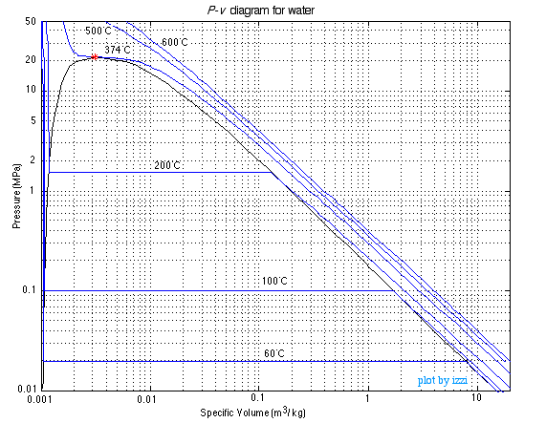

ANSWERS: **Chemical Engineering Thermodynamics**

**Quiz 1 January 16, 2020**



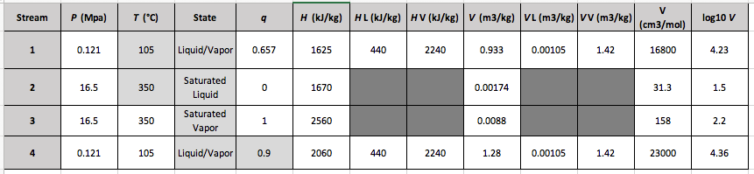

1. Shaft Work = H3-H4 = 500kJ/kg (1200kg/h) (1 h/3600s) = 167 kW
2. Combined Heat = H2 – H3 = -890kJ/kg (1200kg/h) (1 h/3600s) = -297 kW
3. Efficiency = ((H3-H4)-(H2-H1))/(H3-H2) = 455kJ/kg/890kJ/kg = 0.511 (Give comments/calculations on separate sheet)
4. Ideal Efficiency = (350°C – 105°C)/(350°C + 273K) = 0.393 (Give comments/calculations on separate sheet)
5. Find *H*2-*H*1

*W*s = (2580-3100)kJ/kg (1200 kg/h) (1/(3600 s/h)) = -173 kW

1. Find H1-H3

*Q* = (3100-763)kJ/kg (1200 kg/h) (1/(3600 s/h)) = 779 kW

1. ** = 173 kW/779 kW = 0.222 or 22.2% efficiency.

There is loss at the condenser. Also, there is a maximum efficiency associated with the necessary production of entropy limiting the process to about 27% efficiency, see part d.

1. **Carnot = (*T*H – *T*C)/*T*H = (350°C-180°C)/(350°C + 273°C) = 0.273

The Carnot efficiency is higher than the observed efficiency since this is a real process.

1. The lever rule won’t work on a log-scale.