**Chemical Engineering Thermodynamics**

**Quiz 1**

**January 14, 2021**

Treatment of COVID-19 patients often involves the use of a ventilator which supplies compressed air to a patient who is intubated. It has been suggested that the lack of ventilators might be alleviated through sharing of one ventilator between two patients. The human lung has elasticity as well as a muscular response. It might be modeled as a rubber balloon. Rubber is often modeled using the “ideal rubber law” which states that the modulus of a rubber is *RT* where ** is the crosslink density which is related to 1/*M*c the molecular weight between crosslinks. ** is a constant for a given rubber. For a balloon of radius *R*, the retractive force, *F*R,

Consider a simplified steam turbine/condenser/boiler/superheater for production of electricity shown in the schematic below. Using the attached steam table, ***fill in the table below*** the diagram to ***answer the questions***.

1. Use the steam tables to determine the shaft work, *W*s, for the turbine **in kW** (which is kJ/s). Under and adiabatic assumption (no heat loss) the shaft work equals the difference in enthalpy, *H*, between the exiting and entering streams at 100% efficiency. (The flow rate is 1200 kg/h for all streams.)
2. Calculate the combined heat needed for the boiler and superheater (boiler converts from liquid to vapor and superheater further heats the steam) **in kW** (which is kJ/s). (This is the enthalpy (*H*) difference between the streams.)
3. Take the ratio of the shaft work recovered from the steam turbine to the heat needed for the boiler to get an idea of how efficient this system is with a turbine at 100% efficiency. Why is this efficiency less than 100%?
4. The maximum possible efficiency for a heat engine can be shown to be (*T*H – *T*C)/*T*H. Compare this best possible efficiency to your efficiency. (Carefully choose the units of temperature.)
5. On the log-log *P* vs *V* plot, below, approximately show the points 1, 2 and 3. Explain why the lever rule will not work on this plot.

**Water Molecular Weight 18.0 g/mol**

**1 m3 = 106 cm3**

**Watt = J/s**

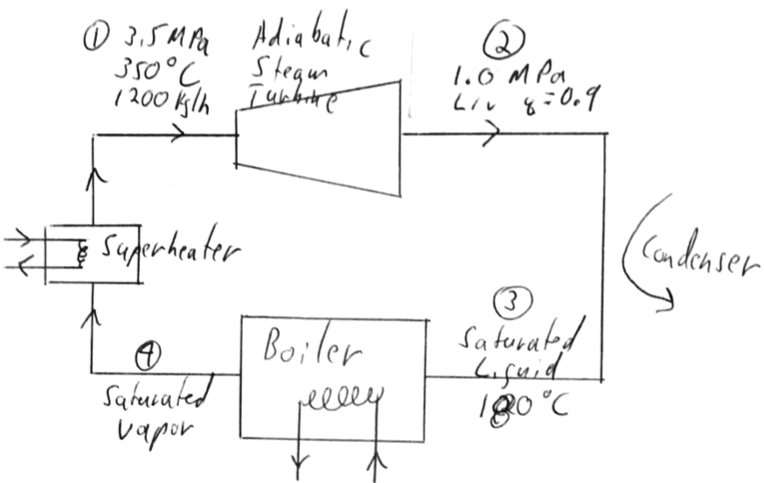

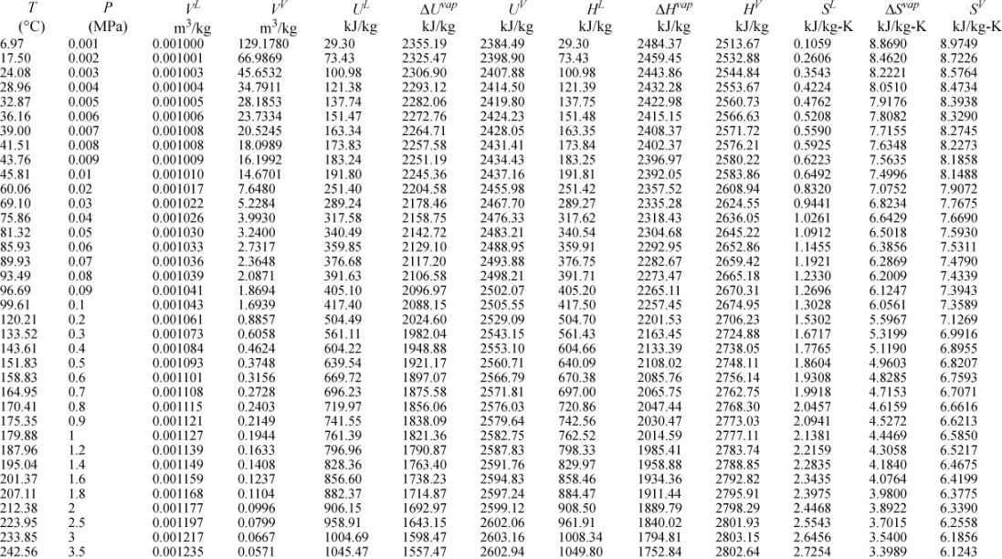

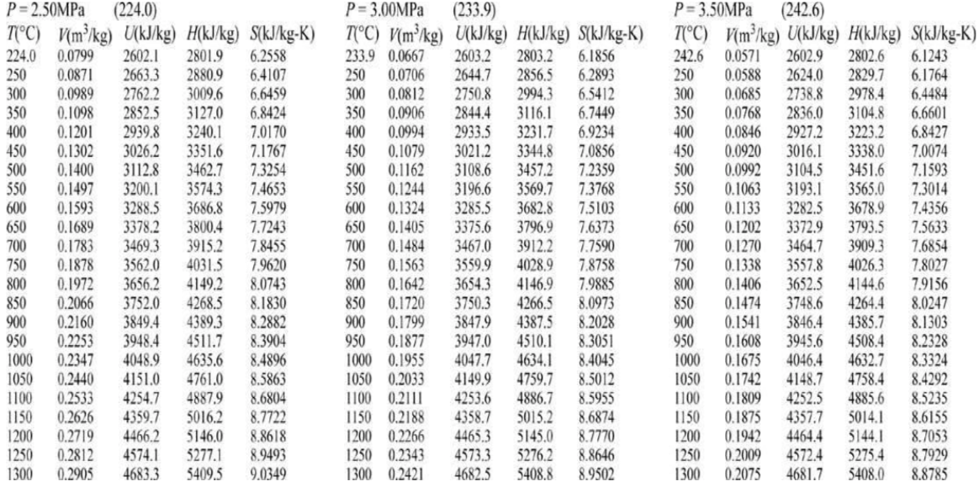

**Turn this sheet in with your answer**



1. Shaft Work =
2. Combined Heat =
3. Efficiency = (Give comments/calculations on separate sheet)
4. Ideal Efficiency = (Give comments/calculations on separate sheet)

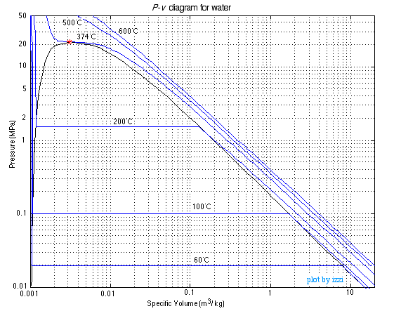

ANSWERS: **Chemical Engineering Thermodynamics**

**Quiz 1 January 16, 2020**

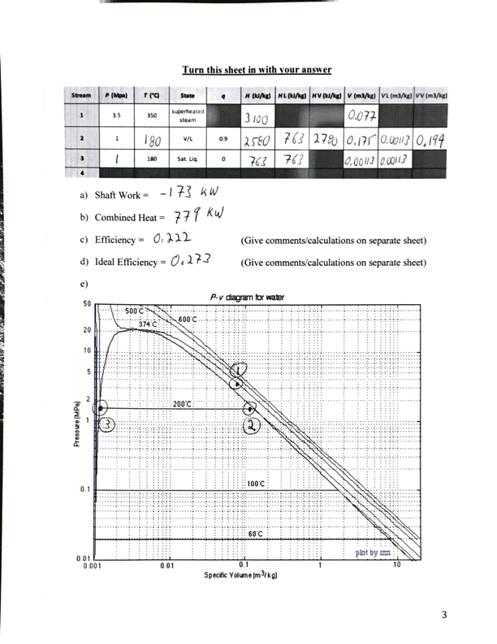

1. Find *H*2-*H*1

*W*s = (2580-3100)kJ/kg (1200 kg/h) (1/(3600 s/h)) = -173 kW

1. Find H1-H3

*Q* = (3100-763)kJ/kg (1200 kg/h) (1/(3600 s/h)) = 779 kW

1. ** = 173 kW/779 kW = 0.222 or 22.2% efficiency.

There is loss at the condenser. Also, there is a maximum efficiency associated with the necessary production of entropy limiting the process to about 27% efficiency, see part d.

1. **Carnot = (*T*H – *T*C)/*T*H = (350°C-180°C)/(350°C + 273°C) = 0.273

The Carnot efficiency is higher than the observed efficiency since this is a real process.

1. The lever rule won’t work on a log-scale.