**Quiz 10**

**Chemical Engineering Thermodynamics March 18, 2021**

a) The fugacity and fugacity coefficient are defined by equation 9.22,

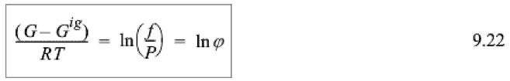

Use the information in this cartoon <http://survivingtheworld.net/ScienceComic5.html> and what you have learned in class to write a paragraph describing the fugacity. Address you paragraph to a chemist who has studied the chemical potential and molar Gibbs free energy but has never heard of the fugacity. Why is the fugacity a better way to consider phase equilibria compared to the molar Gibbs free energy?

Determine the fugacity (MPa) for 1,3 butadiene at **(1)** 400 K and 0.1 MPa and **(2)** 400 K and 8.0 MPa using the virial equation and the shortcut vapor pressure method. **Put your answers in the chart on page 2 below. (Show your work, i.e. write the equations with values, units and answers.) Use the NIST Chemistry WebBook for the critical parameters and the back cover of the book for the acentric factor.**

b) For condition (1) determine if the short-cut method is appropriate.

Calculate the vapor pressure.

Determine the state of matter at this condition.

c) For condition (1) determine if the virial equation is appropriate.

Calculate the fugacity. Is an ideal gas approximation appropriate for this condition?

Fill out the PREOS.xls values in the table for comparison.

d) For condition (2) determine if the short-cut method is appropriate.

Calculate the vapor pressure.

Determine the state of matter at this condition.

e) For condition (2) calculate the fugacity.

Test to see if the virial equation works for *f*sat. In case the viral equation is not appropriate do the calculation using the virial equation and compare the result with the “*correct*” result from PREOS.xls for *f*sat. Use **your calculated** value of *f*sat to obtain the Fugacity and compare this value with the “*correct”* result from PREOS.xls . Is an ideal gas approximation appropriate for this condition? Fill all the cells in the answer table.

|  |  |  |
| --- | --- | --- |
|  | **Part (1)** | **Part (2)** |
| ***T*, K** | **400** | **400** |
| ***P*, MPa** | **0.1** | **8.0** |
| ***T*r** |  |  |
| ***P*r** |  |  |
| ***Short-Cut Appropriate?*** |  |  |
| ***P*sat, MPa** |  |  |
| ***State of Matter*** |  |  |
| ***Virial EOS Appropriate?*** |  |  |
| ***f*sat, MPa** |  |  |
| ***PREOS f*sat, MPa** |  |  |
| ***f*, MPa** |  |  |
| ***PREOS f*, MPa** |  |  |
| ***Ideal Gas Approximation Good?*** |  |  |

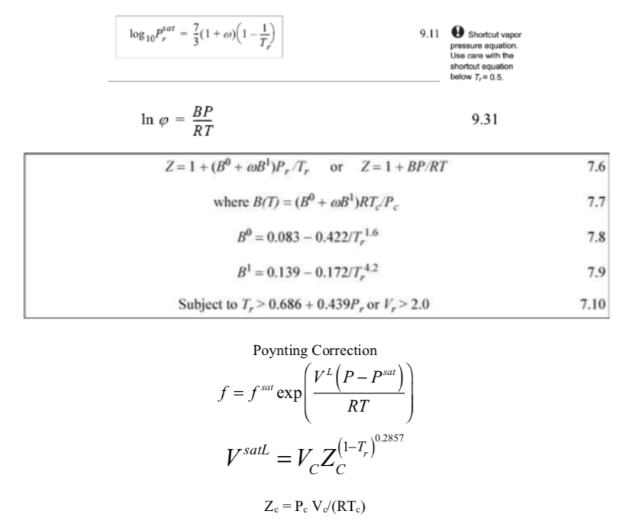

**ANSWERS: Quiz 10**

**Chemical Engineering Thermodynamics March 18, 2021**

a)