**Quiz 11**

**Chemical Engineering Thermodynamics**

**March 25, 2021**

A natural gas process stream contains the following composition. It is desirable to flash a feed liquid at 0.8 MPa and 298 K to produce liquid and vapor streams in order to partially separate the components prior to distillation.

|  |  |  |  |  |
| --- | --- | --- | --- | --- |
|  | zi | Tc, °K | Pc, Mpa |    |
| METHANE | 0.8800 | 190.6 | 4.604 | 0.011 |
| ETHANE | 0.0758 | 305.4 | 4.88 | 0.099 |
| PROPANE | 0.0442 | 369.8 | 4.249 | 0.152 |

1. -What is the bubble point temperature of this mixture at 0.8 MPa?   
   Use solver in excel and the shortcut method.   
   -Comment on if the method is appropriate after solving.  
   -What is the bubble point pressure at 298K?
2. -Compare the K-ratios for the three components for the bubble point temperature with that from PREOS.xls at the final temperature and pressure from the first part of “a” using equation 10.70: *y*i*f*iV = xi*f*iL . (The reference state doesn’t matter for this calculation)  
   When this method doesn’t work because you are in the super-critical state find *P*sat for the bubble point temperature and get the K-ratio from Raoult’s law (use your shot-cut *P*sat as the initial P value for solver).
3. -What is the dew point temperature of this mixture at 0.8 MPa?  
   -Use solver in excel and the shortcut method. Demonstrate that the method is appropriate after solving.  
   -What is the dew point pressure at 298K?
4. -If V/F is desired to be 50% at 0.8 MPa what is the flash temperature?

**-**How does this temperature compare to parts “a” and “b”?

1. -If the feed stream is liquid at 298 K and 0.8 MPa, **calculate the *Q* required per mole of feed** using the ideal gas heat capacities and enthalpies of vaporization given in the table below (the i.g. heat capacities are from the PREOS.xls file).   
   -Compare your resulting *Q* with that using PREOS.xls to determine the enthalpies using the feed stream conditions for *H* = 0 and a real liquid or super critical fluid reference state. If the state at 0.8 MPa and *T*flash is super critical, then the vapor and liquid have the same super-critical enthalpy.

***Please put your answers in the attached Answer Sheet which contains the data tables in separate tabs***

***It is suggested that you do calculations in Excel spreadsheets***

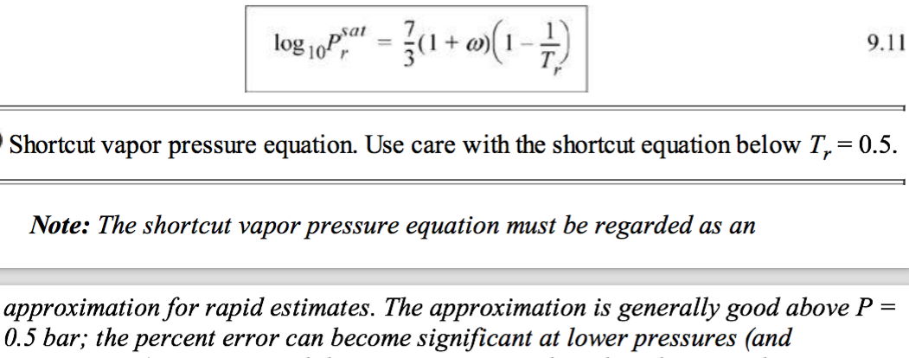



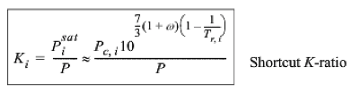





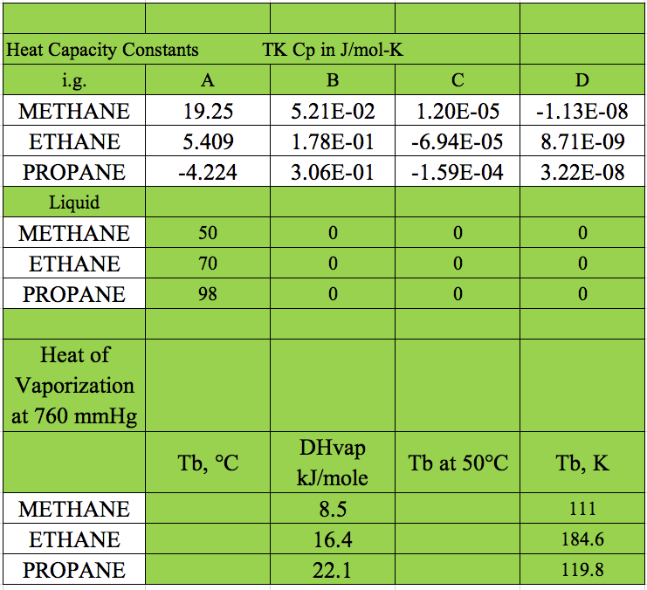

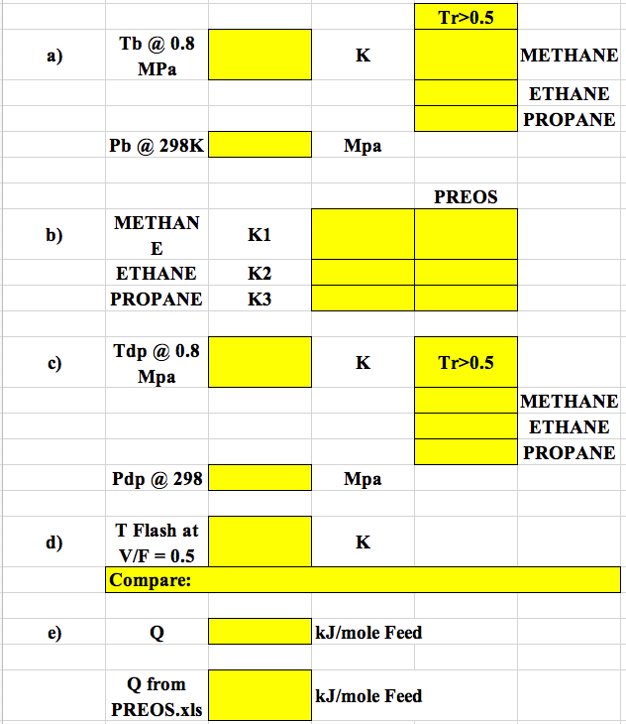

***ANSWERS:* Quiz 11**

**Chemical Engineering Thermodynamics**

**March 25, 2021**

