**Quiz 12**

**Chemical Engineering Thermodynamics**

**April 1, 2021**

Yim et al.* studied the vapor liquid equilibria of 2,3-butanediol (2,3-BDO) in mixtures with 2-methyl-1-pentanol. 2,3-BDO is produced through bioconversion (fermentation) from agricultural waste. 2,3-BDO is seen as a promising carbon neutral feedstock for the chemical industry. It is separated from aqueous dispersions by liquid extraction using 2-methyl-1-pentanol and the binary mixture must be distilled under vacuum to produce pure 2,3-BDO. As an example of uses for 2,3-BDO, it can be easily converted to butadiene to make tires and other value added rubber products. Yim et al.* used UNIQUAC and NRTL (we will study these next week) to model the activity coefficients for this binary mixture with good results. In this quiz we will compare these results with a much simpler two-parameter Margules model for Lim et als.* 80kPa (0.8 bar) data using the Antoine parameters from the NIST webbook (given below for T in K and P in bar). You can use the *GammaFit.xls* spreadsheet for this calculation. ***You will need to unprotect the tabs and delete cells not used as well as modify some of the calculations to include only the cells you are using.*** Using these Margules coefficients we will recreate the 80kPa curves in Figure 3 below and compare with the data, reproducing the black lines shown in Figure 3 for 80kPa. We will also calculate the difference in *y*1 values between calculated and measured based on the measured *x*1 values and make a plot similar to Figure 6 below for the 80kPa data to assess the difference between UNIQUAC and the two-parameter Margules model.

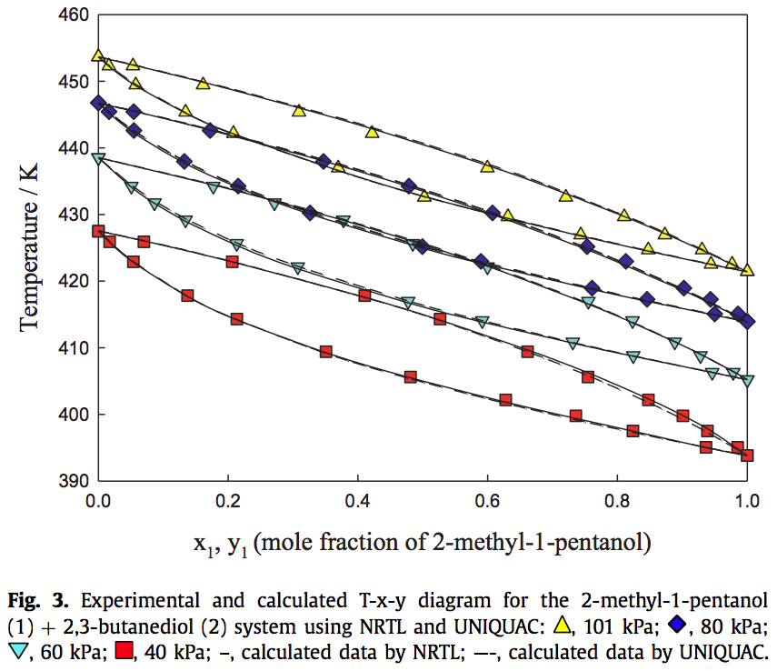 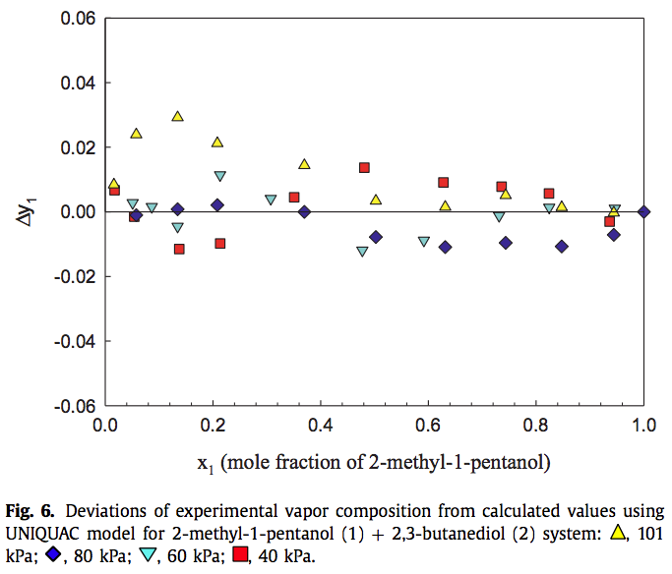

*Yim J-H, Kim H J, Oh JJ, Lim JS, Choi KY, *Isobaric vapor-liquid equilibria for two binary systems (2-methyl-1-pentanol + 2,3-butanediol and 3-methyl-1-butanol + 2,3-butanediol) at (40, 60, 80, and 101) kPa* Fluid Based Equilibria **530** 112897 (2021)

1. Use the Yim et al.* data in the attached spreadsheet, the Antoine coefficients given below and the *GammaFit.xls* spreadsheet to calculate the two Margules coefficients, *A*12 and *A*21. You will need to change the units in the spreadsheet to match the NIST Antoine equation and the Yim et al.* data. Note that **80 kPa = 0.8 bar.** Use the *’T-x-y fit P*’ tab. **Report *A*12 and *A*21**, give a **pdf of the spreadsheet**, and **explain how this tab operates** by listing the steps and giving the equations that it uses.
2. Use the ‘*T-x-y Calc T*’ tab in *GammaFit.xls* to calculate the bubble point composition and temperature. Explain how this tab works and give the equations it is using.
3. Give the plot from the ‘*T-x-y Plot*’ tab, explain what is being plotted (from which spreadsheets and what information) and compare it with Yim et al.* Figure 3.
4. In a new tab (if you change cells much in existing tabs strange things can happen since some calculations are done in invisible cells) paste the *x*- and *y*-experimental and *y*-calculated parameters from the ‘*T-x-y Calc T*’ tab and calculate *y*1. **Make a plot similar to Figure 6** of the difference between the experimental *y*1 and the calculated *y*1 for each of the temperatures. Provide a pdf of this plot.
5. Glance at the Wikipedia pages for UNIQUAC and NRTL (or alternatively Chapters 12 and 13) and give a two to three sentence explanation for what is not accounted for in the two-parameter Margules model that improves the fit for the UNIQUAC and NRTL models used by Yim et al.* (Don’t spend more than 10 minutes on this unless you find it compelling. In that case you should look for a job at Aspen or ChemCAD.)

***Turn in a pdf of your excel spread sheets and the plots of parts c and d. As well as answers to the questions.***

**Component (1)**

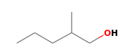

2-methyl-1-Pentanol

Formula: C6H14O

Molecular weight: 102.1748

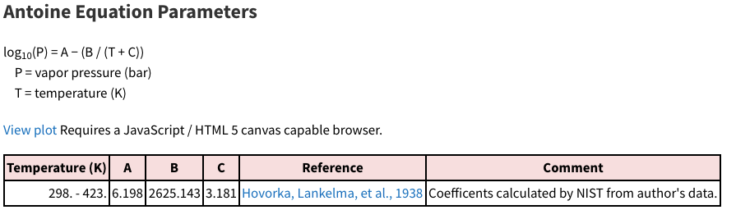

**Component (2)**

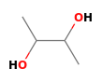

2,3-Butanediol

Formula: C4H10O2

Molecular weight: 90.1210

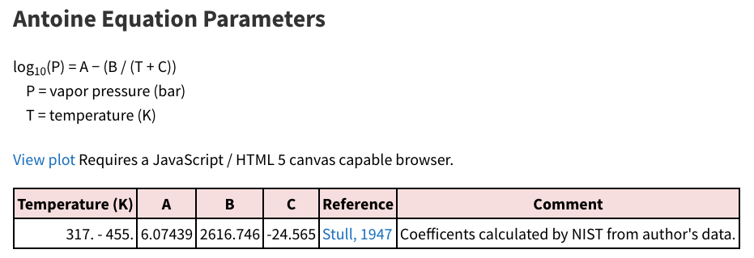

***ANSWERS:* Quiz 11**

**Chemical Engineering Thermodynamics**

**March 25, 2021**

1. Use the Yim et al.* data in the attached spreadsheet, the Antoine coefficients given below and the *GammaFit.xls* spreadsheet to calculate the two Margules coefficients, *A*12 and *A*21. You will need to change the units in the spreadsheet to match the NIST Antoine equation and the Yim et al.* data. Note that **80 kPa = 0.8 bar.** Use the *’T-x-y fit P*’ tab. **Report *A*12 and *A*21**, give a **pdf of the spreadsheet**, and **explain how this tab operates** by listing the steps and giving the equations that it uses.

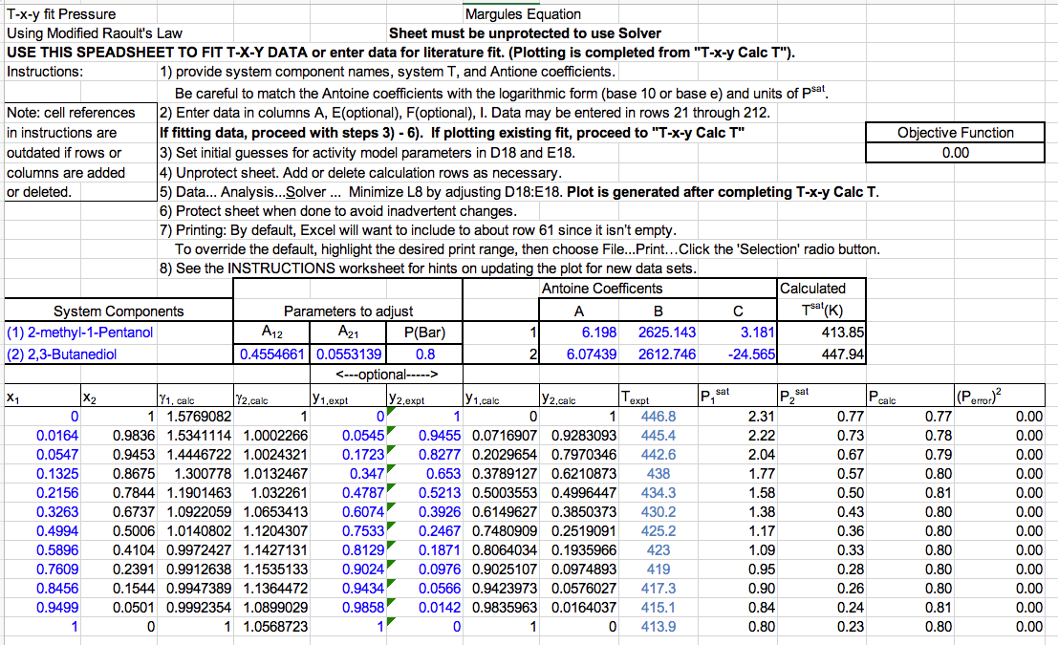

This tab calculates the bubble point temperature and compositions *y*i, using the *x*i values, *P*sat (calculated from the Antoine equation using the generated *T*bp) and *P*. It calculates *P*calc from 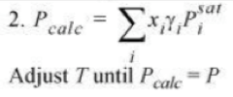and adjusts *A*12 and *A*21 until (*P*calc -*P*)2 reaches a minimum. **i is calculated from 

1. Use the ‘*T-x-y Calc T*’ tab in *GammaFit.xls* to calculate the bubble point composition and temperature. **Explain how this tab works** and **give the equations it is using**. Turn in a **pdf of the spreadsheet**.

This is a bubble point temperature calculation. It uses the *A*12 and *A*21 parameters determined in part a to calculate **i from .

These values are used with



To calculate *P*calc. Rather than compare the square of the difference with P, a better minimization is found using log(*P*calc/*P*) which equals 0 when *P*calc/*P* = 1 and varying 1/*T* rather than *T*. These are used since *P*sat is related to exp(-*E*a/k*T*) by the Arrhenius Equation, so ln(*P*) should be linear in 1/*T* with -*E*a as the slope.

This yields *T*bp. *y*i are calculated using *y*i = *x*i **i *P*sat/*P*.

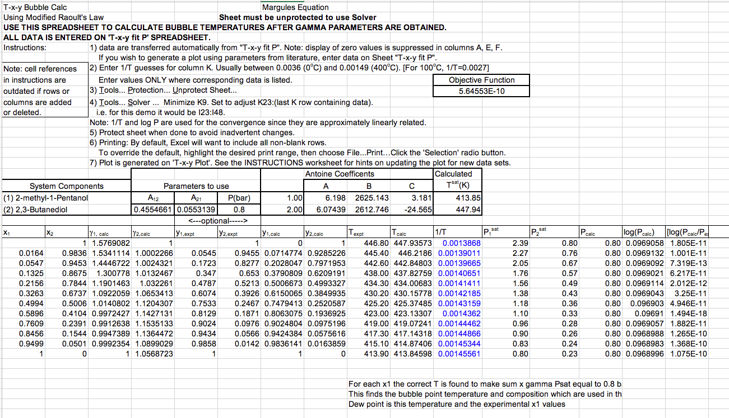

1. Give the plot from the ‘*T-x-y Plot*’ tab, explain what is being plotted (from which spreadsheets and what information) and compare it with Yim et al.* Figure 3.

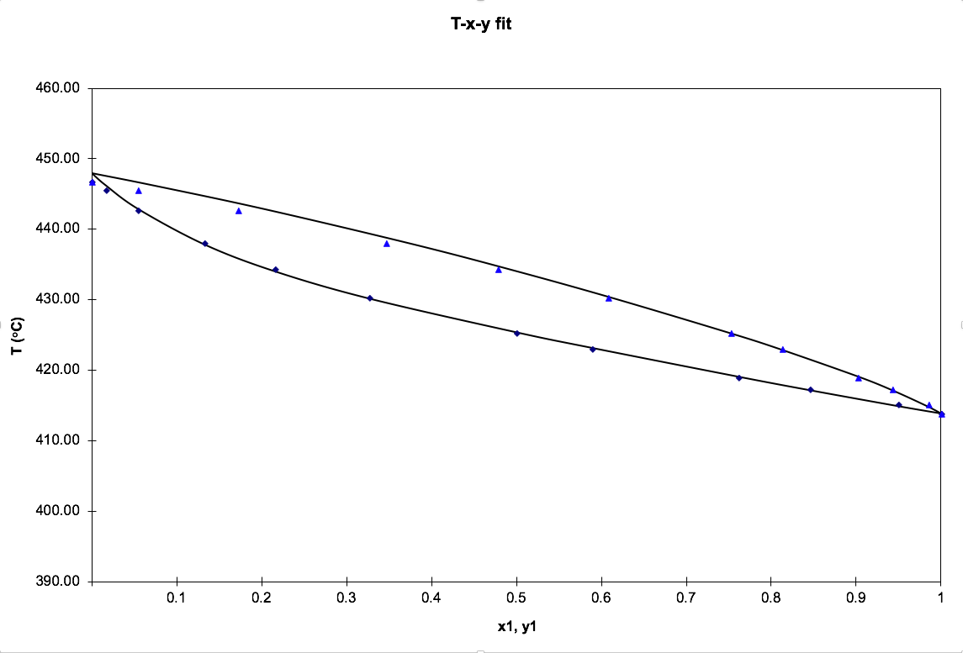

The points are the input data for x and y. The top line is the bubble point temperature and composition from part b. The bottom line is the bubble point temperature from part b versus the experimental x1 values for the dewpoint.

1. In a new tab (if you change cells much in existing tabs strange things can happen since some calculations are done in invisible cells) paste the *x*- and *y*-experimental and *y*-calculated parameters from the ‘*T-x-y Calc T*’ tab and calculate *y*1. **Make a plot similar to Figure 6** of the difference between the experimental *y*1 and the calculated *y*1 for each of the temperatures.

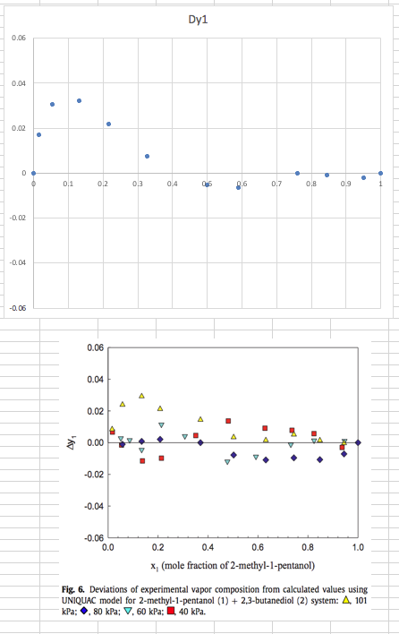

1. Glance at the Wikipedia pages for UNIQUAC and NRTL (or alternatively Chapters 12 and 13) and give a two to three sentence explanation for what is not accounted for in the two-parameter Margules model that improves the fit for the UNIQUAC and NRTL models used by Yim et al.* (Don’t spend more than 10 minutes on this unless you find it compelling. In that case you should look for a job at Aspen or ChemCAD.)

UNIQUAC and NRTL include local clustering of species that impacts the entropy of mixing. They also include specific chemical group contributions and differences between interactions in the vicinity of chemical species. They use many more than two parameters to describe the miscibility.