**Quiz 13**

**Chemical Engineering Thermodynamics**

**April 8, 2021**

L-lysine is an essential amino acid (an amino acid that we do not produce ourselves). It is largely obtained from the consumption of meat, though it also exists in pea protein, hemp and flax flour. It is widely consumed as a supplement for vegans, and purportedly accelerates healing as well as being used in large quantities as an animal feed additive to boost meat production. Commercially L-lysine is produced by microbial fermentation followed by filtration of cellular content. The lysine is separated from the fermentation broth by ion exchange. A solution of L-lysine in ethanol is produced.

Assume that a liquid-liquid phase separation occurs at 25°C in pure ethanol.

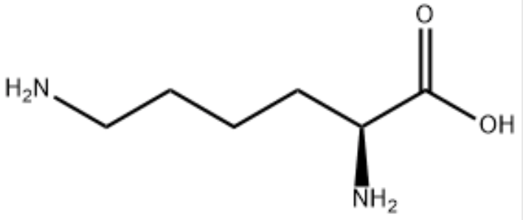

L-Lysine (1)

Melting point 419.65K

*H*fus = 23.85 kJ/mol

Consider **Lys (1)** in **ethanol (2)** at **25°C**.

Assume that Lys (1) can be approximated in UNIFAC LLEa tab in the Actcoeff.xls spreadsheet as:

CH2 4

COOH 1

(***For this problem you can use more than 3 digits where it seems necessary. Try to round to three digits or a minimum number of digits where possible for the sake of sanity.***)

1. What is the composition of the two liquid phases that will form at 25°C? (Assume initially that phase ** is pure 2 (EtOH) and phase ** is pure 1 (Lys).

Iterate until convergence (4 or 5 iterations).   
Use UNIFAC (LLEa) in the ActCoeff.xlsx sheet to calculate the **’s. (The Antione coefficients do not impact **.)

1. Sketch *T* versus *x*1 and show the 2-phase region with your two equilibrium points, as well as a curve demarking the 1- and 2-phase regions. Show a tie line between the ** and ** phases.
2. The binary ethanol/lys mixture is fed from the liquid extraction/solvent exchange process with a molar concentration of 0.25 lys in water.   
   -After phase separation what fraction of this feed goes to the ** and to the ** phase  (Give **/*F* and **/*F*.)   
   -If the total feed is one mole, how many moles of lys are in the ** phase? (Show how this is calculated.)  
   -Add the input composition to the plot you made in part b with an arrow to the tie line.
3. Lys is to be crystallized from the ** phase.   
   -What is the crystallization temperature for Lys at this composition? For Lys: *H*fus = -23.85 kJ/mole *T*m = 419.65K *M*w = 146.19g/mole. (This will require iteration of temperature beginning with 25°C to obtain **1 from UNIFAC LLEa sheet.)  
   -Add the crystallization curve to your plot from part b using the pure lys crystallization temperature and your calculated crystallization temperature.
4. It is desired to obtain crystalline lys that can be separated in a rotary decanter. Will this be possible in the proposed process of phase separation at 25°C. Explain how you expect this phase separation/crystallization to proceed at 25°C. Do you foresee problems with the process as described?

R = 8.314 J/(mol °K)

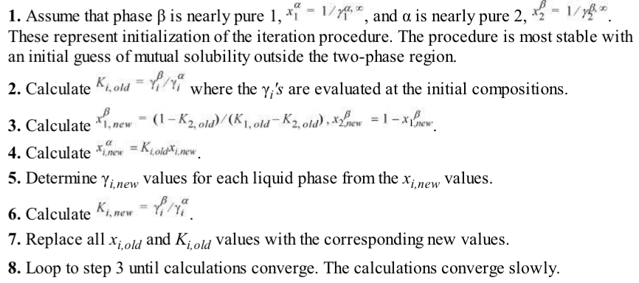

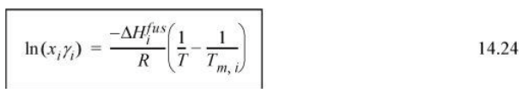

**NAME:**

**Answer Sheet (Please turn in this sheet with your work and one screen shot of the excel sheet that was used).**

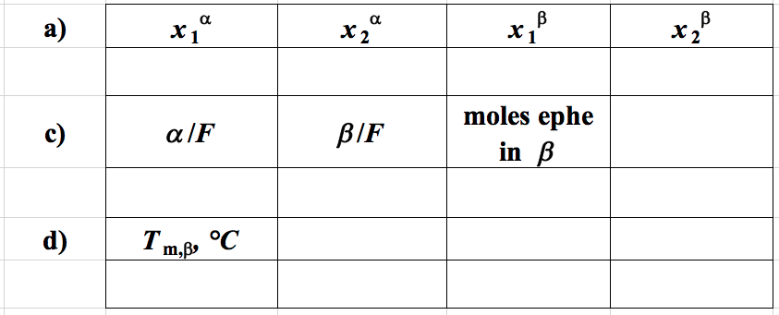

**b) Sketch plot of T versus *x*1 from part a. (Include the melting line and feed composition from parts c. and d.)**

**e) Feasibility of process:**

**NAME:**

**Answer Sheet (Please turn in this sheet with your work and one screen shot of the excel sheet that was used).**

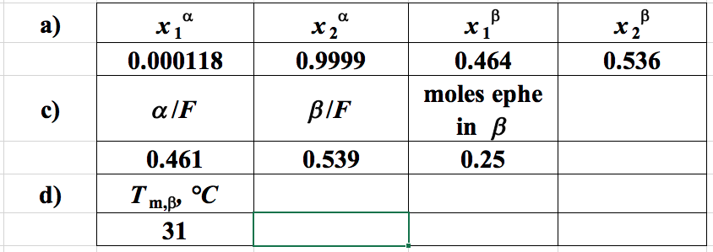

**b) Sketch plot of T versus *x*1 from part a. (Include the melting line and feed composition from parts c. and d.)**

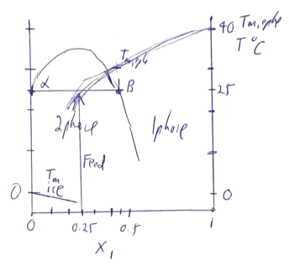

**e) Feasibility of process:**

The crystallization temperature is about 5°C above the phase separation temperature so the crystallization will occur slowly (rate depends on the quench depth, *T*). It is feasible to produce ephe crystals that could be decanted but the process will be very slow.