**Quiz 13**

**Chemical Engineering Thermodynamics**

**April 8, 2021**

In the pharmaceutical industry drugs are often separated to a pure product as crystals. It is necessary to produce supersaturated solutions (far below the equilibrium crystallization temperature) to successfully form pure crystals of the drug.

Consider **paracetamol (1)** (Tylenol®) in **ethanol (2)** at **25°C**.

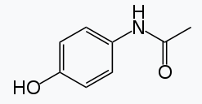

Paracetamol (1)

***Assume that the secondary amine can be represented as a primary amine in UNIFAC, “ACNH2”. Other groups are ACOH, ACH, CH3CO.***

(***For this problem use 4 digits where it seems necessary.***)

1. **What is the composition** of the two liquid phases that will form at 25°C? (Assume initially that phase ** is pure 2 (EtOH) and phase ** is pure 1 (Para).

Iterate do 5 iterations after the initial guess (this is most easily done in excel).   
Use UNIFAC (LLEa) in the ActCoeff.xlsx sheet to calculate the **’s. (The Antoine coefficients in the excel table are not needed since they do not impact **.)

1. Sketch *T* versus *x*1 and show the 2-phase region with your two equilibrium points, as well as a curve demarking the 1- and 2-phase regions. Show a tie line between the ** and ** phases.
2. The binary Para/EtOH mixture is fed from the liquid extraction/solvent exchange process with a molar feed concentration of *x*1,F = 0.55 Para in EtOH.   
   -After phase separation what fraction of this feed goes to the ** and to the ** phase  (**Give **/*F* and **/*F***.)   
   -If the total feed is one mole, how many moles of Para are in the ** phase? (Show how this is calculated.)  
   -Add the input composition to the plot you made in part b with an arrow to the tie line.
3. Para is to be crystallized from the ** phase.   
   -What is the **crystallization temperature for Para at the ** phase composition**? For Para the heat of fusion is 26.49 kJ/mol and Tf is 441.9°K *M*w = 151.2 g/mol. (This will require iteration of temperature beginning with 25°C to obtain **1 from UNIFAC LLEa sheet.)  
   -Add the crystallization curve to your plot from part b using the pure Para crystallization temperature and your calculated crystallization temperature.
4. It is desired to obtain crystalline Para that can be separated in a rotary decanter. Will this be possible in the proposed process of phase separation at 25°C.   
   -**Calculate the crystallization temperature for the feed composition** (*x*1,F = 0.55) (include this point on your plot).   
   -Explain how you expect this phase separation/crystallization to proceed at 25°C. Do you foresee problems with the process as described? Consider the rate of crystallization which could be quite slow depending on the *T*m, nucleation and diffusion rates.

*R* = 8.314 J/(mol °K)

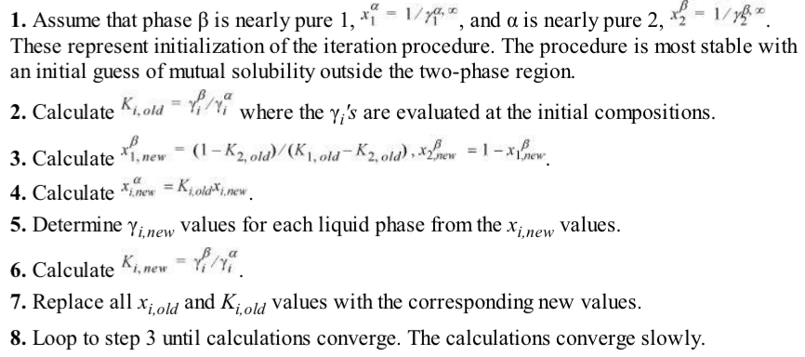

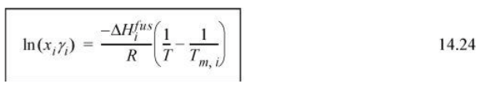

**Answer Sheet (Please turn in this sheet with your work and one screen shot of the excel sheet that was used).**

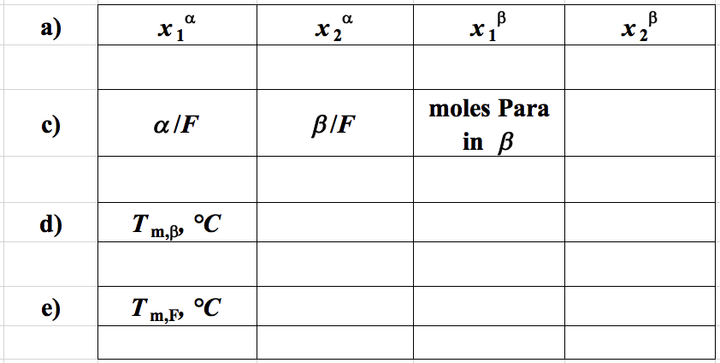

**b) Sketch plot of T versus *x*1 from part a. (Include the melting line and feed composition from parts c. and d.)**

**e) Feasibility of process:**

**Answer Sheet (Please turn in this sheet with your work and one screen shot of the excel sheet that was used).**

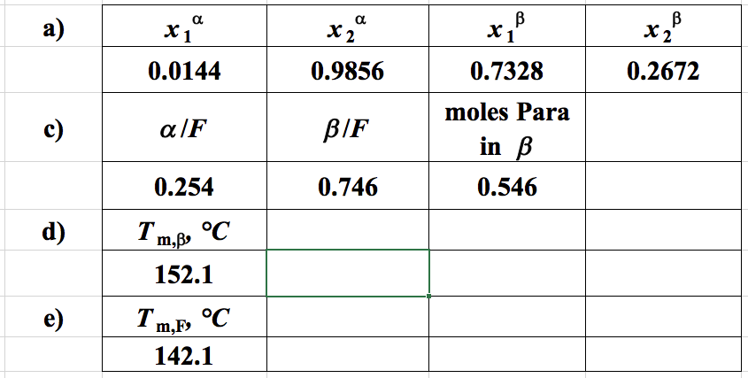

**b) Sketch plot of T versus *x*1 from part a. (Include the melting line and feed composition from parts c. and d.)**

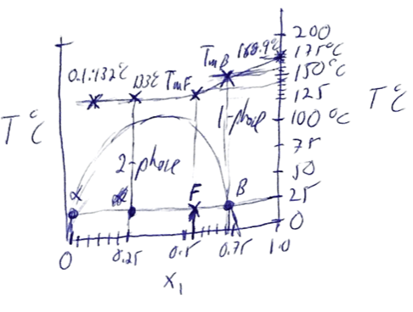

**e) Feasibility of process:**

The crystallization temperature is about 150°C above the phase separation temperature so the crystallization will occur rapidly (rate depends on the quench depth, *T*). Even at the feed composition the melting point far exceeds the process temperature so it is unlikely that this process will work as intended. Also, there is little enhancement in concentration with the phase separation since the two-phase region is narrow (0.4 to 0.7) at 25°C.