**Chemical Engineering Thermodynamics**

**Quiz 2 January 21, 2021**

The Otto Cycle is a model engine to study premixed (air/fuel) engines typical for cars. TDC and BDC refer to the position of the piston (top dead center and bottom dead center). The compression ratio, *V*TDC/*V*BDC is about 10. Typical temperatures for a Nissan Maxima engine are given in the table below, the cylinder has a *V*TDC = 583 cm3 (6 cylinders are 3.5L). The stages are:

0-1 Intake isobaric

1-2 Compression Adiabatic

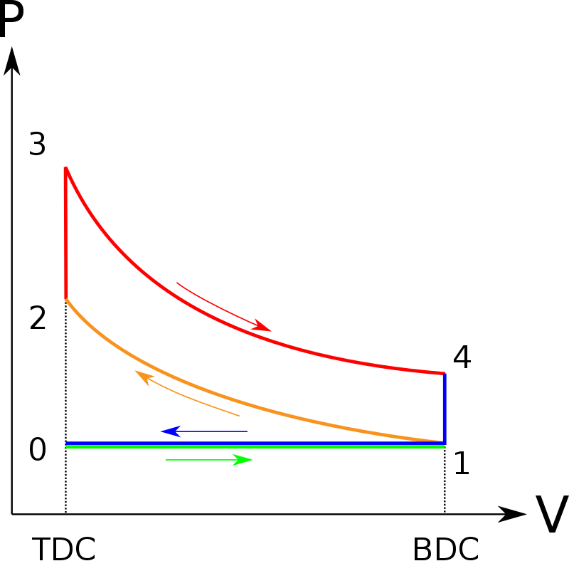 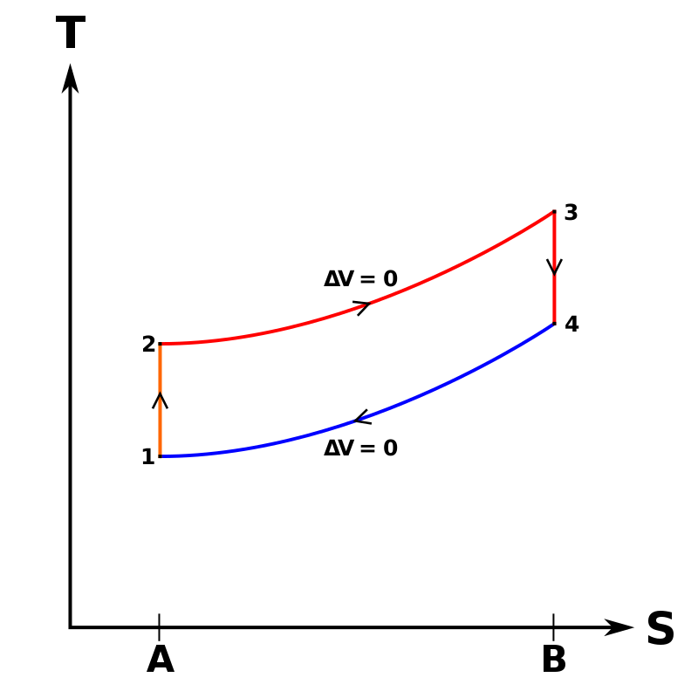

https://en.wikipedia.org/wiki/Otto_cycle#/media/File:P-V_Otto_cycle.svg

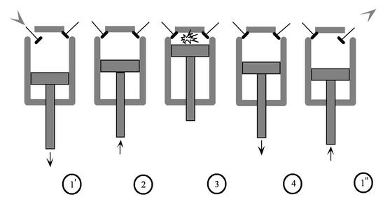

https://web.mit.edu/16.unified/www/FALL/thermodynamics/notes/node26.html

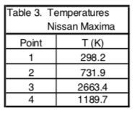 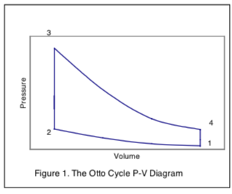

The Toyota Prius hybrid engine introduced the concept of using an Atkinson cycle (or Complete Expansion cycle) engine coupled with an electric motor in a hybrid design. The Atkinson engine has a larger power stroke (3 to 5 below) compared to the compression stroke (2 to 3 below). These strokes are equal in volume change for a traditional four-cycle Otto engine.

Prof. Roney at USC (<http://ronney.usc.edu/AME436/Lecture8/?C=M;O=A>) provides the following specification for an Atkinson engine:



Below is a sketch of the *P*/*V* behavior in this engine. Notice that 2 to 3 has a smaller *V* compared to 4 to 5. The length of 1 to 2 decides the amount of fuel consumed by a cylinder in the four cycles. Steps 4 to 5 determine the work output (steps 2 to 4 consumes work in compression). The advantage of the Atkinson engine is that it returns to the intake manifold the fuel taken in from 2 to 6 in the intake cycle during the first part of the compression cycle (6 to 2).   
**V = Isochoric; S = Adiabatic reversible; P = Isobaric**.

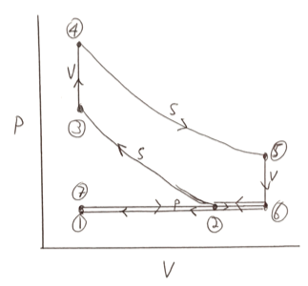

Consider that the material in the cylinder is 10% isooctane and 90% air with ***C*p = 5.4*R***.

Ignore the increase in number of moles with combustion.

1. ***Fill in the table below*** (grey areas cannot be solved). (60 points ~2 pts each) assuming an ideal gas.
2. -***Calculate the efficiency*** of this engine (net work/enthalpy input) if the fuel/air mixture had a combustion enthalpy of 22.4 kJ/mole (accounting for 10% isooctane in air) ignoring the work from 1 to 2.   
   -Also ***calculate the efficiency*** as the ***net*** work output divided by the net enthalpy input ignoring the work from 1 to 2. (The net work includes both the wasted and used work.)   
   -***Compare*** these values with the normal value for efficiency of an Atkinson engine of 30 to 40%. Comment on how the added moles from combustion would impact the efficiency (13.5 moles in 17 moles out C8H18 + 12.5 O2 => 8CO2 + 9 H2O).
3. The Atkinson engine has high efficiency but low power density (power per engine mass). ***Comment*** on why this engine might be useful in a Hybrid vehicle.

|  |  |  |  |  |  |  |
| --- | --- | --- | --- | --- | --- | --- |
|  | **Intake (Mass Changes)** | Compression | Combustion | Expansion | **Blowdown (Mass Changes)** | **Exhaust (Mass Changes)** |
|  | isobaric | adibatic, rev | isochoric | adibatic, rev | isochoric | isobaric |
| Stage | 1-2 | 2-3 | 3-4 | 4-5 | 5-6 | 6-7 |
| *T*i K | 313 | 313 |  | 750 |  |  |
| *T*f K | 313 |  | 750 |  |  | 313 |
| *P*i MPa | 0.1 | 0.1 |  |  |  | 0.1 |
| *P*f Mpa | 0.1 |  |  |  | 0.1 | 0.1 |
| *V*¡ cm3 | 100 | 1000 | 100 | 100 | 1300 | 1300 |
| *V*f cm3 | 1000 | 100 | 100 | 1300 | 1300 | 100 |
| moles i |  |  |  |  |  |  |
| moles f |  |  |  |  |  |  |
| *W*EC kJ/mole |  |  |  |  |  |  |
| H kJ/mole |  |  |  |  |  |  |
| U kJ/mole |  |  |  |  |  |  |
| Q kJ/mole |  |  |  |  |  |  |

1 atmosphere is 14.7 psi, 1.01 bar, 0.101 MPa, 760 mmHg, 29.9 inHg

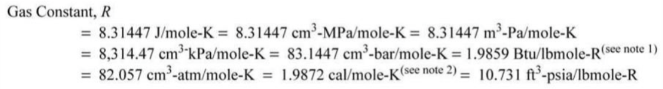

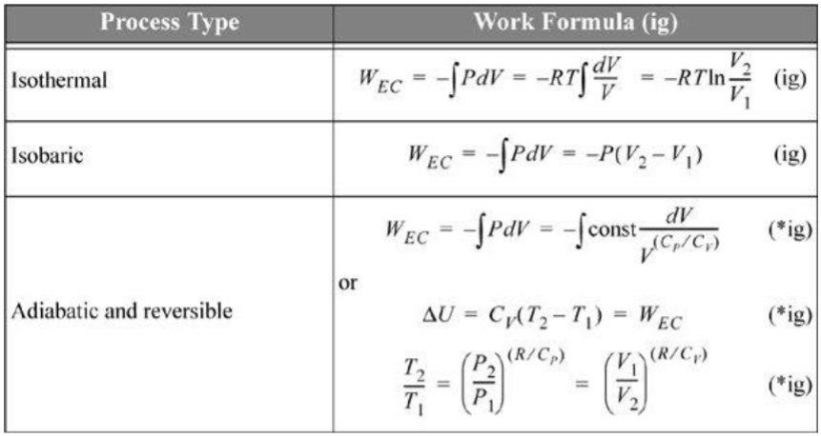

*Q*rev = *U* for isochoric (constant volume) 4.17

d*U* = *C*v d*T*  for isochoric (constant volume)

*C*p = *C*v + *R* (exact for ideal gas)

*H* = *U* + (*PV*) = *U* + *R*(*T*) (exact for ideal gas)

**ANSWERS:** **Chemical Engineering Thermodynamics**

**Quiz 2**

**January 22, 2020**



b) Efficiency = (12.1 kJ/mole – 7.87 kJ/mole)/22.4 kJ/mole = 0.189 or 18.9 % efficiency.

Efficiency = Net Work/Enthapy input = (12.1 kJ/mole – 7.87 kJ/mole)/(9.65 + 9.96) kJ/mole = 0.216 or 21.6% efficiency.

Typically, the Atkinson Engine has an efficiency of about 30-40%.

c) In a hybrid vehicle the electric motor adds torque when it is needed for acceleration and climbing hills. Coupling the Atkinson with high efficiency and the added power from the electric motor makes a functional high mileage car.

