**Chemical Engineering Thermodynamics**

**Quiz 2 January 21, 2021**

The Diesel Cycle is a model engine to study unmixed fuel/air mixture engines typical for trucks. Diesel engines operate at a much higher compression ratio, about *V*1/*V*2 = 20, compared to a gas engine following the premixed (carburated/fuel injected) Otto Cycle. Consider one cylinder of a four-stroke diesel engine with each cylinder having a *V*TDC = *V*1 = 583 cm3 (6 cylinders are 3.5L). The stages are:

0-1 Intake Isobaric

1-2 Compression Adiabatic

2-3 Ignition Isobaric

3-4 Power stroke Adiabatic

4-1 Blowdown Isochoric

1-0 Exhaust Isobaric

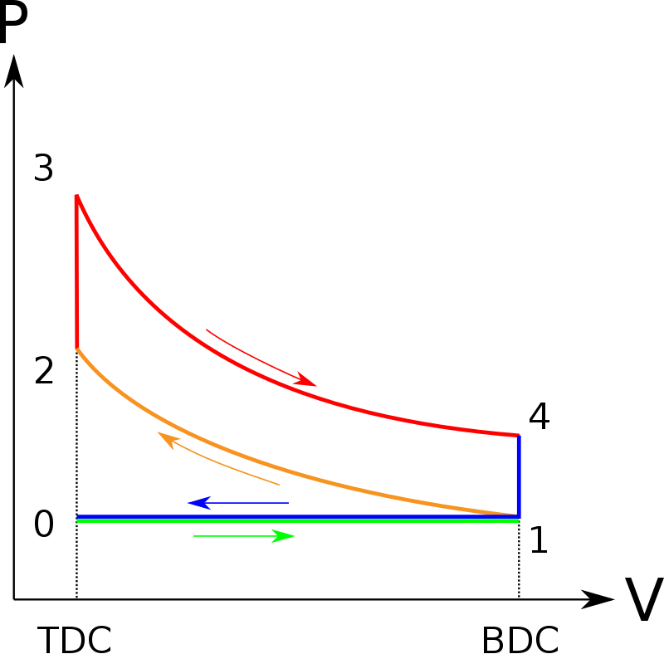

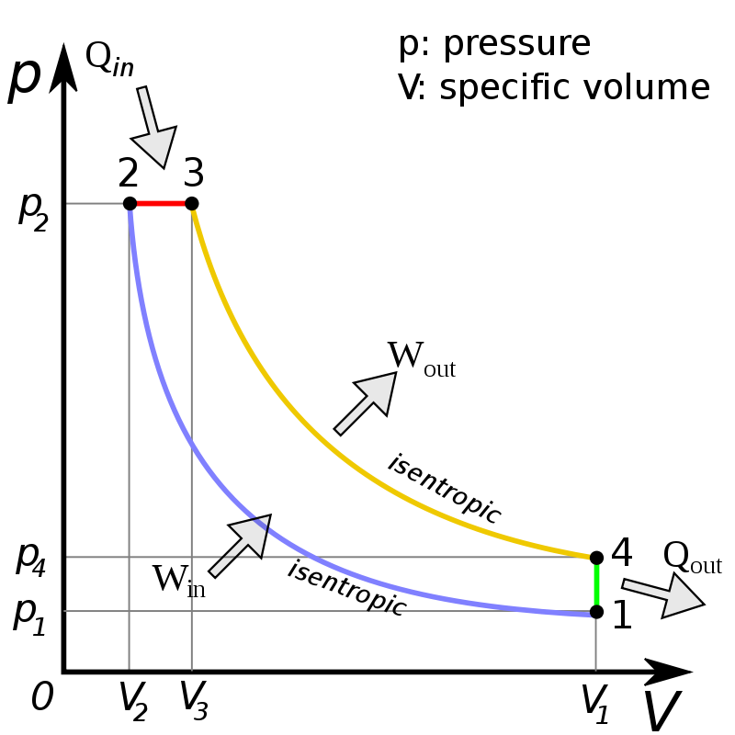

**0**

Four Stroke Otto Cycle (**not used**) Four Stroke Diesel Cycle (***Used Here***)  
*(Both figures from Wikipedia)*

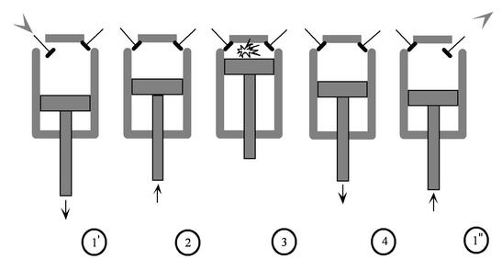

https://web.mit.edu/16.unified/www/FALL/thermodynamics/notes/node26.html

Consider that the material in the cylinder is 2 mole percent isooctane in air with ***C*p = 3.89*R* for the mixture with a combustion enthalpy for pure octane of 5,470 kJ/mole (109 kJ/mole for the mixture).**

***Assume an ideal gas throughout the calculations.***

Ignore the increase in number of moles with combustion.

1. Solve for *P*f and *T*f for the 1-2 stroke.

*(Fill in your answers in the table for each calculation. The table should be filled out by the end of the quiz. Include a sheet showing your work.)*

1. Solve for *V*f in the 2-3 stroke.
2. Solve for *P*f and *T*f for the 3-4 stroke.
3. Calculate *W*EC, *Q*, the internal energy changes, *U*, and enthalpy changes, *H*, using *C*V and *C*P for all of the strokes that are not greyed out in the table. ***Keep in mind that R is in units of Joules not kJ.*** A Joule is equal to MPa cm3.
4. Calculate the efficiency of this engine (net work/enthalpy input) if the fuel/air mixture had a combustion enthalpy of **5,470 kJ/mole * 0.02 = 109 kJ/mole** of the mixed gas in the engine (accounting for 2% isooctane in air). ***Keep in mind that R is in units of Joules not kJ.*** A Joule is equal to MPa cm3.

You can use the attached excel sheet for your answers and calculations. Make sure you write out your calculations on a separate sheet of paper so that I can follow your work. Remember to use 3 significant digits and put units on every number you write down or put in the excel sheet (where possible).

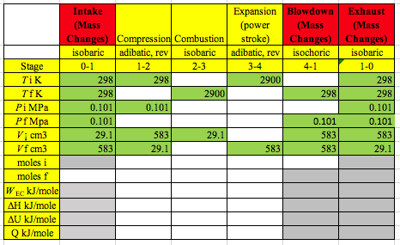

1 atmosphere is 14.7 psi, 1.01 bar, 0.101 MPa, 760 mmHg, 29.9 inHg

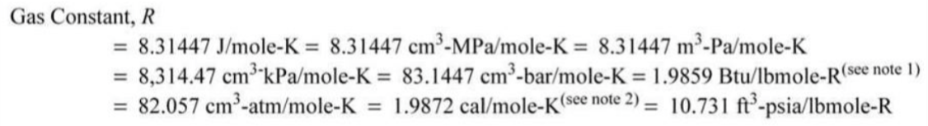

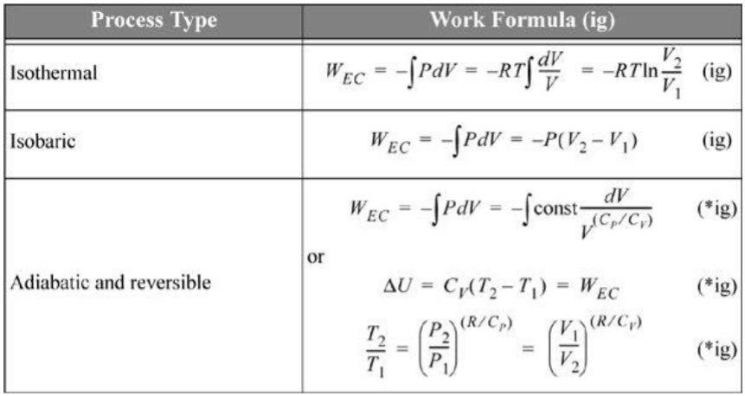

*Q*rev = *U* for isochoric (constant volume) 4.17

d*U* = *C*v d*T*  for isochoric (constant volume)

*C*p = *C*v + *R* (exact for ideal gas)

*H* = *U* + (*PV*) = *U* + *R*(*T*) (exact for ideal gas)

**ANSWERS:** **Chemical Engineering Thermodynamics**

**Quiz 2**

**January 21, 2021**

