**Chemical Engineering Thermodynamics**

**Quiz 3 January 28, 2021**

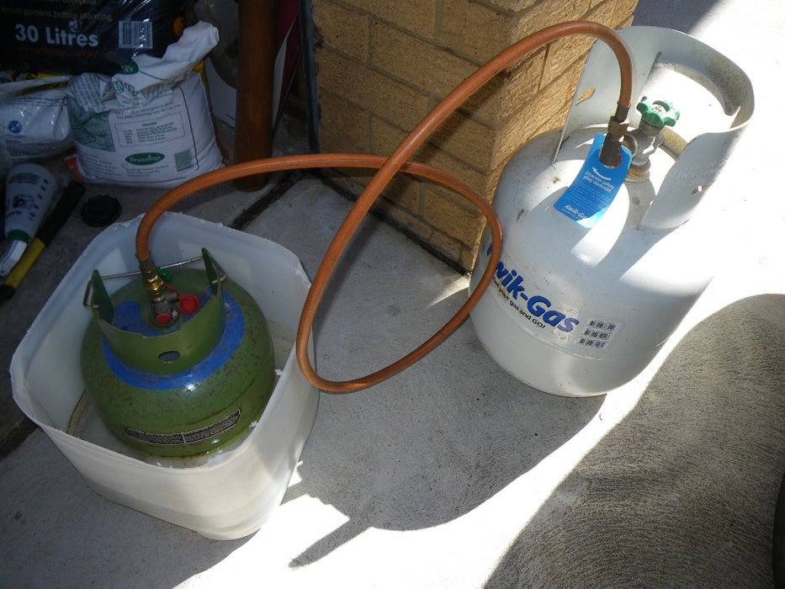

The figure above shows two propane tanks. The large tank is initially at 200 psi (1.38 MPa) and the small tank is initially empty. Assume that propane under all of the conditions in both tanks is an ideal gas with Cp = 8.85R and that the gas transfer is very slow (reversible). The volume of the large tank is 7.1 gallons (2.69x104 cm3) and of the small tank is 4.6 gallons (1.74x104 cm3).

*(Don't actually do this. Messing around with HIGHLY FLAMMABLE GAS UNDER HIGH PRESSURES IS VERY DANGEROUS. Propane under these conditions is actually a liquid so this is a grossly simplified problem.*)

1. The smaller tank is in an ice bath at 0°C and the larger tank is in the sun at 40°C and both tanks and their contents are held at these temperatures. If a valve is opened to a leak between the two tanks, what is the final pressure of the system, and what are the final number of moles of propane in each of the tanks?
2. How many more moles are transferred to the smaller tank compared to a situation where both tanks are at the same temperature?
3. Consider that the large tank is an infinite source so that the temperature and pressure of the large tank remains constant at 40°C and 1.38 MPa. Also assume that the process is adiabatic and that the small tank is completely insulated. What are the final temperature, pressure and number of moles in the small tank after the process reaches equilibrium. (*There is no ice bath in this problem*.)
4. If the large tank is an infinite source and if the valve allows 0.1 mole/minute to flow into the small tank, the small tank is initially at 0.1 MPa and 273K containing propane and is perfectly insulated (adiabatic), what is the functionality of temperature with time in the small tank? (Keep in mind that $n_{B}=n_{B}^{i}+\frac{dn_{B}}{dt}t$ where B is the small tank)
5. Make a plot using excel or another program showing T of the small tank as a function of time for 100 minutes. Draw lines for the final T, the initial T and the temperature of the large tank. At about what time are the two tanks at the same temperature?

*PLEASE TURN IN YOUR WORK, THIS ANSWER SHEET,   
AND THE GRAPH FROM “e)”*

|  |  |  |
| --- | --- | --- |
|  | Answer Sheet |  |
| a) | *P*f, MPa |  |
|  | *n*fA, moles |  |
|  | *n*fB, moles |  |
|  |  |  |
| b) | Excess Moles |  |
|  |  |  |
| c) | *T*fB, K |  |
|  | *P*fB, MPa |  |
|  | *n*fB, moles |  |
|  |  |  |
| d) | Function: $$T_{f}^{B}=A+\frac{B}{Ct+1}$$ |  |
|  | A, K |  |
|  | B, K |  |
|  | C, min-1 |  |
|  |  |  |
| e) | ~Time TB = TA, min |  |

