**Chemical Engineering Thermodynamics**

**Quiz 4 February 4, 2021**

Benzyl alcohol (BnOH) has a high index of refraction close to that of silica, cotton and wool so that if a cotton ball or fumed silica powder are immersed in BnOH they become almost invisible. It is also used as an antiseptic and as a flavor enhancing food additive as well as use as a treatment for head lice strangely enough. BnOH is made from toluene (which is a direct fraction from petroleum refining) via BnCl. BnCl is boiled in water in the presence of potassium carbonate (10%) under reflux. The reaction is run to 30% conversion to avoid chlorination of the aromatic group. BnOH is purified by flash distillation from a fraction at 474 K.

|  |  |  |  |  |
| --- | --- | --- | --- | --- |
|  | Tb, K | Hv, kJ/mole | fH0 (l), kJ/mole | Cp (l), J/(mole K) |
| BnCl (l) | 335 | 48.6 | -33 | A = 182; B = C = D = 0 |
| BnOH (l) | 478 | 63 | -164 | A = 218; B= C = D = 0 |
| K2CO3 (l) |  |  | -1,130 | A = 209; B = -1.63e-7; C = 8.01e-8; D = -1.34e-8 |
| Water (l) | 373 | 40.7 | -285 | A = 72.4; B = 0.0104; C = -1.49e-6; D = 0 |
| HCl (g) |  |  | -92.3 | A = 30.7; B = -0.0072; C = 1.25e-5; D = -3.90e-9 |

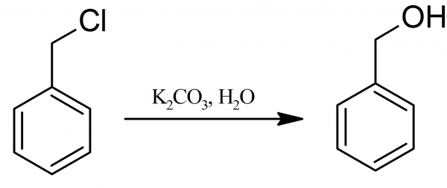

1. Write a balanced reaction for this synthesis.
2. Make a table of the moles feeding into the reactor and the moles flowing out of the reactor for each of the five species.
3. Use the heat of formation method for the energy balance to **determine the heating or cooling** that is required for this reaction per mole of the feed stream. The feed temperature is 298 K, the reaction temperature is 374 K and the reaction mixture is 62 mole percent water/K2CO3 mixture with a 90/10 molar ratio. Assume the reactor is adiabatic. Is the reaction **endothermic or exothermic** under these conditions?
4. The products are separated in a flash tank from a mixture of water, BnOH, BnCl at 201°C (474 K)) by distillation. The feed stream is liquid with 54 mole % water, 14 mole % BnOH, and 32 mole % BnCl **at 320 K**. The liquid stream exiting the flash distillation, **B**, is 99% BnOH; the vapor stream, **V**, is 1 % BnOH and both streams are at 474 K. **Make a table of the mole fractions and moles of the three components in the three streams of the flash tank.** Assume that the ratio of BnCl to water in streams **B** and **V** is the same as in stream **F**.
5. **Find the heat load** for the separation (kJ/mole of the feed stream, **F**). Is this an **endothermic or exothermic** process?

**ANSWER SHEET:**

For the answers please fill out the following answer sheet below and send a pdf of the excel sheet printed in landscape.

1. Balance Equation:
2. Table **in Excel Sheet** pdf.
3. Heating or Cooling Required:

Endo or exothermic?

1. Table in **Excel Sheet** pdf.
2. Heat Load:

Endo or exothermic?

You can **use the attached excel sheet** to do your calculations. Please **write down all equations** that you use in the Excel sheet on your work sheet and turn it in with the quiz.