**Quiz 5**

**Chemical Engineering Thermodynamics**

**February 11, 2021**

The two main types of commercial nuclear power reactors are pressurized water reactors (PWR) and boiling water reactors (BWR). PWRs are favored by countries with nuclear navies since the radioactive part of the reactor can be much more compact/contained, and the reactor core cooling is better controlled. For countries with no nuclear navies, such as Japan, BWRs are favored due to simplicity of the design and better thermal efficiency (0.48 versus 0.32).

Consider a PWR who’s simplified schematic is shown below. **The turbine has an efficiency of 0.80 and all pumps have an efficiency of 0.85**. The steam generator and heat exchanger are adiabatic (**no loss**). The radioactive/high pressure/high mass flow rate components are contained in the containment vessel. The primary coolant stream (deionized light water) in the reactor is designed to be in the liquid phase throughout the cycle. Leaving the reactor core (stream 1), the temperature is 344°C and contains saturated liquid. The liquid water is cooled in the steam generator (a very complex heat exchanger) where **it loses 0.5 MPa** in pressure. Stream 2 then enters the reactor coolant pump which increases the pressure and provides the energy for a 10,000 kg/s flowrate through a 24 cm diameter pipe that feeds into the core (stream 3).

The power generation cycle starts with saturated steam at 322°C in stream 4. This flows into a turbine for power generation. The exiting stream 5 flows into a heat exchange where a saturated vapor stream is condensed, stream 6. This flows into a pump to feed the steam generator. A large cooling tower is needed to remove the excess heat from the turbine effluent stream (stream 8) (use Cp constants A = 72.4; B = 0.0104; C=-1.50e-6; D=0 for liquid water in the cooling tower cycle).

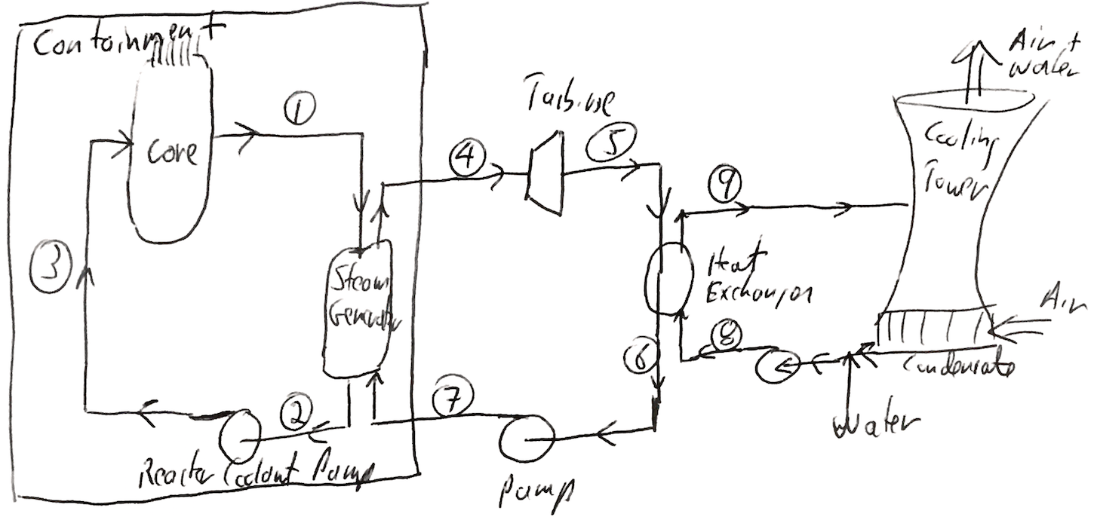

Fill out the table detailing the various streams in the simplified PWR reactor. Calculate the overall efficiency for the plant **(Net Ws/QCore)** Ignore the shaft work for the cooling tower cycle. Use linear interpolation to find the values from the steam tables. Compare the efficiency of this PWR with that of a Carnot engine. (Note: **GW = 1e6 kJ/s**).