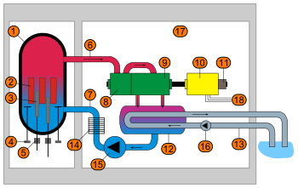

Schematic diagram of a *boiling water reactor* (BWR):

1. Reactor pressure vessel
2. Nuclear fuel element
3. Control rods
4. Recirculation pumps
5. Control rod drives
6. Steam
7. Feedwater
8. High-pressure turbine
9. Low-pressure turbine
10. Generator
11. Exciter
12. Condenser
13. Coolant
14. Pre-heater
15. Feedwater pump
16. Cold-water pump
17. Concrete enclosure
18. Connection to electricity grid

Boiling Water Reactor 7 – 7.5 MPa

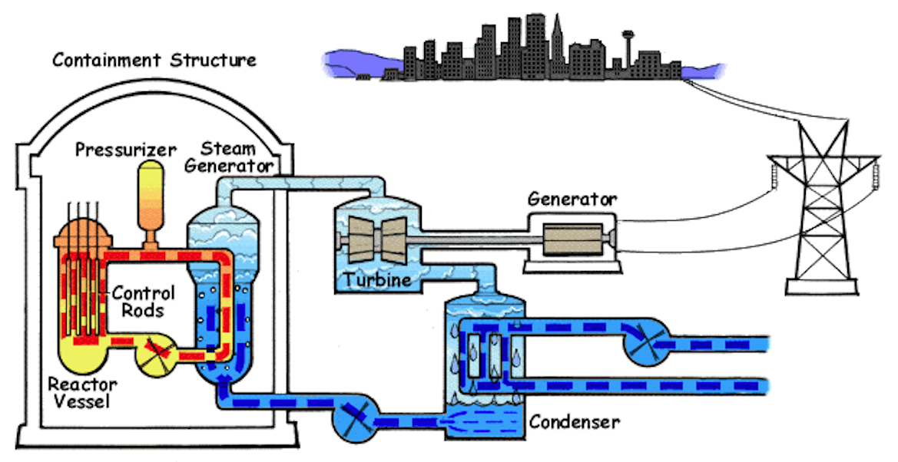

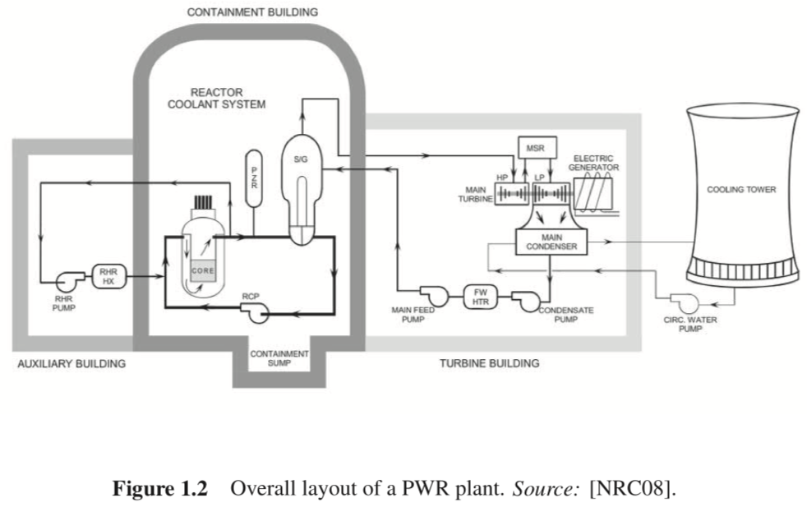



The two main types of commercial nuclear power reactors are pressurized water reactors (PWR) and boiling water reactors (BWR). PWRs are favored by countries with nuclear navies since the radioactive part of the reactor can be much more compact/contained, and the reactor core cooling is better controlled. Since many of the reactor operators in the US are Navy veterans the military precedence favors PWRs in commercial use. For countries with no nuclear navies, such as Japan, BWRs are favored due to simplicity of the design and better thermal efficiency (0.48 versus 0.32).

Consider a PWR who’s simplified schematic is shown below. The radioactive/high pressure/high mass flow rate components are contained in the containment vessel which is the primary fail safe mechanism of the reactor. The primary coolant stream (deionized light water) in the reactor is designed to be in the liquid phase throughout the cycle. Leaving the reactor core (stream 1), the pressure is 15.5 MPa and the temperature is 315°C. The liquid water is cooled in the steam generator (a very complex heat exchanger) where it loses 0.6 MPa in pressure. Stream 2 then enters the reactor coolant pump which increases the pressure and provides the energy for a 10,000 kg/s flowrate through a 24cm diameter pipe that feeds into the core (stream 3).

The power generation cycle starts with saturated steam at 322°C in stream 4. This flows into a turbine for power generation. The exiting stream 5 flows into a heat exchange where a saturated vapor stream is condensed, stream 6. This flows into a pump to feed the steam generator.

A large cooling tower is needed to remove the excess heat from the turbine effluent stream, stream 8 = 15,000kg/s. The large amount of low-grade waste heat generated could cause significant environmental impact on river water without the cooling tower which releases only water vapor.

The unique features of the PWR method of power generation include highly radioactive, extremely high pressure, extremely high flow rate primary coolant at the L/V transition point necessitated by the absence of vaporization of the coolant and its associated large enthalpy change. The advantage of the PWR is the small containment vessel which can be closely controlled in the limited space of a nuclear aircraft carrier, icebreaker or submarine. For commercial power generation on land the BWR design seems to be more reasonable. Despite the inherent dangers of the PWR method, the US Navy has never had an accident with these power sources in 70 years of use. Commercial use has had a lower success rate which has had significant political impact. For instance, the Three Mile Island reactor 2 was a PWR plant.

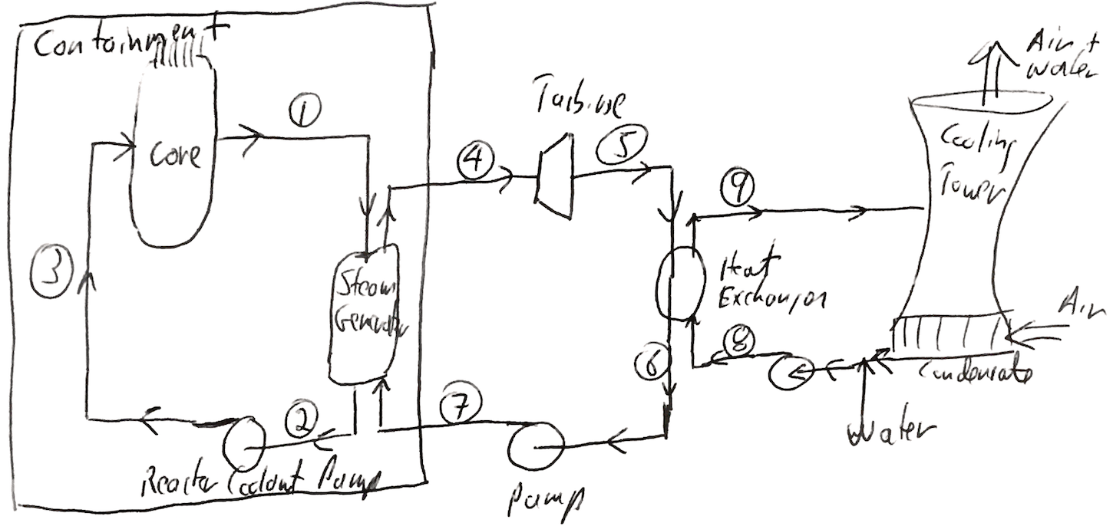

1. Fill out the table detailing the various streams in the simplified PWR reactor noting that the overall efficiency for the plant (Net Ws/QCore) is 0.32 and that a significant kinetic energy might be contributed by the reactor coolant pump and cooling tower pump both through 24 cm diameter pipes, ½ mv2, in addition to the pressure change. Use linear interpolation to find the values from the steam tables.
2. Compare the efficiency of this PWR with that of a Carnot engine. (The BWR operates at higher temperatures).