**Chemical Engineering Thermodynamics**

**Quiz 5 February 11, 2021**

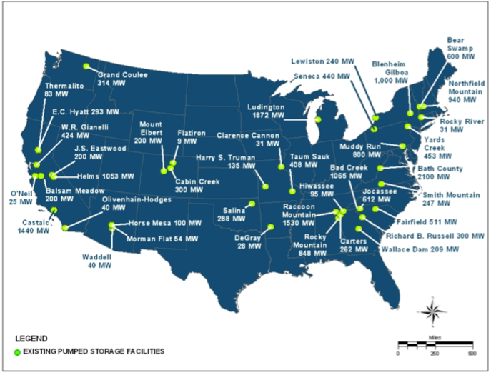 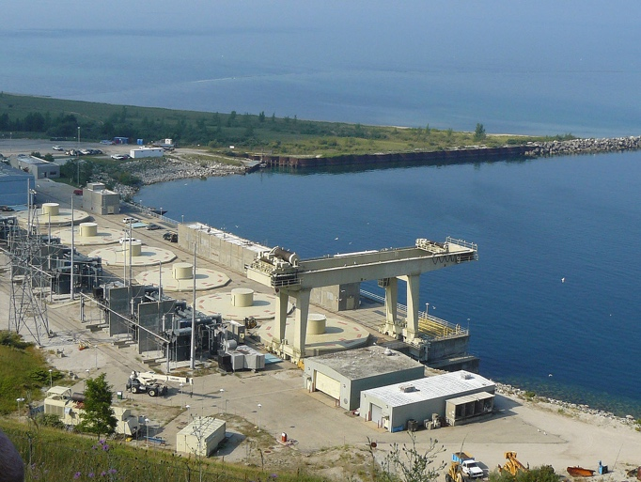

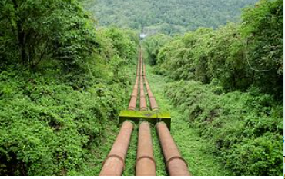

Pumped storage is used to level the generation/use patterns to make the electrical grid more efficient. In pumped storage water is pumped up hill to a large reservoir when energy demand is low or energy production is high. The water flows back through turbines to generate electricity when demand is high and production is low. The Michigan shore of Lake Michigan has steep sand dunes that offer a unique opportunity for this technology. The Ludington hydro-electric plant is tied to local nuclear power to store energy at night. Similar storage facilities could store wind power, Lake Michigan having the high potential for offshore wind. The 1.9 GW Ludington, MI hydro storage plant is the largest in the US. It includes a 27 x 109 gallon storage reservoir lined with asphalt and clay. It has six 312 MW reversible turbines that connect to six 1000 ft penstocks that rise 111 meters to the reservoir. The flow is 33 x 106 gallons per minute. The plant can routinely switch from full storage to full power generation in 30 minutes making it the most flexible large-scale energy source in existence. (Typically, a coal fired power plant might require a week for startup.) The plant is currently being expanded to 2.2 GW to accommodate expanding wind power generation.