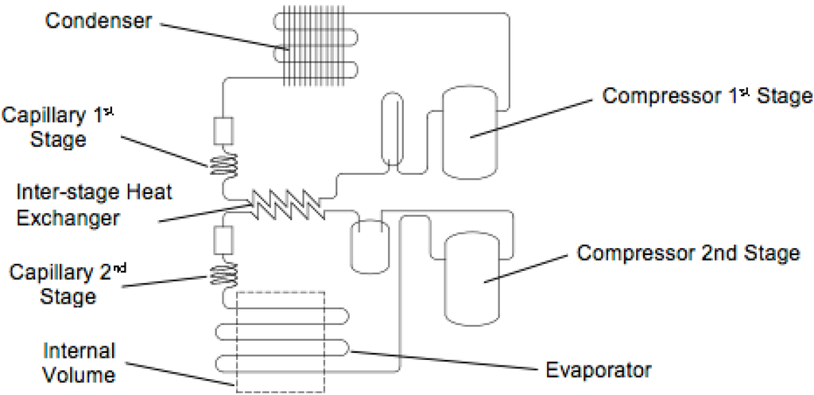

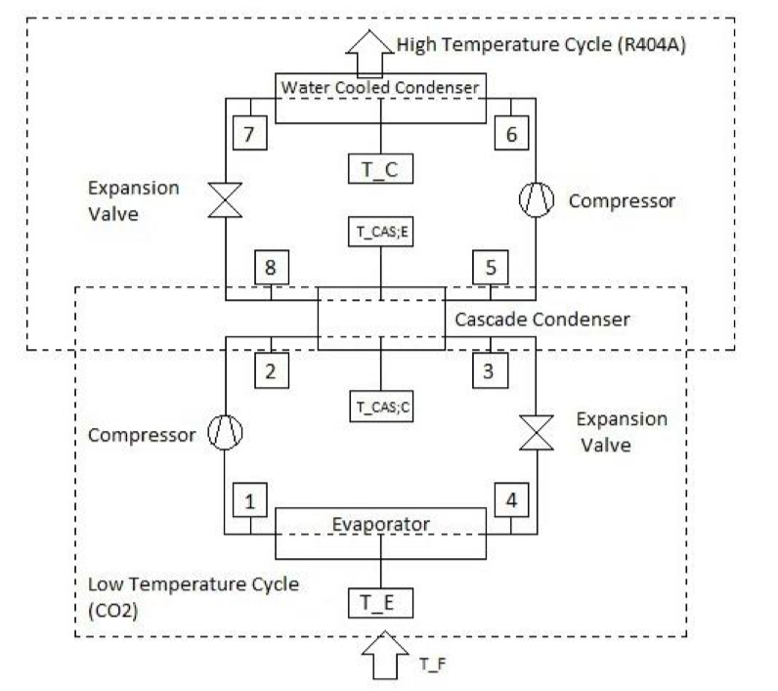

ULT-Freezers (Ultra low temperature) are needed for COVID-19 vaccine. A 5-ton rated cascade refrigerator is used to cool COVID RNA vaccine. Find the COP for the refrigerator and that for a Carnot cycle and the flowrates for the two cycles in the cascade. Stage 1 uses R134A refrigerant and Stage 2 uses ethane. The condenser is at 30°C, the inter-stage heat exchanger is at -30°C and the evaporator is at -86°C. Assume that the heat exchanger has no loss. 1 ton = 12,600 kJ/h. Use the pressure enthalpy charts and the saturated table (following the chart in the book) for R134A.