**Quiz 6**

**Chemical Engineering Thermodynamics**

**February 18, 2021**

ULT-Freezers (ultra-low temperature) are needed for storage of COVID-19 mRNA vaccine and other nucleic acids (DNA and RNA) in order to prevent degradation reactions. Consider a **5-ton** rated binary cascade refrigerator to cool COVID-19 mRNA vaccine. **Find the COP for the cascade refrigerator and that for a Carnot cycle.** **Stage 1 uses R134A refrigerant and Stage 2 uses ethane. The condenser (8) is at 30°C, the inter-stage heat exchanger (6, 4) is at -30°C and the evaporator (2) is at -86°C.** Assume that the heat exchanger has no thermal loss.

**Use the closest values from the saturated table for R134A for the saturated values** and the pressure-enthalpy chart for the other values;

and **interpolate the values from the saturated table for ethane for the saturated values** and use the pressure-enthalpy chart for ethane for the other values (*use the attached Excel sheet to do the interpolation by inserting the values from the table*). For -86°C (187K) use the saturated pressure from the saturated table interpolation to find the equilibrium tie-line in the chart (1 to 2 in the schematic chart below).

The two compressors have an **efficiency of 0.85**.

**1 ton refrigeration = 12,600 kJ/h**

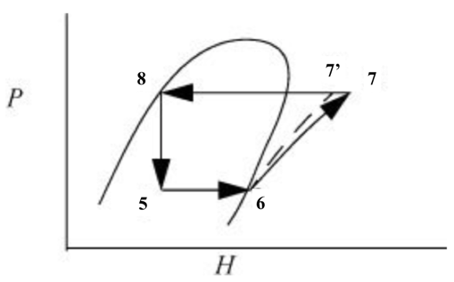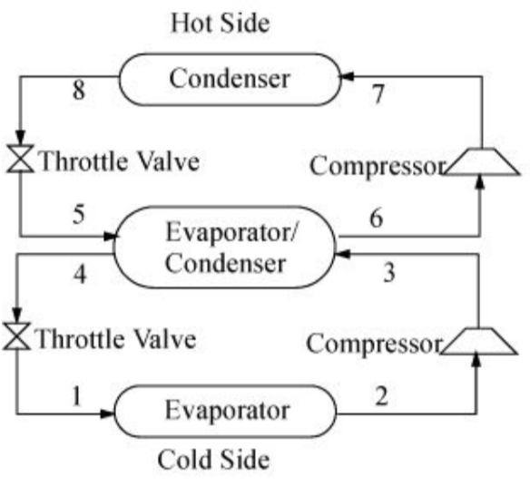 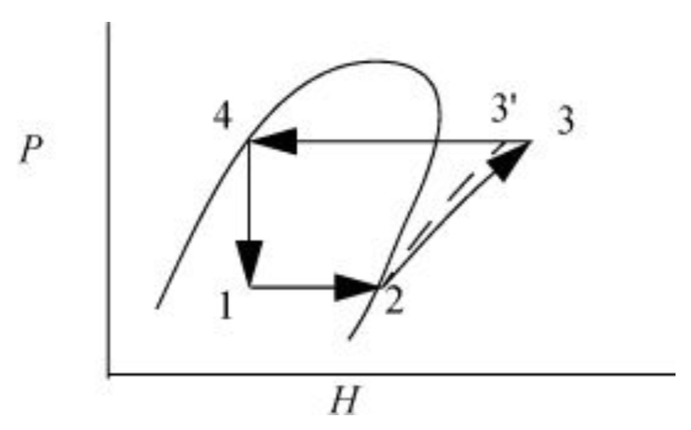

*Figure 1. Cascade refrigeration cycle. The refrigerants do not mix in the evaporator/condenser. P-H diagrams for the upper and the lower cycles.*

**Fill the table values in the process stream table.**

**Plot the process stream points on the two P-H charts with lines connecting as in Figure 1 above.**

