**Quiz 7**

**Chemical Engineering Thermodynamics**

**February 25, 2021**

1. For a throttle valve, such as used in a refrigerator, *H* = 0. You might want to know analytic expressions in terms of *T, P, V, Cp, Cv, p,* and *T* for the change in **entropy and temperature** (*JT*) across a throttle valve, ${\left(\frac{∂S}{∂P}\right)}_{H}, {\left(\frac{∂T}{∂P}\right)}_{H}$. Derive these analytic expressions.
2. Last week we calculated the COP for a **5-ton** cascade refrigerator for RNA/DNA using R134a and ethane.   
   Repeat that calculation of COP **using propane and ethane**. Determine the values **using PREOS.xls**. ***For the reference state use HR = 0; T = 298K; P = 0.1 MPa; Real Fluid; and the lowest fugacity root with a solution.***  
     
   **Stage 1 uses propane as a refrigerant and Stage 2 uses ethane. The condenser (8) is at 30°C, the inter-stage heat exchanger (6, 4) is at -30°C, and the evaporator (2) is at -86°C.** The total cooling is **5 tons of refrigerant**. Assume that the heat exchanger has no thermal loss.   
   **Use PREOS.xls to obtain all values**.  
   The two compressors have an **efficiency of 0.85**.   
   **1-ton refrigeration = 12,600 kJ/h**  
   **Fill the table values in the process stream table.**

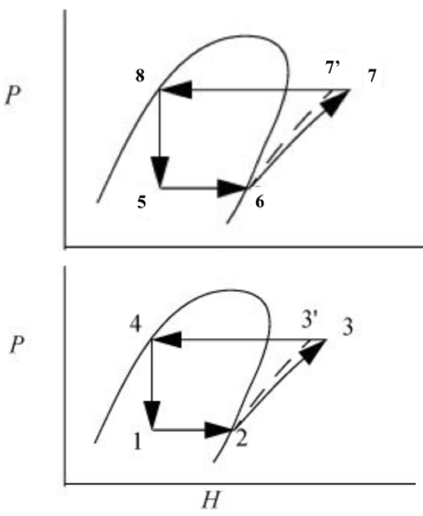

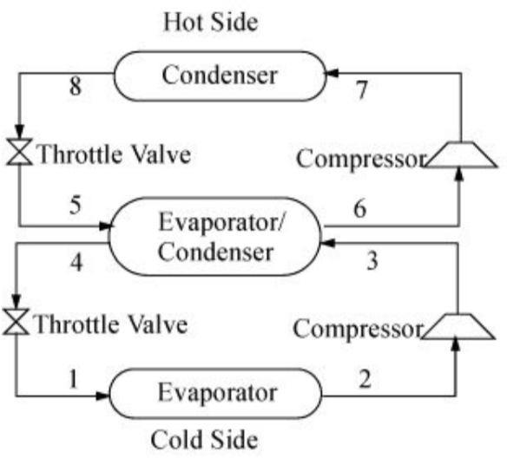

Stage 1

Stage 2

*Figure 1. Cascade refrigeration cycle. The refrigerants do not mix in the evaporator/condenser. P-H diagrams for the upper and the lower cycles.*