**Quiz 9**

**Chemical Engineering Thermodynamics**

**March 11, 2021**

Consider a gas that follows the equation of state

*PV/RT* = 1 + (*b* – *a/T*) *P*/(*RT*)

where *b* = 20 cm3/mole; *a* = 40,000 cm3K/mole; and *C*P = 41.8 + 0.084 *T*(K) J/mol-K.

The gas is under high pressure and is fed through a throttle valve to lower the pressure. The molar density decreases by a factor of 20, **20 **2 = **1**.

1. Compare the equation of state to the Van der Waals equation of state. Can this fluid form a liquid state? Does it have excluded volume?
2. What happens to this fluid at very low temperatures? Can this fluid become an ideal gas?
3. If the initial fluid is at 5 MPa and 300K, what is the pressure and temperature of the resulting liquid/vapor mixture after throttling using the inlet stream as the reference state (a real gas with *H* = 0)?
4. What is the change in Gibbs free energy for the throttling process?
5. What is the Gibbs free energy, *G*, of the exiting stream?

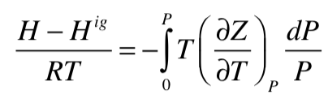

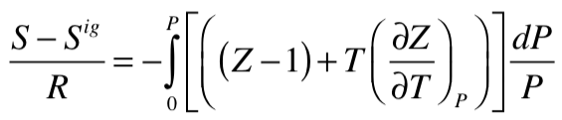

**Include the attached answer sheet with your answers and a sheet with your work and a description of the solver routine used.**

**Please use this answer sheet**

Include a sheet with your work and a description of solver routine in excel.

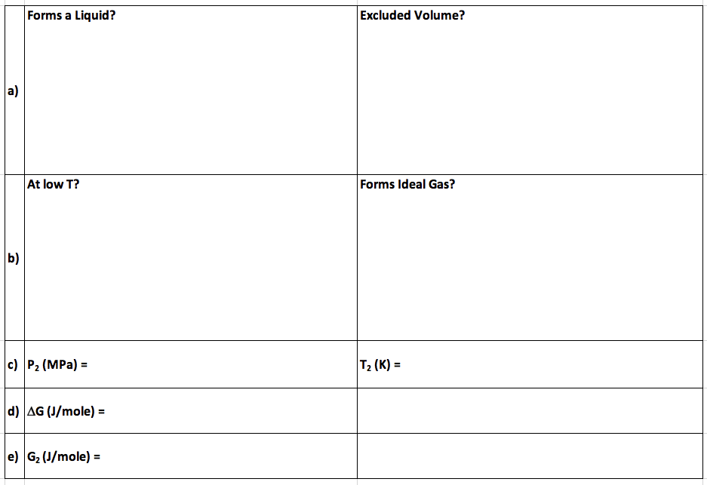

**ANSWERS: Quiz 9**

**Chemical Engineering Thermodynamics**

**March 11, 2021**

