X-Ray Reflectivity using the PANalytical X’Pert Pro MPD

Scott A Speakman, Ph.D

Center for Materials Science and Engineering at MIT

<http://prism.mit.edu/xray>

Modified for configuration used at University of Cincinnati

Sandip Argekar

Schaefer Research Group

This SOP assumes that you are familiar with the basic operation of the PANalytical X’Pert Pro MPD. If there is an instruction in this document that you do not understand, you can find more detailed instructions in the X’Pert SOP, which is available in the red-binder by the data collection computer and as a MS Word document, XPertSOP.doc, on the desktop of the data collection computer.

# I. Configure the Instrument

This section walks you through the steps of setting up the instrument to begin your measurement. Many of these items are covered in more detail in the X’Pert SOP, sections IV and V.

1. Assess instrument status and safety
   1. Is the instrument on?
   2. Is the generator on?
   3. What is the tube power?
   4. Is the shutter open?
2. Determine if the correct PreFIX optics and sample stage are on the instrument
   1. Incident-beam PreFIX module should be the X-ray Mirror
   2. Diffracted-beam PreFIX module should be the 0.27° Parallel Plate Collimator
   3. Sample stage should be the MRD Cradle (MRD)
   4. The X-ray tube must be the Cu tube
3. Ready the instrument
   1. If the diffractometer is off, then turn it on
   2. If Data Collector is already running, quit it
   3. Start X’Pert Data Collector
      1. Enter your user name and password to log in to your account
      2. Select *Instrument>Control* to connect the computer to the instrument
   4. Make sure the tube power is at 45 kV and 20 mA
4. Insert the appropriate Optics and Accessories for the PreFIX Optics
   1. Incident-beam side should be using the X-Ray Mirror
      1. Insert the 1/32° Divergence Slit
      2. Use an appropriate width limiting mask for your sample
         1. the actual size of the X-ray beam will be about 2x the size of the beam mask
      3. The Automatic Beam Attenuator must be attached to the X-ray mirror and plugged in. *This is absolutely crucial.*
   2. Diffracted-beam side should use the 0.27° Parallel Plate Collimator
      1. Insert the matching Parallel Plate Collimator Slit
      2. Insert the 0.04rad Soller Slit
      3. Make sure the detector is attached to the collimator
5. Change the instrument configuration in Data Collector
   1. Configure the Incident Beam Optics tab in the ***Instrument Window***
      1. Set the PreFIX Module to **Mirror Cu W/Si (parabolic MPD)**
      2. Set the Divergence Slit to “**Slit Fixed 1/32°”**.
      3. Use an appropriate Mask to limit the beam width.
      4. Set the Beam Attenuator to **Ni 0.125mm automatic**
         1. Set usage to **“Do not Switch”** and check the **“Activated”** box
         2. Make sure the attenuation factor is correct (162.88). 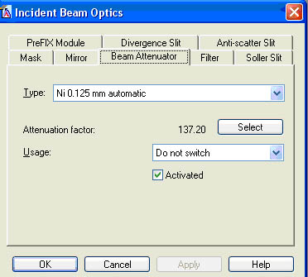
   2. Configure the Diffracted Beam Optics tab in the ***Instrument Window***
      1. Set the PreFIX Module to “**Parallel Plate Collimator 0.27°”**
      2. Set the Receiving Slit to “**Parallel Plate Collimator Slit”**
      3. Set the Soller Slit to **“Soller 0.04rad”**
      4. Set the Detector will be set to **“PW3011/20”**
6. Turn up the generator power to 45 kV and 40 mA

# II. Measure the Direct Beam Intensity

In this section, you will position the system so that the X-ray beam is aimed directly into the detector and you will determine the intensity of the direct X-ray beam. If you did not correctly configure the instrument in section I, *this step could destroy the X-ray detector!* Double-check your set-up before proceeding!

1. Make sure that the Enclosure Doors are completely closed.
2. Drive the goniometer to 0°
   1. In the Instrument Settings tab, double-click any item related to **Positions**
   2. Set positions
      1. 2Theta = 0°
      2. Offest = 0°
      3. Psi = 0°
   3. Press **OK**
3. Run a Manual Scan of 2Theta
   1. Select *Measure>Manual Scan* from the main menu.
   2. Enter the following parameters in the ***Prepare Manual Scan*** Window
      1. Scan Axis: **“2Theta”**
      2. Range= **1.0**
      3. Step Size= **0.01**
      4. Time per Step= **0.1**
      5. As you set values, some numbers may change slightly (like range). This is ok.
   3. Press **Start**
4. Determine the peak position
   1. Left-click and drag to zoom in on the peak (leaving some background to either side)
   2. To use the automatic peak finder
      1. Right-click on the ***Manual Scan*** window
      2. Select **Peak Mode**
      3. If the computer adequately finds the peak, then click **Move To**
      4. If the computer does not correctly locate the peak, C**lose** the ***Peak Mode*** window
   3. If peak mode does not work, you can manually find the peak
      1. Right-click on the ***Manual Scan*** window
      2. Select **Move mode**.
      3. Locate the green line in the ***Manual Scan*** window
      4. Left-click and drag the green line until it is at the center of gravity of the peak.
      5. Release the left-mouse button. The goniometer will move to the selected position.

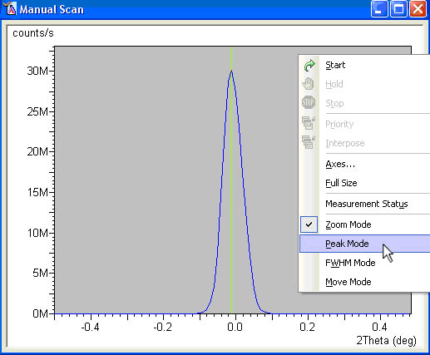

1. Determine the direct beam intensity
   1. Intensity is the count rate in the status bar on the bottom of the Data Collector screen.
   2. Record this intensity. This is the “Direct Beam Intensity”

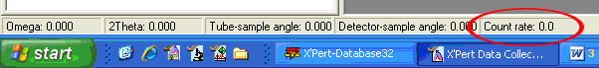

1. Close the Shutter
   1. There are three ways to close the shutter
      1. Close the ***Manual Scan*** window
      2. Click on the **Open/Close Shutter** button in the menu toolbar 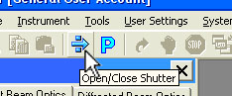
      3. In the Instrument Settings tab of the ***Instrument Window***,
         1. double-click any item related to the generator.
         2. Uncheck the O**pen Shutter** box and press **Apply**.
2. Configure the Automatic Attenuator
   1. Select the Incident beam optics tab.
   2. Double-click on the **Beam Attenuator** field
   3. In the ***Incident Beam Optics*** window, set the Beam Attenuator
      1. Usage= **‘At preset intensity’**.
      2. Activate at level = **600,000**
      3. De-activate at level = **400,000**
      4. Press the **OK** button.

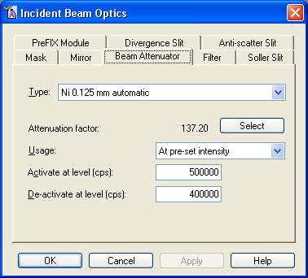

1. Specify the new zero value for 2theta
   1. Select *User Settings >Fine calibration Offsets* from the main menu.
   2. Enter 0 in the **“2Theta”** field.
   3. Close the window.
   4. This step is to be performed only once per batch before measuring samples.

# III. Sample Alignment routine

1. Run the automatic alignment routineof Omega
   1. Select *Measure>Program> General batch* from the main menu.
      1. Run the program “**Alignment_routine_z_thin”.** This program will align the instrument for X-ray reflectivity measurements of substrates with a thickness of 0 – 3 mm. Substrates thicker than 3 mm can run the routine “**Alignment_routine_z_thick”.**
   2. Press **Start.** The program will align the substrate to be perfectly parallel to the beam, and identify the position of the interface
   3. Select *User Settings >Sample Offsets* from the main menu.
   4. Enter 0 in the **“Omega”** field.
   5. Close the window.

# IV. Reflectivity measurements

1. Select *Measure > Program > Absolute scan > [XRR program]*
2. Note multiple X-ray reflectivity measurement programs have been written and details of scan resolution, time of scan and range are mentioned in comments. Please choose conditions appropriate to substrate and estimated thin-film thickness.
3. Choose destination folder and sample name in the pop-up box.

V. When you are done

1. Remove your sample

2. Turn down the generator power to 45 kV and 20 mA

3. Quit X’Pert Data Collector