X-Ray Reflectivity using the PANalytical X’Pert Pro MPD

Scott A Speakman, Ph.D
Center for Materials Science and Engineering at MIT
http://prism.mit.edu/xray

This SOP assumes that you are familiar with the basic operation of the PANalytical X’Pert Pro MPD. If there is an instruction in this document that you do not understand, you can find more detailed instructions in the X’Pert SOP, which is available in the red-binder by the data collection computer and as a MS Word document, XPertSOP.doc, on the desktop of the data collection computer.

I. Configure the Instrument
This section walks you through the steps of setting up the instrument to begin your measurement. Many of these items are covered in more detail in the X’Pert SOP, sections IV and V.

- Assess instrument status and safety
  - Is the instrument on?
  - Is the generator on?
  - What is the tube power?
  - Is the shutter open?

- Determine if the correct PreFIX optics and sample stage are on the instrument
  - Incident-beam PreFIX module should be the X-ray Mirror
  - Diffracted-beam PreFIX module should be the 0.09° Parallel Plate Collimator
  - Sample stage should be the Open Eularian Cradle (OEC)
  - The X-ray tube must be the Cu tube
  - If the correct modules are not installed, ask SEF staff to change them for you

- Ready the instrument
  - If the diffractometer is off, then turn it on
  - If Data Collector is already running, quit it
  - Start X’Pert Data Collector
    - Enter your user name and password to log in to your account
    - Select Instrument>Control to connect the computer to the instrument
    - Select OEC Motorized Platform as the configuration and click OK
  - Make sure the tube power is at 40 kV and 10 mA

- Insert the appropriate Optics and Accessories for the PreFIX Optics
  - Incident-beam side should be using the X-Ray Mirror
    - Insert the 1/32° Divergence Slit
    - Use an appropriate width limiting mask for your sample
      - the actual size of the X-ray beam will be about 2x the size of the beam mask
      - you might replace this with an attenuation foil when aligning the sample
    - The Automatic Beam Attenuator must be attached to the X-ray mirror and plugged in. This is absolutely crucial.
  - Diffracted-beam side should use the 0.09° Parallel Plate Collimator
    - Insert the matching Parallel Plate Collimator Slit
    - Insert the 0.04rad Soller Slit
    - Make sure the detector is attached to the collimator
  - Make sure the platform on the OEC stage is lowered out of the path of the X-ray beam
    - Lower the platform by turning it clockwise

- Change the instrument configuration in Data Collector
  - Configure the Incident Beam Optics tab in the Instrument Window
    - Set the PreFIX Module to Mirror Cu W/Si (parabolic MPD)
    - Set the Divergence Slit to “Slit Fixed 1/32°”.
    - Use an appropriate Mask to limit the beam width.
    - Set the Beam Attenuator to Ni 0.125mm automatic
      - Set usage to “Do not Switch” and check the “Activated” box
      - Make sure the attenuation factor is correct (137.2). 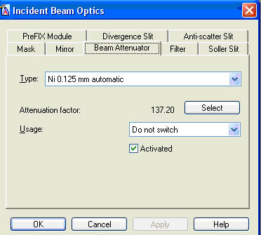
  - Configure the Diffracted Beam Optics tab in the Instrument Window
    - Set the PreFIX Module to “Parallel Plate Collimator 0.09°”
    - Set the Receiving Slit to “Parallel Plate Collimator Slit”
    - Set the Soller Slit to “Soller 0.04rad”
    - Set the Detector will be set to “PW3011/20 (Miniprop. Large window)[1]”

- Turn up the generator power to 45 kV and 40 mA

II. Measure the Direct Beam Intensity
In this section, you will position the system so that the X-ray beam is aimed directly into the detector and you will determine the intensity of the direct X-ray beam. If you did not correctly configure the instrument in section I, this step could destroy the X-ray detector! Double-check your set-up before proceeding!

- Make sure that the Enclosure Doors are completely closed.

- Drive the goniometer to 0°
  - In the Instrument Settings tab, double-click any item related to Positions
  - Set positions
    - 2Theta = 0°
    - Offest = 0°
    - Psi = 0°
  - Press OK
- Run a Manual Scan of 2Theta
  - Select Measure>Manual Scan from the main menu.
  - Enter the following parameters in the Prepare Manual Scan Window
    - Scan Axis: “2Theta”
    - Range= 1.0
    - Step Size= 0.01
    - Time per Step= 0.1
    - As you set values, some numbers may change slightly (like range). This is ok.
  - Press Start

- Determine the peak position
  - Left-click and drag to zoom in on the peak (leaving some background to either side)
  - To use the automatic peak finder
    - Right-click on the Manual Scan window
    - Select Peak Mode
    - If the computer adequately finds the peak, then click Move To
    - If the computer does not correctly locate the peak, Close the Peak Mode window
  - If peak mode does not work, you can manually find the peak
    - Right-click on the Manual Scan window
    - Select Move mode.
    - Locate the green line in the Manual Scan window
    - Left-click and drag the green line until it is at the center of gravity of the peak.
    - Release the left-mouse button. The goniometer will move to the selected position.
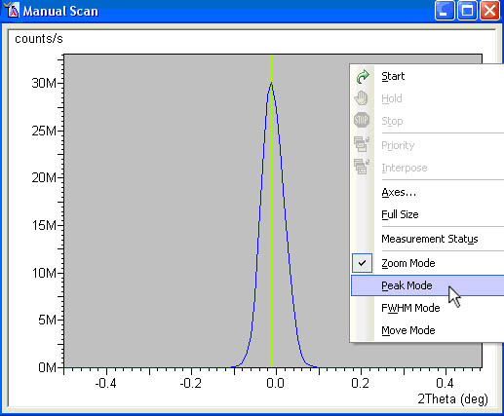

- Determine the direct beam intensity
  - Intensity is the count rate in the status bar on the bottom of the Data Collector screen.
  - Record this intensity. This is the “Direct Beam Intensity”
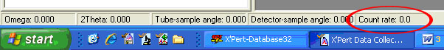

- Close the Shutter
  - There are three ways to close the shutter
    - Close the Manual Scan window
    - Click on the Open/Close Shutter button in the menu toolbar 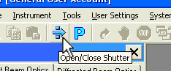
    - In the Instrument Settings tab of the Instrument Window,
      - double-click any item related to the generator.
      - Uncheck the Open Shutter box and press Apply.

- The count rate of the direct beam should be less than 700,000 cps
  - If the count rate was larger than 700,000 cps, then
    - Make sure that the shutter is closed
    - Open the enclosure doors
    - In the X-ray mirror, replace the width limiting mask with the Cu0.1 attenuator.
    - You do not need to indicate this change in the instrument configuration
    - Close the enclosure doors

- Specify the new zero value for 2theta
  - Select User Settings >Sample Offsets from the main menu.
  - Enter 0 in the “2Theta” field.
  - Close the window.

III. Bisect the Direct Beam
The sample height must be adjusted within a couple of micrometers of the true zero, and the sample surface must be perfectly level with the X-ray tube and detector. This procedure will allow you to adjust the sample height and tilt (offset).

- Mount the sample on the stage
  - Make sure that the shutter is closed before opening the enclosure doors.
  - Center your sample on the OEC stage
  - Use the dial gauge to position your sample
    - Attach the dial gauge to the stage
    - Center the sample under the dial gauge
    - Turn the stage counter-clockwise to raise it; turn clockwise to lower
    - Adjust the height until the dial gauge reads 1mm
    - Remove the dial gauge
    - Consult the XPert SOP, Section V 5.3C (3) for more detailed instructions
  - Close the enclosure doors

- Optimize the Sample Height using the X-ray Beam
  - Open the shutter by clicking on the Open/Close Shutter button in the menu toolbar
  - Read the beam intensity in count rate field of the status bar on the bottom of the screen.
  - You want to adjust the height of the sample until the intensity of the X-ray beam is ½ the Direct Beam Intensity, within ±10%.
    - The Direct Beam Intensity was determined in step II.5 above.
    - If the intensity is too high, raise the sample (turn the stage counter-clockwise)
    - If the intensity is too low, you need to lower the sample (turn the stage clockwise)
  - Begin an iterative process of adjusting the sample height and reading the beam intensity
    - Close the shutter using the button
    - Adjust the sample height
    - Close the enclosure doors
    - Open the shutter using the button
    - Read the beam intensity
    - Repeat this process until the measured beam intensity is within the target range

- Run a Manual Scan of Omega
  - Select Measure>Manual Scan from the main menu.
  - Enter the following parameters in the Prepare Manual Scan Window
    - Scan Axis: “Omega”
    - Range= 2
    - Step Size= 0.005
    - Time per Step= 0.1
    - As you set values, some numbers may change slightly (like range). This is ok.
  - Press Start

- After the measurement is completed, determine the peak position
  - Right-click the Manual Scan window and use either the Peak Mode or the Move Mode, as described above in section II.4, to determine the center of gravity of the peak.
  - This will move the goniometer to the selected position.

- Read beam intensity from the count rate field of the status bar on the bottom of the screen
  - The target intensity is now ½ (±1%) the Direct Beam Intensity (from step II.5 above)
  - If the intensity is within this range, then continue to Section IV.
  - If the intensity is outside the target range, then use this iterative process until the beam intensity is within the target range:
    - Close the shutter using the button
    - Adjust the sample height (turn CW to lower, CCW to raise the sample)
    - Close the enclosure doors
    - Open the shutter using the button
    - Read the intensity of the X-ray beam
    - Repeat steps i through v until the intensity is ½ (±1%) the direct beam intensity
    - Run a Manual Scan of Omega
      - Select Measure>Manual Scan from the main menu.
      - Enter the following parameters in the Prepare Manual Scan Window
        - Scan Axis: “Omega”
        - Range= 1
        - Step Size= 0.005
        - Time per Step= 0.1
        - As you set values, some numbers may change slightly (like range). This is ok.
      - Press Start
    - Determine the peak position using either Peak Mode or Move Mode
    - Read the intensity of the X-ray beam
    - Repeat steps i through ix until the intensity is ½ (±1%) the direct beam intensity
      - you must achieve the target intensity after step ix; do not stop after step v
      - when you achieve the target intensity, proceed to section IV

IV. Optimizing the Reflected Intensity
In this step, you will use the first interference fringe of the reflected X-ray beam to optimize the sample tilt in omega and psi directions. Complicated samples, such as an irregular sample shape, poor film quality, or unusual structure, could make these steps more difficult. Consult X-ray SEF staff if you are having trouble.

- Drive 2Theta to 1.6°
  - In the Instrument Settings tab, double-click on any the items related to Positions
  - Set positions: 2Theta = 1.6°
  - Press OK

- Use Manual Scan to collect a preliminary reflectivity curve
  - Select Measure>Manual Scan from the main menu.
  - Enter the following parameters in the Prepare Manual Scan Window
    - Scan Axis: “2Theta/Omega”
    - Range= 3
    - Step Size= 0.005
    - Time per Step= 0.2
    - As you set values, some numbers may change slightly (like range). This is ok.
  - Press Start

- Change the y-axis to log scale
  - Right-click in the Manual Scan window,
  - Select Axes
  - In the resulting window, select logarithmic for the intensity axes.

- Move the goniometer to a reflection fringe
  - When the scan is done, right-click in the Manual Scan window and select Move mode
  - Locate the green line in the Manual Scan window
  - Left-click and drag the green line until it is placed over the maximum intensity of the first clearly visible fringe (the fringe at the lowest angle 2theta)
    - If no fringes are visible, move the green cursor to a position just to the right of the critical angle (the angle at which reflected intensity begins to drop significantly).
    - The appearance of these data will vary depending on your sample’s structure
  - Release the left-mouse button. The goniometer will move to the selected position.
    - Do not close the Manual Scan window
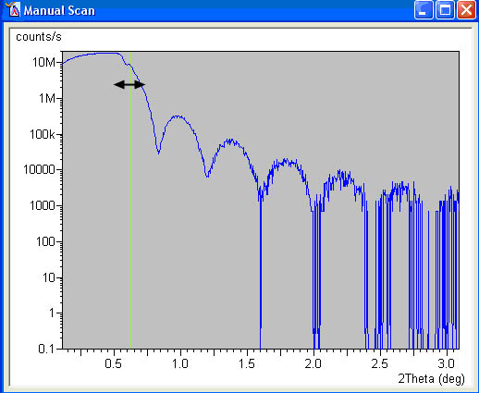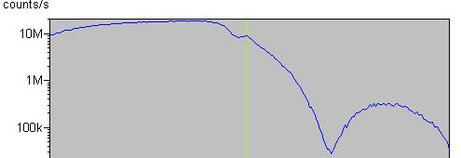

- Optimize Omega using a Manual Scan
  - Leaving the Manual Scan window still open, click on the Prepare Manual Scan window
    - If you closed the Manual Scan window, then just select the Prepare Manual Scan window or select Measure>Manual Scan from the main menu.
  - Enter the following parameters in the Prepare Manual Scan Window
    - Scan Axis: “Omega”
    - Range= 1
    - Step Size= 0.005
    - Time per Step= 0.2
    - As you set values, some numbers may change slightly (like range). This is ok.
  - Press Start

- Change the y-axis to linear scale
  - Right-click in the Manual Scan window,
  - Select Axes
  - In the resulting window, select linear for the intensity axes.

- Determine the peak position and move the goniometer
  - Right-click the Manual Scan window and use either the Peak Mode or the Move Mode, as described above in section II.4, to determine the center of gravity of the peak.
    - If the omega scan has two broad low intensity peaks, then reflectivity on this sample will not be possible due to high interface roughness.
    - If the omega scan has three peaks, with a sharp peak in the middle, then select the position of the sharp peak in the middle using Move Mode.
  - This will move the goniometer to the selected position.
  - Do not close the Manual Scan window

- Optimize Psi tilt using a Manual Scan
  - Leaving the Manual Scan window still open, click on the Prepare Manual Scan window
    - If you closed the Manual Scan window, then just select the Prepare Manual Scan window or select Measure>Manual Scan from the main menu.

  - Enter the following parameters in the Prepare Manual Scan Window
    - Scan Axis: “Psi”
    - Range= 4
    - Step Size= 0.01
    - Time per Step= 0.2
    - Even if a value is correctly set from default in the Prepare Manual Scan window, you need to explicitly change its value; otherwise, you will get an error when you try to run the manual scan
    - As you set values, some numbers may change slightly (like range). This is ok.
  - Press Start

- Determine the peak position and move the goniometer
  - Right-click the Manual Scan window and use the Move Mode, as described above in section II.4, to determine the maximum intensity of the peak.
    - The psi tilt peak will be very broad; approximating the maximum is good enough
  - This will move the goniometer to the selected position.
  - Do not close the Manual Scan window
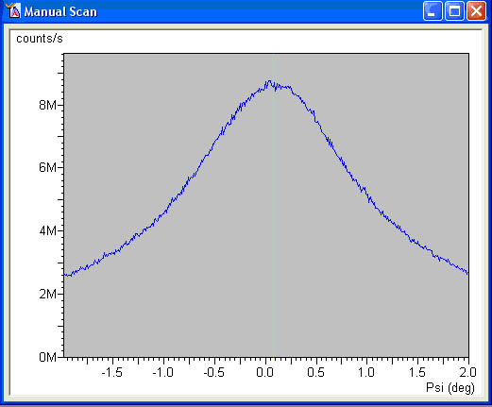

- Optimize Omega using a Manual Scan
  - Leaving the Manual Scan window still open, click on the Prepare Manual Scan window
    - If you closed the Manual Scan window, then just select the Prepare Manual Scan window or select Measure>Manual Scan from the main menu.
  - Enter the following parameters in the Prepare Manual Scan Window
    - Scan Axis: “Omega”
    - Range= 0.3
    - Step Size= 0.002
    - Time per Step= 0.2
    - As you set values, some numbers may change slightly (like range). This is ok.
  - Press Start

- Determine the peak position and move the goniometer
  - Note the value of “Offset” in the Instrument Settings tab in the Instrument Window
  - Right-click the Manual Scan window and use either the Peak Mode or the Move Mode, as described above in section II.4, to determine the center of gravity of the peak.
  - This will move the goniometer to the selected position.
  - Note the new value of “Offset” in the Instrument Settings tab in the Instrument Window
    - If the new “Offset” value is more than 0.1° different than the starting value, then repeat steps 8 through 11 above.
  - Close the Manual Scan window
    - The shutter should close
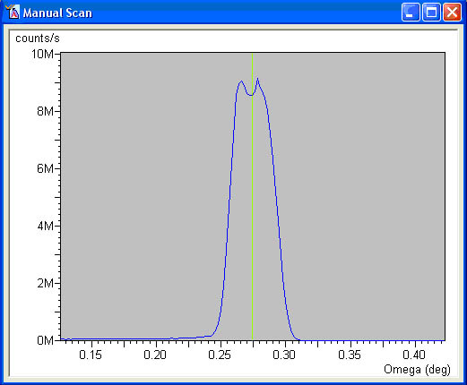

- Set Sample Offsets
  - Drive 2Theta to 0°
    - In the Instrument Settings tab, double-click on any the items related to Positions
    - Set positions: 2Theta = 0°
    - Do not change any of the other settings
    - Press OK
  - Select User Settings >Sample Offsets from the main menu
    - Set “Omega” to 0
    - You may also set “Psi” to 0
    - This will apply a sample specific offset for the omega axis.
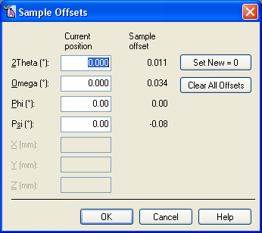

V. Collect Reflectivity Data

- Reconfigure the Automatic Attenuator
  - Select the Incident beam optics tab.
  - Double-click on the Beam Attenuator field
  - In the Incident Beam Optics window, set the Beam Attenuator
    - Usage= ‘At preset intensity’.
    - Activate at level = 500,000
    - De-activate at level = 400,000
    - Press the OK button.
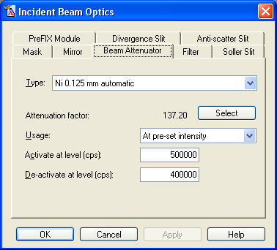

- Create an Absolute Scan Program
  - If you already have a measurement program, you can skip this step.
  - Select File> New Program
  - Choose “Absolute Scan” from the ‘List programs of type:’ drop-down menu
  - In the Prepare Absolute Scan window, specify the values
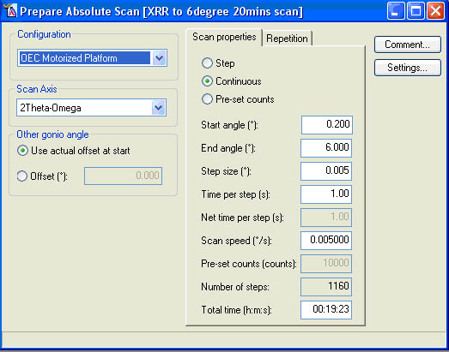
    - Configuration = OEC Motorized Platform
    - Scan Axis = 2Theta-Omega
    - Other gonio angle=Use actual offset at start
    - Scan Mode = Continuous
    - Start Angle = 0.200
    - End Angle = 5.00
      - 5° is the practical upper limit
    - Step Size= 0.005
    - Time per step = 1.00
      - the Time per step may need to be longer
      - typical values are between 1 to 5 sec
    - You could improve the high angle signal by using Pre-Set Counts instead of Continuous mode.
      - This would be appropriate for an overnight scan.
      - Typical values for Pre-set counts would be from 10000 to 100000
  - Select File>Save As and enter a file name for this scan program
  - Click OK
  - Close the Prepare Absolute Scan window.
- Collect data using the Measurement Program
  - In the main menu, select Measure> Program…
  - In the Open Program window,
    - Select “Absolute Scan” in the ‘List programs of type:’ drop-down menu
    - Select the program that you created for collecting XRR data
  - The Start window will open
    - Specify the filename, data folder, and sample description
    - Click OK
  - To see the XRR data plotted correctly during data collection
    - right-click in the Measurement window
    - Select Axes
    - In the resulting window, select logarithmic for the intensity axes.
    - click OK

VI. Running another Sample
If you want to collect XRR data from another sample, then when the preceding scan finishes:

- Close the Measurement window for the completed scan

- Drive the goniometer to 0°
  - In the Instrument Settings tab, double-click on any the items related to Positions
  - Set positions
    - 2Theta = 0°
    - Offest = 0°
    - Phi = 0°
    - Psi = 0°
  - Press OK

- Reset the Sample Offsets
  - Select User Settings >Sample Offsets from the main menu
    - Look at the Offset value for Omega
      - Set the Current Position for “Omega” to the –Offset
    - do the same for “Psi”
  - Click OK
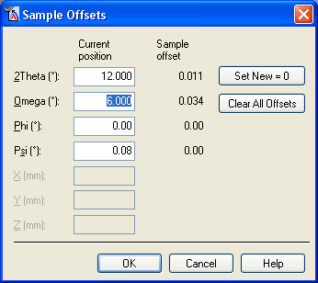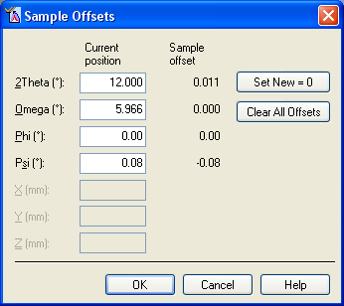

- Reset the attenuator!!!!
  - Set usage to “Do not Switch” and check the “Activated” box
  - Make sure the attenuation factor is correct (137.2).

- Go to Section III above and repeat with the new sample

VII. When you are done

- Remove your sample
- Turn down the generator power to 40 kV and 10 mA
- Quit X’Pert Data Collector

