Lab 14: Torque Rheometer

The oscillatory torque rheometer is an instrument that can measure the complex viscosity or complex shear modulus for a material. The complex modulus is important for viscoelastic materials. The storage modulus and is related to the loss viscosity and the loss modulus to the storage visocsity so that η’ = G”/ω.

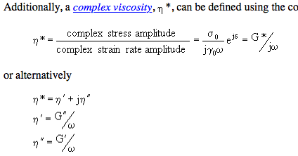

<http://ciks.cbt.nist.gov/~garbocz/SP946/node11.htm>

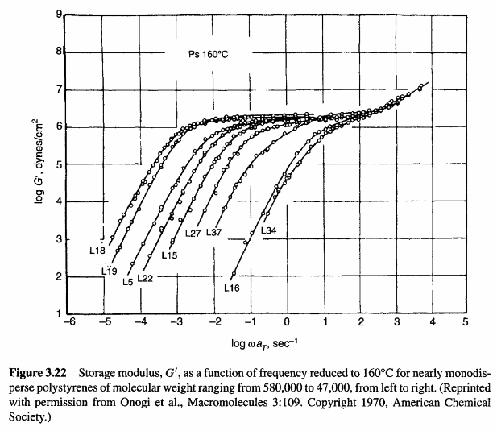

From Ron Larson the Rheology of Complex Fluids (on UC electronic library chapter on entangled flow.)