Synthesis of an Aqueous Ferrofluid

Version 3.0



The California NanoSystems Institute & Materials Creation Training Program
University of California, Los Angeles
Science Outreach Program

Doris Chun, Steven Karlen, Chris Kolodziej, Bob Jost,
Shabnam Virji, Michelle Weinberger

November 2005

Overview
Students prepare a ferrofluid – a liquid that contains small particles, approximately 10 nanometers in diameter, that spontaneously magnetizes in the presence of a magnetic field – through solution chemistry materials.

Outline
Teacher Pre-Lab – 20 minutes
Prepare solutions of 2M FeCl₂, 1M FeCl₃, and 0.5M NH₄OH
Distribute Supplies to Work Areas
Student Procedure – 45 minutes
Synthesize magnetite nanoparticles from iron chloride and ammonia
Isolation of the magnetite nanoparticles
Stabilize the magnetite with tetramethylammonium hydroxide
Observe spiking
Teacher Post-Lab – 10 minutes
Collect, neutralize, and dispose waste
Collect Supplies and Clean Up

For the latest update to the manuals, visit
http://voh.chem.ucla.edu/outreach.php3
Discussion board password: nano
or email: tolbert@chem.ucla.edu

California State Science Standards Grades 9-12
Addressed by the Solar Cell Experiment

Physics

1m. *Students know how to solve problems involving the forces between two electric charges at a distance (Coulomb's law) or the forces between two masses at a distance (universal gravitation).
5j. *Students know electric and magnetic fields contain energy and act as vector force fields.
5f. Students know magnetic materials and electric currents (moving electric charges) are sources of magnetic fields and are subject to forces arising from the magnetic fields of other sources.

Ferromagnetism is the permanent magnetic dipole that results from the alignment of unpaired electron spins in elements such as iron, cobalt, nickel, etc. In this experiment, students will experiment with a fluid they create that exhibits ferromagnetism. They will synthesize magnetic nanoparticles from iron chlorides and disperse them into a tetramethylammonium hydroxide surfactant to form a colloidal suspension. They will then study the behavior of this ferrofluid in the presence of an external magnetic field.

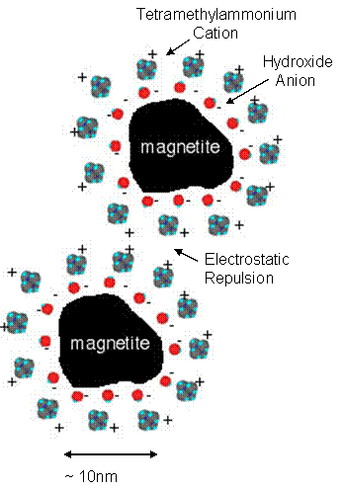
Discussion questions 3, 4, and 5 relate to the concept of Coulomb’s Law, which describes the magnitude of electrostatic force, repulsion or attraction, between two charged particles at a finite distance. The tetramethyl-ammonium hydroxide surfactant used in this experiment is composed of two charged species, (CH₃)₄N⁺ and ⁻OH. The hydroxide anions adhere to the surface of magnetite particles, and these negative charges attract their counter ions, tetramethylammonium cations, forming a positively charged outer shell. Since like charges repel, the electrostatic repulsion between positively charged outer shells prevent magnetite particles from agglomerating. This results in a colloidal suspension of magnetite nanoparticles, which is what we called a ferrofluid. Discussion question 6 deals with magnetic fields and vector force fields. Ferromagnetic materials respond to external magnetic fields by aligning their unpaired electron spins with the vector fields. When a magnet is far away from the solution, no external vector fields interact with the ferrofluid, thus there is nothing interesting to see except a black solution. When a magnet is brought closer to the solution, the magnetic force is large enough to dominate the forces of surface tension and gravity, the ferrofluid forms spikes in the direction of the magnetic field lines. The stronger the vector field lines, the larger the spikes.

Nano particle picture from: Berger, P.; Adelman, N. B.; Beckman, K. J.; Campbell, D. J.; Ellis, A. B.; Lisensky, G. C. J. of Chemical Education 1999, 76, 943-8.
Chemistry

2f. *Students know how to predict the shape of simple molecules and their polarity from Lewis dot structures.
2h. *Students know how to identify solids and liquids held together by van der Waals forces or hydrogen bonding and relate these forces to volatility and boiling/ melting point temperatures.
5a. Students know the observable properties of acids, bases, and salt solutions.
6a. Students know the definitions of solute and solvent.
6b. Students know how to describe the dissolving process at the molecular level by using the concept of random molecular motion.
6d. Students know how to calculate the concentration of a solute in terms of grams per liter, molarity, parts per million, and percent composition.

The formation of ferrofluid involves various types of forces that hold the different components together. On the molecular level, magnetite (Fe₃O₄) is held together by ionic interactions in the crystal lattice, while tetramethylammonium and hydroxide are covalent molecules held together by ionic interactions. Ionic attractions between hydroxide anions and tetramethylammonium cations enable the coating of magnetite nanoparticles, while electrostatic interparticle repulsions among tetramethylammonium cations allow colloidal suspension of the magnitite in solution. Without tetramethylammonium hydroxide as a surfactant, magnetite nanoparticles tend to aggregate due to van der Waals forces. Therefore, it is critical to have the appropriate surfactant to stabilize an aqueous ferrofluid. In this experiment, students will learn that these forces are responsible for the formation of ferrofluid.

Discussion questions 7, 8, and 9 deal with basic quantitative chemistry in which students practice balancing equations, determining oxidation state in metals, and calculate solution concentrations. Students can also practice writing out the Lewis dot structures of chemicals used in this experiment to identify their charges, for example (CH₃)₄N⁺ and –OH. Discussion question 10 deals with the packing and layer sequence of magnetite in the crystal lattice.

Investigation and Experimentation

1b. Identify and communicate sources of unavoidable experimental error.
1c. Identify possible reasons for inconsistent results, such as sources of error or uncontrolled conditions.
1d. Formulate explanations by using logic and evidence.

Discussion questions 1 and 2 address the importance of adding ammonium hydroxide at a slow rate in the early stage of the experiment. In order for magnetite particles to remain in suspension their diameters must be on the order of 10nm (100Å) or less. By adding ammonium hydroxide slowly, one can ensure nanoscale particle formation. If ammonium hydroxide was added too quickly, large chunks of magnetite will form instead of the desired nanoparticles, consequently the experiment will fail. Toward the end of the synthesis, it is important to decant excess liquid out of the ferrofluid such that it has the right viscosity to form spikes in response to a nearby magnetic field. If the ferrofluid has too much excess liquid in it, it will not form spikes. Experiment with the ferrofluid by placing the magnet under the solution. If no spikes form, continue decanting until the right viscosity is achieved.

*****Tip for Teachers*****

Read the entire teachers manual before you begin this experiment with your students! There are a number of ways in which students may be assessed on this experiment. You may choose to assign some of the discussion questions from the student manual for credit, you may ask the students to keep a lab notebook, or you may ask the students to prepare a lab report.

Ferrofluid Supplies List

Reusable Supplies Included in Kit:
- 40 Safety Glasses
- 250 mL Plastic Bottle
- 125 mL Plastic Bottle
- 2 L Plastic Jug
- 100 mL Graduated Cylinder
- 9 (10 mL) Graduated Cylinders
- ~70 (150 mL) Plastic Beakers
- ~300 Large Weigh Boats
- ~100 Pipettes
- 20 Magnets
- 1 Stainless Steel Scoopula Spatula
- 3 pk Gloves

Consumable Supplies Included in Kit:
(Reorder requests: http://voh.chem.ucla.edu/outreach.php3)
- 500g FeCl₃•6H₂O (Ferric Chloride)
- 200g FeCl₂•4H₂O (Ferrous Chloride)
- 500 mL Ammonium Hydroxide (29%)
- 220 mL Tetramethylammonium Hydroxide
- 500 g Citric Acid
- pH paper

Supplies to be Obtained by Teacher:
- Distilled Water

Each Group of 2-5 Students Will Need:
- 3 Plastic Beakers (150 mL)
- 1 Pasteur Pipette
- 1 Large Weigh Boat
- 1 Magnet
Teacher Pre-Lab – 20 Minutes

Prepare the FeCl₂, FeCl₃, and NH₄OH Solutions

The empty 250 mL bottle will be used for the 1M FeCl₃ solution. The empty 125 mL bottle will be used for the 2M FeCl₂ solution. To prevent oxidation of FeCl₂, minimize exposure of FeCl₂ solid and solution to air by keeping bottles capped when not in use. The 2L jug will be used for the 0.5M ammonium hydroxide solution. Two liters is enough for 40 experiments. If over 40 experiments are needed, use a larger container if available, or split the solution into 2 batches: preparing the second after the first is consumed. The experiment should be done with 2-5 students per experiment. The teacher will determine how many experiments are required given class sizes, student attention, and time. For solution prep calculations, adding excess experiments (~10%) to the minimum # of experiments required would be a good idea, allowing for spills/ accidental overuse of certain reagents.

1M FeCl₃: 1.0813 g of FeCl₃•6H₂O is required for each experiment. Therefore:

# of Experiments X 1.0813 = Grams FeCl₃•6H₂O Required for Teacher to Measure

FeCl₃•6H₂O solution requires 4 mL of water per experiment. Therefore:

# of Experiments X 4 = mL Water Required for the FeCl₃ Solution

2M FeCl₂: 0.39762 g of FeCl₂•4H₂O is required for each experiment. Therefore:

# of Experiments X 0.39762 = Grams FeCl₂•4H₂O Required for Teacher to Measure

FeCl₂•4H₂O solution requires 1 mL of water per experiment. Therefore:

# of Experiments X 1 = mL Water Required for FeCl₂ Solution

0.5M Ammonium Hydroxide: 1.6667 mL of concentrated (29%) Ammonium Hydroxide is required for each experiment. Therefore:

# of Experiments X 1.6667 = mL Concentrated Ammonium Hydroxide Required
for Teacher to Measure

0.5M Ammonium Hydroxide requires dilution to 50 mL per experiment. Therefore:

# of Experiments X 50 = Total Volume to Dilute Concentrated Ammonium
Hydroxide (Affords 0.5M Solution)

Distribute the Supplies

Each Group of 2-5 Students Should Have:
- 2 Graduated Cylinders (10 mL)
- 3 Plastic Beakers (150 mL)
- 1 Pasteur Pipette
- 1 Large Weigh Boat
- 1 Magnet

Set Up FeCl₃ Station With:
- 250 mL Bottle of 1 M FeCl₃
- Several Plastic Pipettes
- 4 Graduated Cylinders (10 mL)

Set Up FeCl₂ Station With:
- 125 mL Bottle of 2 M FeCl₂
- Several Plastic Pipettes
- 4 Graduated Cylinders (10 mL)

Set Up NH₄OH Station With:
- 2 L Jug of 0.5 M NH₄OH
(If time is an issue, this station can be pre-poured 150 mL beakers of 50 mL 0.5 NH₄OH)

Set Up Rinse Water Station With:
- Distilled Water (NOT Tap Water)
(If time is an issue, this station can be pre-poured 150 mL beakers of 50 mL H₂O)

Set Up (CH₄)₄NOH Station With:
- 250 mL Bottle of tetramethylammonium hydroxide
- Several Plastic Pipettes [only use these pipettes with (CH₄)₄NOH]

*****Tip for Teachers*****

When preparing the FeCl₂, FeCl₃, and NH₄OH solutions we recommend preparing an excess 10%, this will allow for any spills or accidental overuse of the reagents that might occur. The four solution stations should be in different parts of the classroom, this will help to keep a flow to and from the reagents to a minimum. Also, if time is an issue, pre-pour the NH₄OH and distilled water into beakers for your students.
Student Procedure – 45 Minutes
Note: Procedure contains more detail and advanced terminology than the student manual

A
Preparation of the Ferrofluid

- Add 4 mL of the FeCl₃ solution (0.004 mol) and 1 mL of the FeCl₂ solution (0.002 mol) to a 150 mL beaker.

- While swirling the iron chloride solution, slowly add 50 mL of 0.5 M ammonium hydroxide dropwise over 5 minutes. Picture A It is important that the ammonium hydroxide is added dropwise, especially at the beginning. The students can add the ammonium hydroxide more quickly at the end (the last 10-20 mL) if they are short on time.

- A black precipitate should form during the slow addition. This is magnetite. Picture B The students should see this precipitate form with the first drops of ammonium hydroxide, however as long as the students add the ammonia slowly at first these will be small particle that will dissolve back into solution.

- After all the ammonium hydroxide has been added, stop swirling.
B
- Place one of the bar magnets under the beaker. It should pull all of the magnetite out of the solution, and the water should become clear. Picture C
- Keeping the magnet on the bottom of the beaker, pour off the excess water. This technique is called decanting. If the magnet is removed then the particles will pour off into the waste container.

- Add a minimal amount of water and transfer the magnetite to a weigh boat. Students may want to use a second portion of water to help transfer all the particles to the weighboat.

- Place the magnet under the weigh boat to settle the magnetite.
C
- Pour off the excess water.

- Rinse the magnetite two more times by adding a small amount of water, using the magnet to settle the magnetite, and discarding the clear water. These rinsings remove the excess ammonium hydroxide from the particles.

- Remove as much water as necessary to form a viscous fluid. Be careful NOT to remove all of the water, or you will form a solid. The sample has the correct consistancy when there is no flow of nanoparticles when the weigh boat is turned sidways and the magnet is removed. It is important to achieve this consistancy before stabilizing the ferrofluid. Once stabilized the magnetite nanoparticles become water soluble and will be lost when removing off excess water.

- Add 1 mL of the 25% tetramethylammonium hydroxide solution, and mix the ferrofluid for 2 minutes by moving the weigh boat over the magnet.

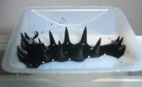
D

- Once thoroughly mixed, place the magnet under the weigh boat and remove the excess black liquid into an empty beaker, as you did before during the rinsing. We recommend having the students use the empty rinse water beaker just incase they pour off too much of the ferrofluid.

- Place the magnet under the ferrofluid and move it until you see spiking. Picture D You may want to ask your students to bring magnets from home for this experiment. Different magnets will have different field lines.

NOTE: The ferrofluid is extremely difficult/impossible to remove from clothing. It is also difficult to remove from magnets. Students should take care to avoid direct contact of the ferrofluid with clothing and magnets.

Teacher Post-Lab – 10 Minutes

Collect, Neutralize, and Dispose of Waste
Collect the waste from all the experiments in a large container and neutralize the base with citric acid. Once the pH is between 6 and 10 you can pour waste down the drain followed by plenty of water (to ensure that all suspended solids are flushed down the drain). The pH can be measured using the pH paper provided in the kit, there is a color scale on the side of the pH paper container.

Suggested Topics for Discussion

1. What is the molarity of the FeCl₃ and FeCl₂ solutions?

1M for FeCl₃ and 2M for FeCl₂.

2. Why do you think slow (dropwise) addition of ammonium hydroxide is important? What might happen if you add ammonium hydroxide quickly?

The ammonium hydroxide solution is added slowly to ensure nanoscale particle formation, rather than formation of large chunks of magnetite. Thus, if it is added quickly, large chunks of magnetite will form instead of the desired nanoparticles.

3. Magnetite, Fe₃O₄, consists of iron in what oxidation states?

Oxidation states of iron are +2 and +3.

4. . Why do you place a magnet underneath the beaker while removing water?

In the presence of a magnetic field (i.e. a magnet) the magnetite is magnetic. By placing a magnet underneath the beaker, the magnetite is attracted to magnet and product loss is minimized while the water is removed.
5. What is the purpose of the stabilizing agent tetramethylammonium hydroxide? What might happen if NO stabilizing agent is used?

Tetramethylammonium hydroxide is a stabilizing ligand that is used to keep the nanoparticles in solution and from sticking to each other. That is, it adheres to the particles creating a net repulsion between them so the particles do not agglomerate. In the absence of a stabilizing agent the particles will agglomerate. These conglomerates will then precipitate from the solution as a black solid.

6. Describe what happens when a magnet is brought near a ferrofluid. What happens when the magnet
is removed from the ferrofluid?

When the magnet is far away from the solution there is nothing interesting to see except a black solution. When the magnet is brought closer to the solution then you see spikes corresponding to the magnetic field lines. The stronger the field lines, the lager the ferrofluid spikes along the line.

9. ADVANCED: Balance the following equation.

2FeCl₃ + FeCl₂ + 8NH₃ + 4H₂O Fe₃O₄ + 8NH₄Cl

10. Chemistry classes may wish to discuss the crystal packing of magnetite, shown below.²

This is one of the crystallographic planes of the magnetite crystal lattice.
In this diagram there is a ratio of 2 Fe⁺³ : 1 Fe⁺² : 4 O⁻²

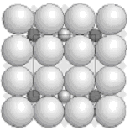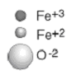

Further Disscussion
Topics for Advanced Students

What is a Ferrofluid?

A ferrofluid is a collection of superparamagnetic nanoparticles that are suspended in a liquid. These nanoparticles are approximately 10 nm in diameter. The majority of nanoparticles, like the ones you make in this lab, are iron-based, such as magnetite (Fe₃O₄). If as-synthesized nanoparticles are put into solution, they aggregate and form clusters due to van der Waal interactions. These clusters are too large to be kept in suspension by Brownian motion and settle to the bottom of the container. The use of a magnet can accelerate the settling of these clusters allowing for easy washing of the particles.

Nanoparticles will remain suspended in a solution as long as they do not aggregate. A technique to prevent aggregation is to ‘stabilize’ the particles by encapsulating them with an outer shell. The general method to achieve this is to use a surfactant. Surfactants are molecules with two contrasting properties. They can be a linear molecule with a hydrophilic region and a hydrophobic region, or a cation anion pair. The former works by having the hydrophilic end of the molecules attach to the magnetite nanoparticles positioning the hydrophobic end to form a ‘greasy’ layer around the particle. This ‘greasy’ layer prevents nanoparticles from getting close enough to each other to aggregate. The later is the method used in this experiment. The ion pair keeps particles separated through Coulombic repulsion by encapsulating the particles with a cationic outter shell. The anions adhere to the surface of the magnetite nanoparticles, and they attract its counter cations to form the positively charged outer shell. Since like charges repel, the positively charged outer shell prevent magnetite nanoparticles from aggregating.

Applications of Ferrofluids

There are many applications of ferrofluids. Most applications are based on these properties:
- The ferrorfluid will go to where the strongest magnetic field is and stay there (this is called localizability).
- Ferrofluids absorb electromagnetic energy at convenient frequencies and heat up.
- The physical properties of ferrofluids change when a magnetic field is applied.

Mechanical Applications

Ferrofluids are used as seals in gas lasers, motors, and blowers. In these applications the ferrofluid is held in place by a strong magnet and separate two different pressured chambers. They have also been used to as a media for vibrational dampaning in electronic applications, such as hard drives, graphic plotters, and instrument gauges. Ferrofluids are also found in almost all high power loudspeakers. The ferrofluid is kept in place by the magnet on the horn of the loudspeaker, and serves to seal the speaker chamber, cool the speaker, and dampen unwanted overtones.¹

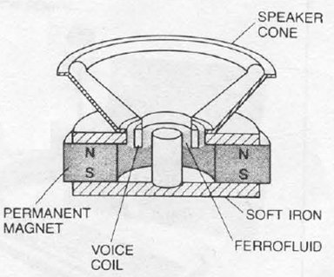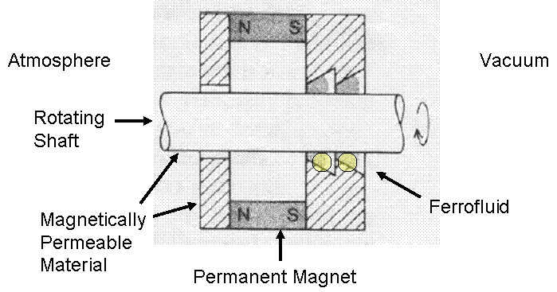

Medical Applications

There is also a substantial interest in using ferrofluids for medical applications. For example, if a drug used to treat cancer was injected into a person with the ferrofluid, a magnetic field could be used to focus the drug onto the tumor. Or, a ferrofluid, once injected, could be easily heated locally to burn a tumor. These methods have already been successful at destroying cancers in rats.

Other Application

Perhaps one of the most interesting applications is in ink; ferrofluid based ink is used by the US government to print the one dollar bill.² This helps the government to identify counterfeit bills.

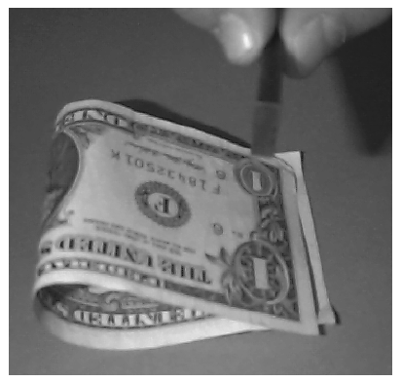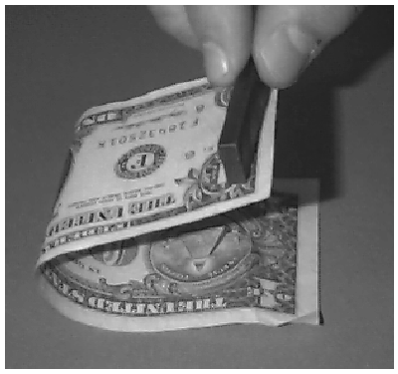
References

- Rosensweig, R. E. Scientific American 1982, 247(4), 136-45.
- Berger, P.; Adelman, N. B.; Beckman, K. J.; Campbell, D. J.; Ellis, A. B.; Lisensky, G. C. J. of Chemical Education 1999, 76, 943-8.
- http://www.mrsec.wisc.edu/EDETC/cineplex/index.html
- Scherer, C. and Neto, A.M.F. Brazilian Journal of Physics, 35, 3A, 718 (2005).
- Odenbach, S. Journal of Phys. Cond. Matter., 16 (2004), 1135.
- Here are some web sites with more information on magnetism:
http://solar-center.stanford.edu/magnetism/introduction.html
http://www.school-for-champions.com/science/magnetism.htm

Adapted from

The Institute For Chemical Education
Department of Chemistry
University of Wisconsin, Madison
http://ice.chem.wisc.edu

Copyright © 2003 by Sarah Tolbert. All rights reserved; revised 2007

