The following figure from Heimenz's book Colloid Science shows the presence of liquid crystalline phases in surfactant ternary phase diagrams.
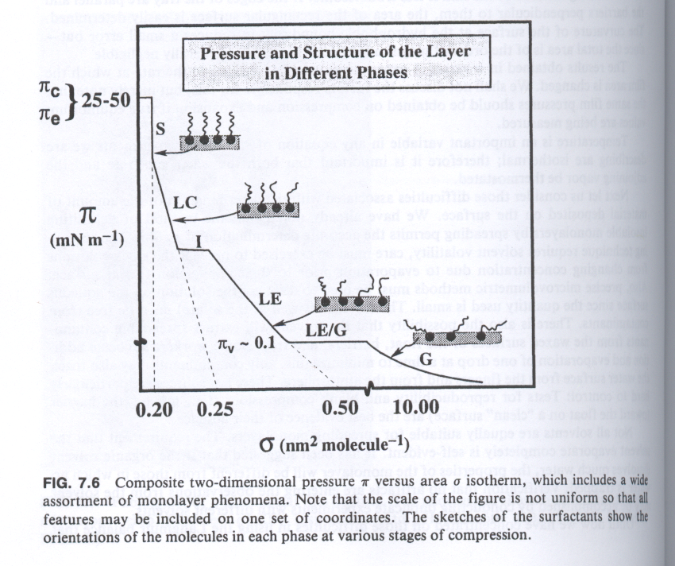
You may have heard the terms "liquid crystal" in the context of watch, calculator and computer displays (a technology invented in the US at the University of Colorado but now only produced in Asia). Ohio is a world leader in liquid crystal technology with an NSF center for liquid crystals at Kent State in Northern Ohio and with expertise at Case Western. Although organic liquid crystals span a wide range of impact on science, from natural biological and medical importance to secondary oil recovery, materials scientists generally deal with three main aspects of liquid crystals,
1) low molecular-weight, electro-responsive, rigid molecules used for display devices,
2) main-chain liquid crystal polymers used for ultra high strength plastics including polyesters such as Kevlar made by Dupont and similar high-strength, ultra-oriented polymers developed in Dayton at the Wright Patterson Airforce Materials Directorate for stealth aerospace fuselages for example (the black stealth bomber fuselage is made using liquid crystalline polymers developed in Ohio),
3) Side chain liquid crystal polymers used for non-linear electro-optical components such as optical transistors in an optical computer (much faster than an electronic computer and with no generation of heat and very low power consumption).
4) Surfactant and block copolymer molecular "micro-"phases.

-Define the terms lyotropic, thermotropic, disclination, orientation function.
-Explain the difference between a 3d crystal and a liquid crystal.
-Give chemical structure and synthetic path of two main-chain liquid-crystalline polymers including one from labs of Dupont and one from WPAFB in Dayton.
-Discuss generally the use of size-chain liquid-crystal polymers giving on example of a chemical structure and a synthetic scheme for a side chain liquid crystalline polymer.
-Mention generally how low molecular weight liquid crystals are used in display devices.
-Discuss ways to orient liquid crystals for instance shear, electrical field, magnetic field, epitaxy, and others and couple each of these with a commercial device or product such as a flak jacket.
-Briefly mention what liquid crystals have to do with the figure above.

cholesteric

