050929 Quiz 1 Introduction to Polymers

1) In class we discussed a hierarchical categorization of the terms: macromolecule, polymer and plastics, in that plastics are polymers and macromolecules and polymers are macromolecules; but all macromolecules are not polymers and all polymers are not plastics.
a) Give an example of a macromolecule that is not a polymer.
b) Give an example of a polymer that is not a plastic.
c) Define polymer.
d) Define plastic.
e) Define macromolecule.

2) In class we observed a simulation of a small polymer chain of 40 flexible steps. The chain was observed to explore configurational space.
a) Explain what the phrase "explore configurational space" means.
b) Consider the two ends of the chain to be tethered with a separation distance of about 6 extended steps. If temperature were increased would the chain ends push apart or pull together the tether points? Explain why.
c) If one chain end is fixed in Cartesian space at x = 0, what are the limits on the x-axis for the other chain end as it explores configurational space?
d) What is the average value of the position on the x-axis?

3) Polymer melts are processed at high rates of strain, $\frac{dγ}{\text{dt}}$, in an extruder, injection molder, or calander.
a) Sketch a typical plot of polymer viscosity versus rate of strain on a log-log plot showing the power-law region and the Newtonian plateau at low rates of strain.
b) Explain using this plot why polymers are processed at high rates of strain.
c) Using your own words propose a molecular model that could explain shear thinning in polymers.
d) Sketch a plot of log viscosity versus log strain rate for a series of polymers of different molecular weight showing the effect of molecular weight on this plot.

4) The zero shear rate viscosity, η₀, displays power-law behavior in molecular weight in two distinct and universal regimes.
a) Sketch log viscosity versus log of molecular weight showing these two regimes and give the slope of the curve in these two regimes.
b) Explain why two regimes are observed
c) How does this plot relate to the definition of a plastic given in question 1?
d) Why would similar behavior be seen in viscosity versus concentration for high molecular weight polymer solutions?

ANSWERS: 050929 Quiz 1 Introduction to Polymers
1) a) A protein in its native (folded) state is not a polymer because its structure does not explore configurational space.

b) A low molecular weight polymer below the entanglement molecular weight is a polymer but not a plastic since it does not display entanglements.

c) Polymer is usually a long chain molecule that displays thermal equilibration through exploration of configurational space. Polymers do not display a fixed size but show a statistical size, that is they are constantly changing size as they equilibrate thermally.

d) Plastic is a polymer that displays chain entanglements. Plastics are polymers with molecular weights larger than the entanglement molecular weight.

e) A macromolecule is a large molecule, probably greater than about 1000 Daltons.

2) a) Explore configurational space means that the chain structure is constantly changing and the sum of energetic interactions associated with changes in bond rotational angle and steric interaction between chain units is compared/equilibrated with the available thermal energy, kT.

b) When the temperature increases the thermal motion of the chain units increases. This results in longer mean free paths for each unit which translates to a tightening of the ends of the chain, i.e. the chain ends are pulled together at higher temperatures. (You can consider that this is as if you had an ideal gas and could couple a linear path of the atoms together into a chain.)

c) The limits for the other chain end are -40 steps and + 40 steps for the fully extended chain in two directions.

d) The average value of the position on the x-axis is 0. This means that the first moment or mean is useless to describe chain size.

3)
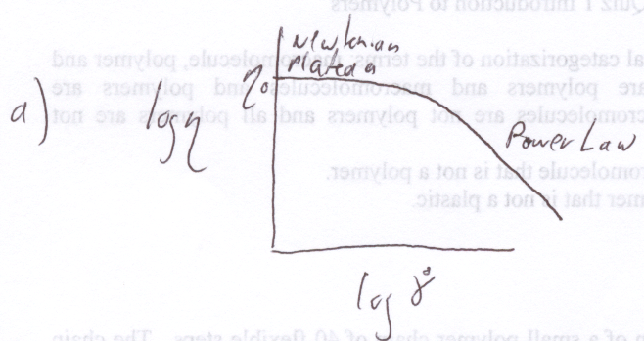
b) At high rates of strain the viscosity drops so it becomes easier to process. This is called shear thinning.

c) In class we discussed that at high rates of strain we are effectively detangling the entanglements and lowering the viscosity. The higher the rate of strain the larger is this disentanglement. You could also consider that the chains straighten out and become like uncooked spaghetti which will flow easily out of the box, for instance.
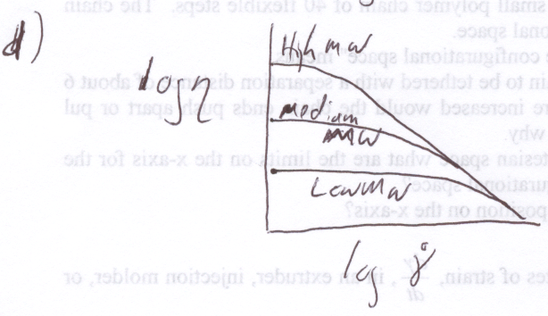

4) a)
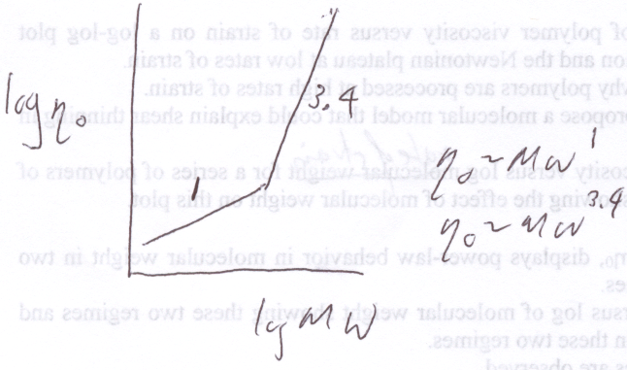
b) Below the entanglement molecular weight, increasing molecular weight is additive, that is viscosity is linear in molecular weight. Above the entanglement molecular weight there is a much stronger dependence on molecular weight.

c) Plastics are found to the right of the entanglement molecular weight. Below this molecular weight are found high molecular weight organics.

d) The behavior seen in "a" is related to the presence or absence of entanglements. Entanglements can be removed by diluting the polymer chains in direct analogy to increasing the molecular weight.

