051013 Quiz 3 Introduction to Polymers

This week we saw a demonstration of nylon synthesis, we generally discussed step-growth (or condensation) and chain-growth (or addition) polymerization and went through a list of about 30 common polymers and copolymers including their chemical structure.

1) Vinyl polymers are generally made by addition polymerization.
a) Give 4 vinyl polymers and their chemical structure.
b) Give the 4 monomers used for the addition polymerization and their chemical structure.
c) By comparing the monomer to the polymer repeat unit explain why these polymers are not made by condensation (step) polymerization.

2) Nylon is commonly made by step-growth polymerization. In class we made nylon 6,10.
a) Give the structure of Nylon 6,10 circling the chemical group that defines this polymer as nylon.
b) Draw the structure of the two chemicals that were used in class to make nylon 6,10.
c) Explain why this is a condensation polymerization and what molecule condenses (is a byproduct). What is added to the reaction mixture to neutralize this molecule?
d) How is this reaction driven to completion and why is driving the reaction to completion important to condensation polymerizations?

3) The following three statements are true of Chain Growth (Addition) Polymerization. Make 3 contradictory statements for Step Growth Polymerization (e.g. the Nylon reaction from class).
a) Mechanism: Initiation step followed by Propogation steps followed by a Termination step.
b) Monomer Concentration: Monomer is left even at the end of the reaction.
c) Polymer Molecular Weight Graph:
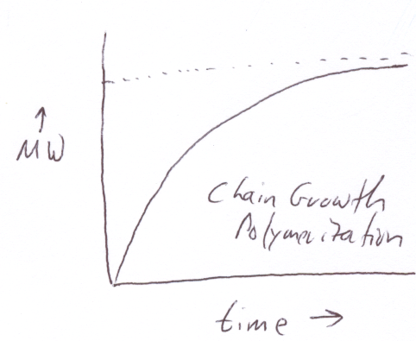

4) a) Give a function that describes the relationship between n₁ and the extent of reaction p for a step growth polymerization (this is called the "Most Probable Distribution").
b) Explain how this function is obtained by i) writing an expression for the extent of reaction, p, in terms of the original number of molecules N₀ and the number of molecules at a given time of reaction, N; ii) writing an expression for n₁ in terms of N and N₀. iii) Relating n₁ and p.
c) n_{w} for a bifunctional monomer (2 reactive atoms) made by step-growth is, n_{w} = (1+p)/(1-p)
What is the polydispersity index (PDI) for a step growth polymerization that has fully reacted, p = 1? What is the standard deviation, σ, for this polymer in terms of n₁?
d) The Most Probable distribution is also found for a randomly degraded (cleaved) polymer, regardless of initial distribution. Can you explain why this might be the case? (Hypothesize what the similarity is between random cleavage and step growth polymerization.)
ANSWERS: 051013 Quiz 3 Introduction to Polymers

1) a&b)
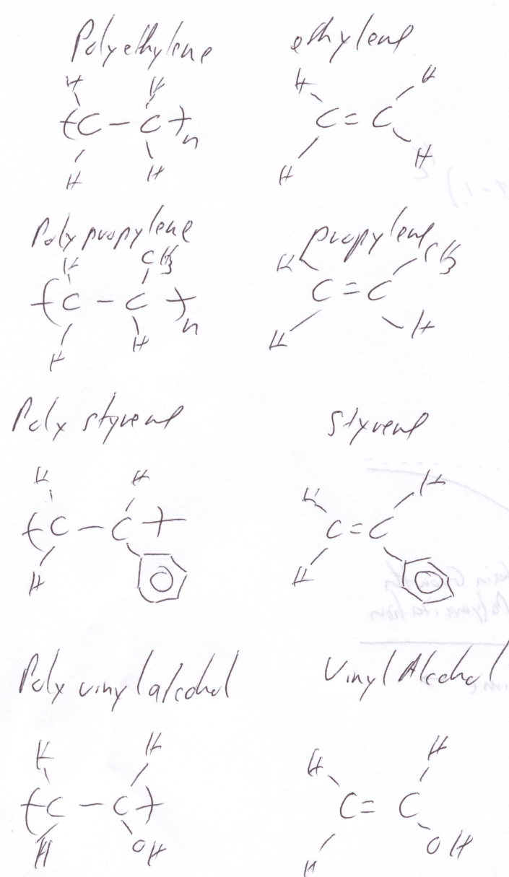
c) The polymers are not made by condensation (step-growth) because no mass is lost to a byproduct in the polymerization reaction. (monomer and repeat unit have the same molar mass).

2). a)
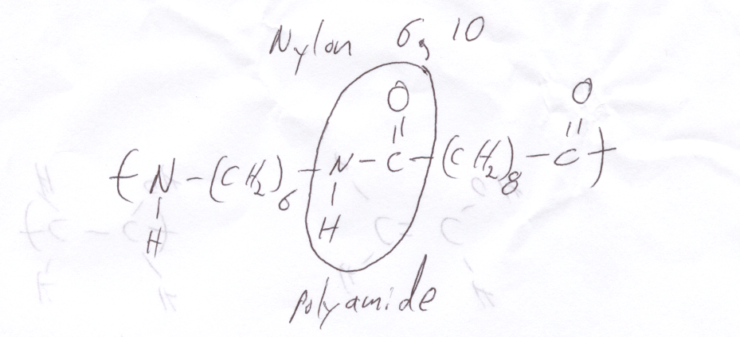
b)
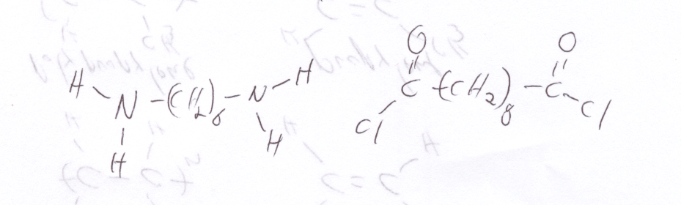
c) It is a condensation reaction because HCl is condensed (appears as a byproduct) during the polymerization. HCl is neutralized by NaOH which is added to the aqueous phase to produce water and NaCl salt.
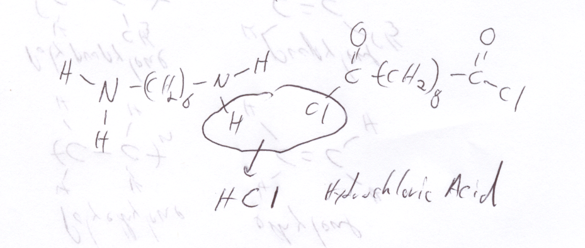
d) Removing the product (Nylon) and byproduct HCl drives the reaction to completion at the interface between the organic and aqueous phase.

3) a) There is only one reaction in step growth, the reaction terminates when the last condensation occurs.
b) Monomer in the step growth reaction is consumed almost immediately as it is transformed into dimers and trimers.
c)
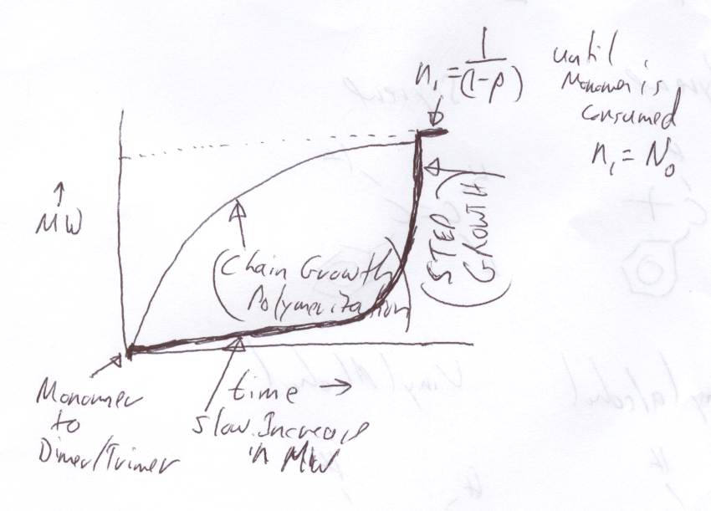

4) a) n₁ = 1/(1-p)
b) i) The extent of reaction is given by p = 1-N/N₀
ii) n₁ = N₀/N
iii) p = 1 - 1/n₁ or n₁ = 1/(1-p)
c) PDI = 2 and σ = n₁
d) In random cleavage the largest chains are more likely to break by a factor of (N_{large}/N_{small}). For step polymerization smaller chains are more likely to react on a per mass basis by the same factor since the number density of reactive chain ends is 2/N. The same distribution results from chain cleavage and step growth because the same probability factor governs both reactions. (This is a difficult question intended as a test of your reasoning using what we covered in class.)

