051020 Quiz 4 Introduction to Polymers (Chemistry)

This week we looked at synthesis of a polyester network polymer "glyptal", Carother and Flory/Stockmayer (Miller/Macosko)'s interpretation of network formation and the swelling of a hydrogel (sodium polyacrylate).
1) PET or PETE is a polyester. Propose a synthesis for PETE based on the synthesis of glyptal in class.
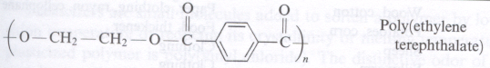
For your synthesis propose
i) monomer(s),
ii) reaction conditions (temperature etc.) and
iii) suggest the PDI that might result from this synthesis.
iv) How might you qualitatively monitor the extent of reaction, p, in this system?

2) i) If a network polymer was desired what monomer could be added to your PET synthesis?
ii) What would be the average functionality, <f_{avg}> for this system (write an equation)?
iii) Using the Carothers equation what would be the critical extent of reaction based on your equation for average functionality?

3) i) How would you measure/observe when the system forms a gel? (Define a gel) That is how did we determine the system was a gel in class? (Sketch a plot of this versus reaction time).
ii) Give three definitions of a gel based on molecular weight and topology (network structure). These are due to Carothers; Miller/Macosko; and Flory/Stockmayer.
iii) Percolation is a feature of many disordered, complex systems. Percolation was first seriously considered in polymers by Flory and Stockmeyer. Explain in your own terms what "percolation of a network" means .
4) The hydrogel we observed in class can swell more than 100 times (q_{m} = 10,000!) its volume with water. The plot below, from Flory's first book, shows the swelling ratio of an early polyacrylic acid hydrogel as a function of the degree of ionization (ionized fraction) and molecular weight between crosslinks, n.
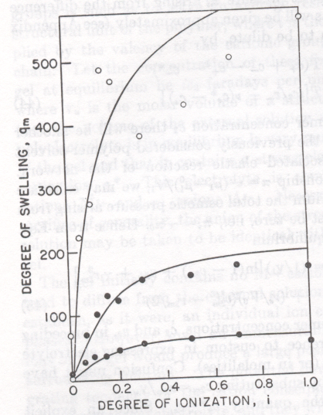
i) Explain in your own words the behavior as a function of n (top curve is highest n).
ii) Explain in your own words the behavior as a function of Degree of Ionization, i.
iii) Guess at the reason for the plateau in swelling ratio.
iv) Why does salt make the hydrogel deswell?
ANSWERS: 051020 Quiz 4 Introduction to Polymers (Chemistry)

1) i) You would use terephthalic acid and ethylene glycol in a condensation reaction,
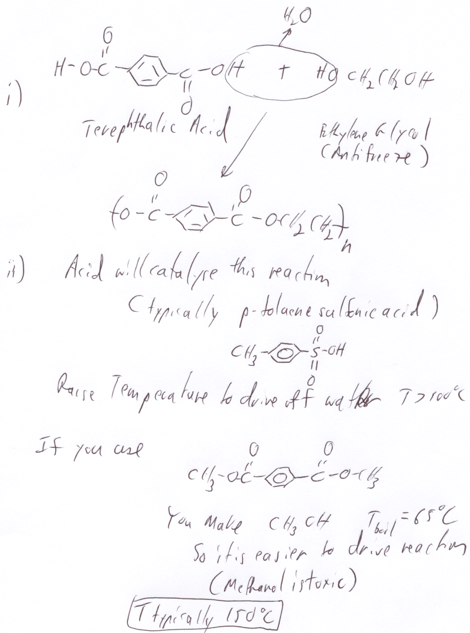
iii) PDI = 2 for condensation
iv) As the reaction proceeds water is produced and acid is consumed so the reaction could be monitored by the pH of the system.

2) i) Glycerol (glycerin) can be added to give branching.
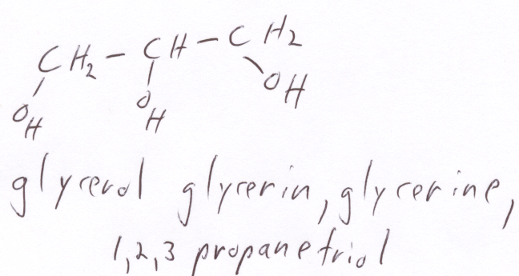
ii) If the mole fractions of terephthalic acid, ethylene glycol and glycerin are A, B and C, then the average functionality is <f_{avg}> = 2 (A+B) + 3*C
iii) p_{c} = 2/<f_{avg}>. If C = 0.1 then <f_{avg}> = 2.1 and p_{c} = 0.95 .

3) i) The (low shear rate) viscosity becomes infinite for a gel as shown in Flory's Plot.
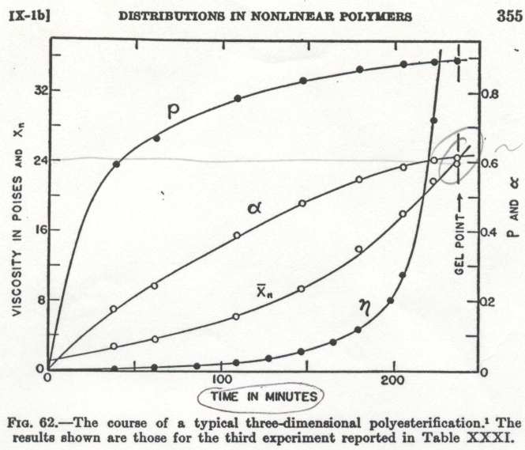
ii) Carothers: n₁ => infinity
Miller/Macosko: n_{w} => infinity
Flory/Stockmayer: α => 1
where α is a way to measure when you have reached the percolation threshold, that is when the network connects across the sample. α is the average number of bonds a crosslink site sees in looking away from a networked chain.
iii) Percolation means that there is a connecting pathway across the system in 3d.

4) i) The functionality can be described by the Flory-Rehner equation:
$$\text{ln}\left(1−v_{2}\right)+v_{2}+{χv}_{2}^{2}=\frac{V_{1}}{n}\left[\frac{v_{2}}{2}−v_{2}^{13}\right]K_{\text{dangling}\text{chain}}$$
where n is the molecular weight between crosslinks, v₂ is 1/q_{m}, χ is the interaction parameter and V₁ is the molar volume of the solvent. q increases with n because the elastic response of the network to swelling is smaller for longer chains, that is the single chain modulus or spring constant k_{spring} is proportional to kT/n. With a smaller elastic response the enthalpic attraction of ionic groups and water drives more swelling.
ii) The more ionic groups the stronger the enthalpic interaction and the greater the swelling.
iii) Several reasons, the elastic response of the network is non-linear at high extensions, at high charging levels the charging is screened (as described by Debye) and the effect of addition of more charges is diminished, the Flory Rehner equation is non-linear.
iv) The addition of salt effectively blocks the ionic groups so salt reduces the average interaction parameter between the polymer and water.

