051027 Quiz 5 Introduction to Polymers (Chemistry)

1) Explain the statement "polyimide synthesis is like a double polyamide synthesis.
a) Show the monomers and product for Nylon 6, 10
b) Show a two step reaction involving the following monomers:
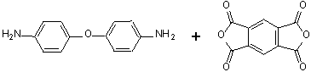
c) Explain the relationship between part a and part b.
d) Why is the polymer made by this synthesis heat and flame resistant (speculate)?

2) a) Explain how the polyurethane shown below is a hybrid of a polyester and a polyamide.
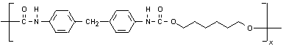
b) What monomers would be used to make this polymer?
c) What is the byproduct of this reaction?
d) Why might your answer to part "c" be important to a coating application?
3) Hydrolysis/condensation reactions are the basis for a wide range of ceramic and polymer synthesis reactions. Show how silica (SiO₂) is made from TEOS (Si(OC₂H₅)₄) and water in a two step reaction.
a) Sketch the chemical structure of the reactants and products.
b) What catalyst is used in this reaction?
c) What is a byproduct from this reaction?
c) Explain the following graph from Mauritz's web page: (What is the role of Ethanol?)
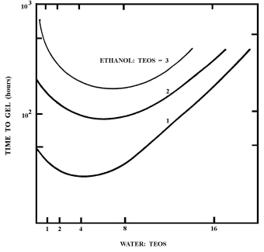
4) In class we crosslinked Hydroxyl terminated polydimethyl siloxane (PDMS) using TEOS.
a) Sketch the crosslinking reaction mechanism between TEOS and PDMS.
b) In addition to the rate of the hydrolysis/condensation reaction, what governs the rate of crosslinking for PDMS networks?
c) What is the critical extent of reaction for this reaction to form a gel? (Stoichiometric)
d) Would you use a pre-polymer above or below the entanglement molecular weight for this reaction? Why?
ANSWERS: 051027 Quiz 5 Introduction to Polymers (Chemistry)
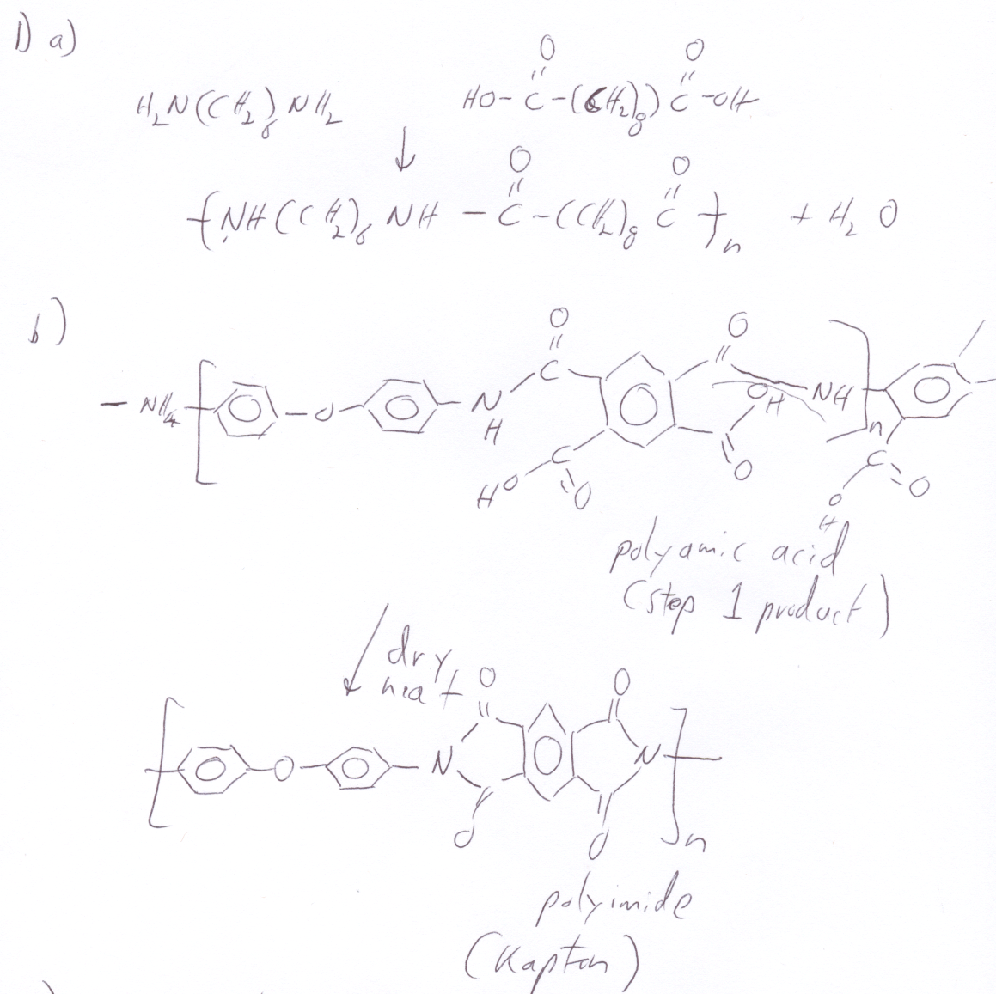
c) Both involve condensation reaction of a diamide and a dicarboxylic acid or an anhydride. For the polyimide the reaction occurs twice.

d) There doesn't seem to be a clear answer to this in the literature. Basically, it is heat resistant because the aromatic ring structures are stable and the OC bond that would normally be easy to break is stabilized by the ability of the double aromatic rings to donate electrons. The imide structure has resonance structures where the double bonds switch around the triple ring structure. It is flame resistant because it makes a dense and copious ash. This is because the byproducts are solid for the most part and not gaseous. Solid byproducts because there is a lot of unsaturated carbon in the structure and not much hydrogen and oxygen. C₂₂O₅N₂H₁₀ so the combustion product is 5 H₂O (gas), 22 C (soot), 1 N₂ (gas), lots of soot. Some of the soot turns to CO₂ but probably not much.

2)
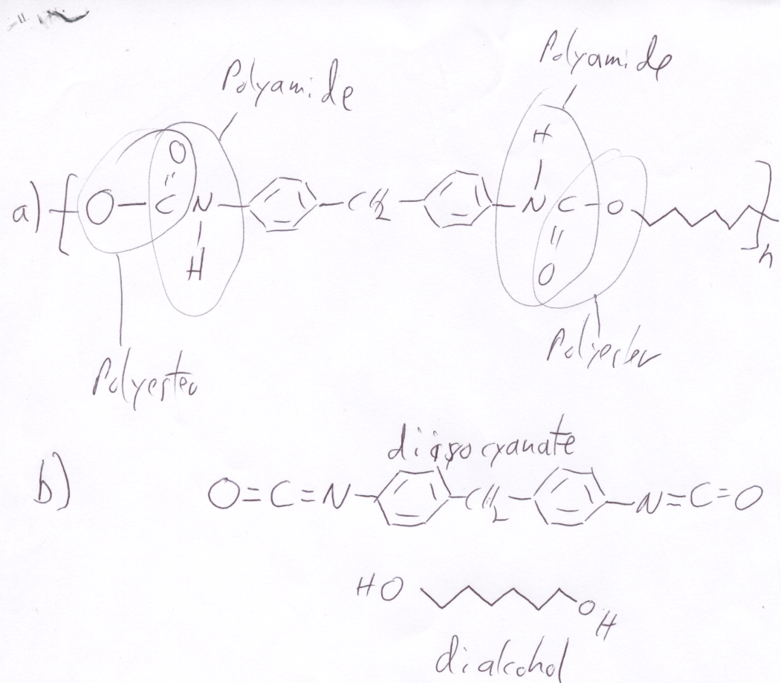
c) There is no byproduct.
d) With no byproduct there is no solvent to phase separate and produce domains or flaws in a coating. The product does not need to dry after reaction.

3)
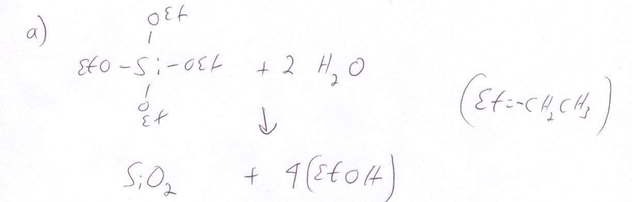
b) Acid or base can be used as a catalyst. The structure of the product is different for acid and base.
c) Ethanol.
d) TEOS and water don't mix. However, TEOS mixes in ethanol and water is miscible in ethanol (the latter is the basis of beer). So ethanol can be used to mix TEOS and water. The plot shows that the reaction of TEOS and water varies with the relative fraction of water to TEOS with a maxium rate between 4 and 8 for [Water]/[TEOS]. Stoichiometrically this ratio is 2 as noted above so more water than is used in the reaction is needed (water acts like a catalyst for the hydrolysis step). Adding more ethanol relative to TEOS at fixed TEOS water ratio decreases the reaction rate. This is primarly an issue of dilution of the reactive groups.

4)
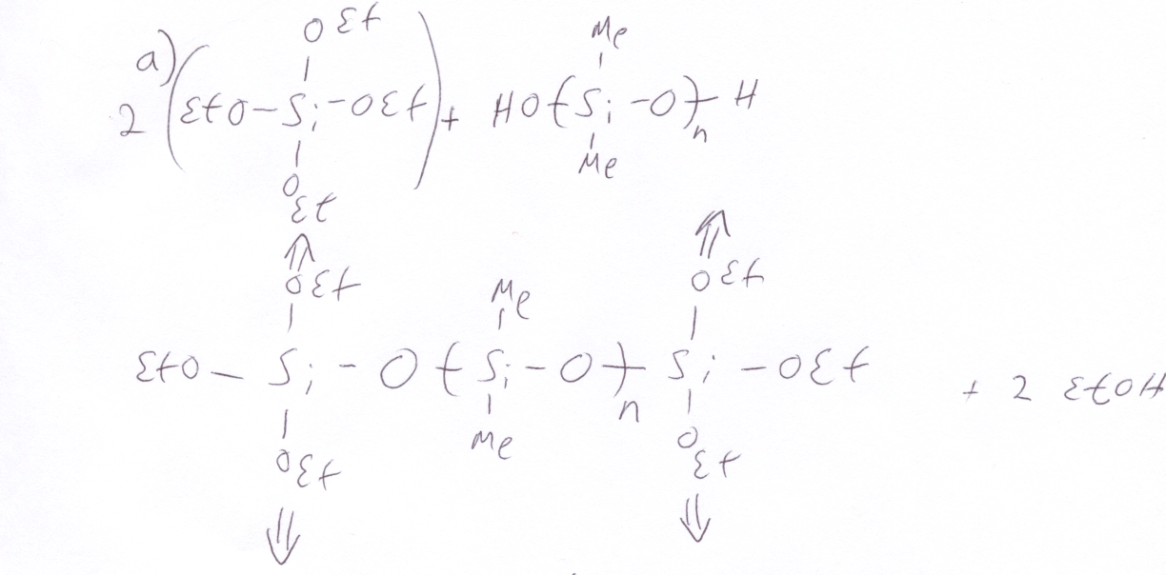
b) Diffusion of TEOS and hydroxyl end-groups to the reaction site. This is governed by the viscosity of the reaction mixture. Transport becomes a problem for high molecular weight prepolymers.

c) <f_{avg}> = 2.67 = (2*2+1*4)/3 so p_{c} = 2/<f_{avg}> = 0.75

d) For a crosslinking reaction prepolymers well below the entanglement molecular weight are used to reduce the viscosity, increase the rate of reaction and make the material processable prior to crosslinking, so it can fill a mold for instance.

