051117 Quiz 8 Introduction to Polymers (Chemistry) (Figures from Heimenz Colloid Sci.)
1) Surfactants are amphiphilic molecules (molecules having one end hydrophobic and the other hydrophilic) and are often represented in figures as a circle and a line. We used such a soap molecule in class to emulsion polymerize styrene. Amphiphilic molecules will locate at the free surface of water and form a monolayer if sufficient concentration is present. The surface concentration, moles/area, can be increased by dragging a metal paddle across the surface to reduce the area, see the first figure below. The force on the paddle divided by the area of the monolayer is a measure of the "surface pressure", π, within the monolayer. A plot of π versus the area per surfactant molecule, σ, 1/(surface density) or specific area (like specific volume), may show discrete transitions.
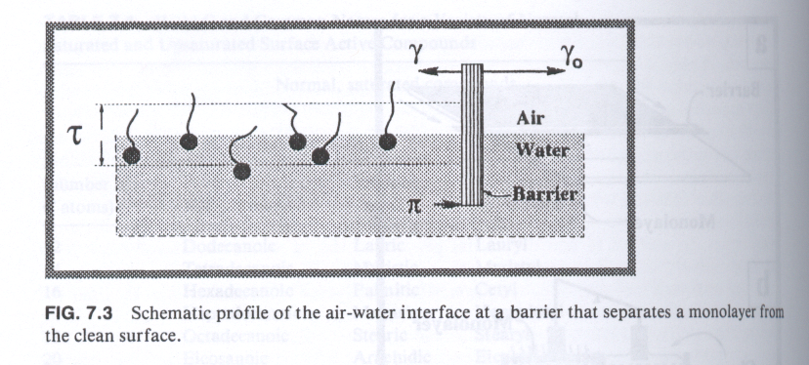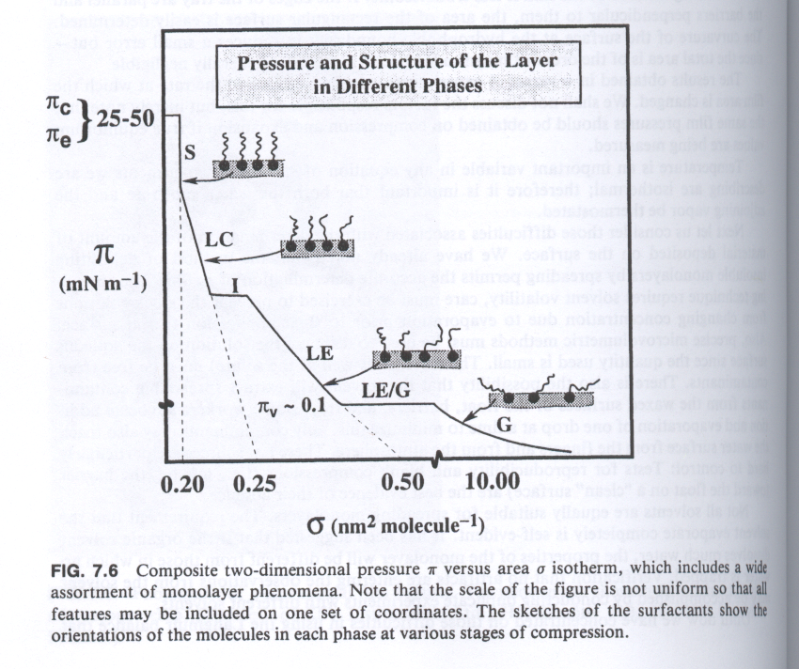
a) Sketch the molecular structure of the amphiphilic molecule used in class.
b) Explain what a monolayer is.
c) Compare the transitions seen in the second figure above with liquefaction and crystallization of a gas with increasing density.
d) If the surfactant molecules have some solubility in water, explain what can occur structurally in the soap solution with increasing bulk (3d) soap concentration.
e) Explain how soap can remove "oily" dirt.
f) What is the difference between a surfactant molecule in a micelle and the same molecule in a monolayer?

2)
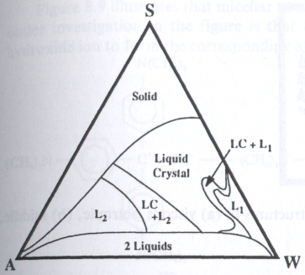
In the figure above, S is SDS, A is styrene and W is water.
a) Explain where you would find an equal mixture of water, styrene and SDS in this plot. Where would you find a 50:50 mixture of styrene and water with no SDS?
b) Which of these two mixtures is a stable emulsion?
c) In class we made a mixture of about 3/4 water, 1/4 styrene and a small amount ~1% SDS. Is the phase diagram above consistent with your idea of the system morphology?
d) What was the catalyst used in the emulsion polymerization and in which phase did it reside?
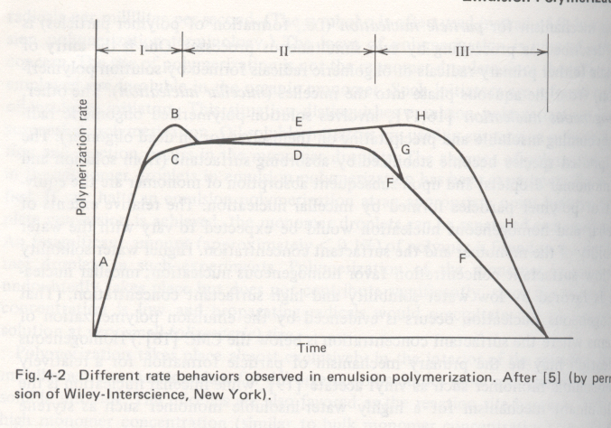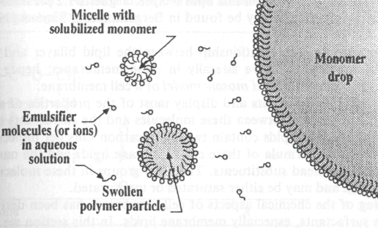
e) The figure above shows three regimes for emulsion polymerization and a schematic of the structure of the reaction media. Explain the difference between regimes I, II, and III in terms of the presence of a droplet phase, the change in the number of micelles with time, and the fraction of micelles with an active radical. (Explain the polymerization.)

3)
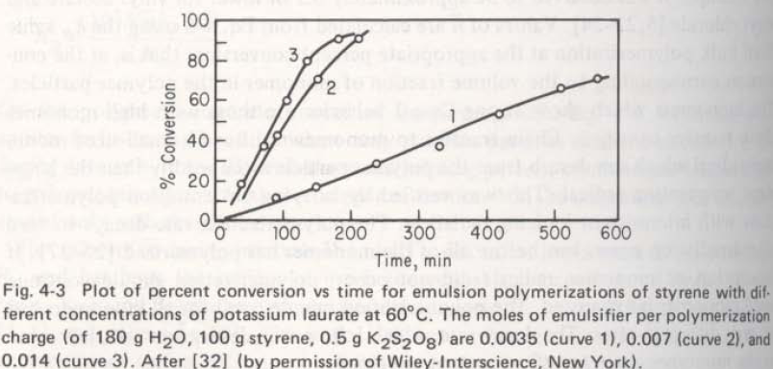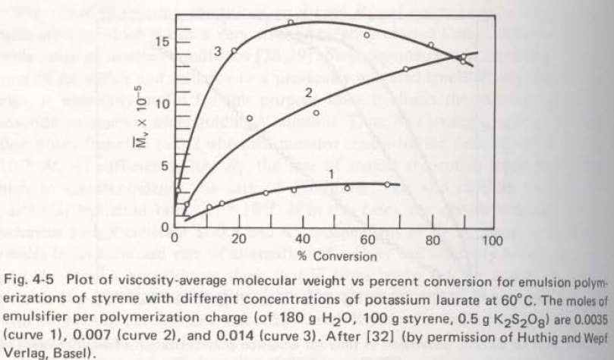

The first figure above shows the conversion versus time for emulsion polymerization with variable surfactant concentration while the second shows the molecular weight versus conversion for different surfactant concentrations.
a) Write an expression for the rate of polymerization, R_{p}, that shows the behavior of the first figure and compare this with R_{p} for a suspension polymerization.
b) Write an expression for the first moment of the molecular weight that shows the behavior of the third figure.
c) What assumptions are needed to obtain these expressions?
d) Which Regime in question 2 do these two equations correspond with?
e) Why can it be said that a micelle is binary reactor, either totally on or totally off?
f) How can the average molecular weight drop for the third curve in the third figure?
ANSWERS :051117 Quiz 8 Introduction to Polymers (Chemistry)
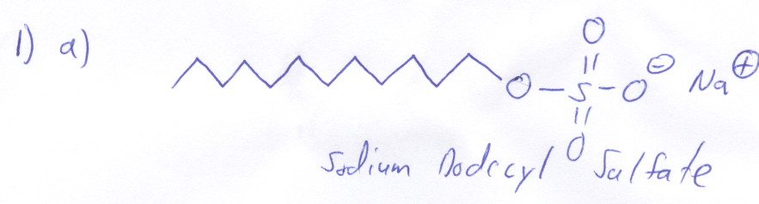
b) A monolayer is a surface layer with a surface concentration that equals the 1/(molecular cross-sectional area). This is called the overlap concentration in 3d solutions.
c) There is a direct analogy between surface density effects and transitions of gas atoms with increasing pressure or decreasing specific volume. At low density, high specific volume, the gas and the surfactant are free to move as independent atoms or molecules. This is the gas state signified by G in the figure. At higher densities or lower specific area/volume, the molecules pack just as gas atoms pack into a liquid. This occurs when there is sufficient density for frequent molecular collisions. When density reaches a critical value the system must crystallize. For the surfactant liquid crystalline ordering is possible with the molecules aligned parallel to the surface for instance, or at a fixed tilt angle.
d) As the bulk solution concentration increases the critical micelle concentration is reached where micelles spontaneously form. This is called self-assembly since it requires no external input other than an increase in concentration.
e) Soap removes dirt since the inside of the micelle is organophilic (oily) while the outside is hydrophilic (watery). The micelle can encapsulate oil and make it soluble as an emulsion in water.
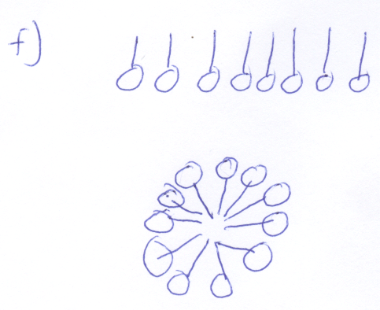
The difference between a surfactant in a micelle and a monolayer has to do with the packing geometry. The packing of tail groups is tighter in a micelle for the same head group packing as a monolayer. This balance of head group and tail group cross sectional area with enthalpic interactions decides the thermodynamically optimal micelle diameter (and shape).
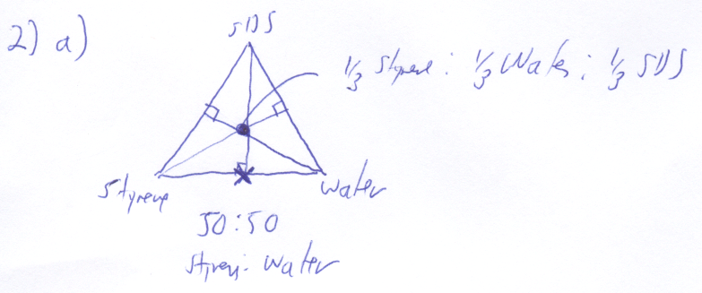
b) The equal mixture of Styrene/Water/SDS is a stable emulsion since it is away from the two phase regime.
c) The phase diagram indicates two liquid phases for this mixture, indicating that droplets of styrene exist in the water phase. The diagram does not indicate the presence of SDS micelles which are an important minor component of the polymerization mixture.
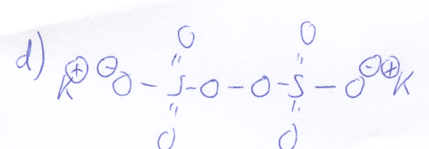
The catalyst was potassium persulfate which resided in the water phase.
e) Droplet phase is present in I and II but not in III this leads to depletion of monomer in the water phase and the decline in polymerization rate in regime III. The number of micelles is very large at the start of the reaction but only a very few are initiated. The initiated growing polymer micelles require more surfactant to stabilize the polymer particles which they obtain from non-initiated micelles. When an equilibrium number of polymer/micelle particles form for the system initiation and termination of micelles offset each other and the micelles are either on or off in terms of growth. This is regime II.
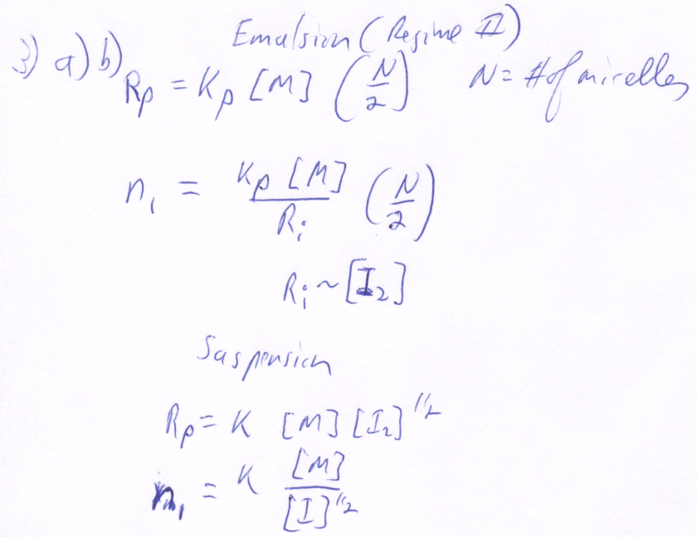
c) The assumptions are those involved in Regime II, constant number of micelles, unlimited monomer reservoir in droplets, micelles are either on or off in terms of propagation and half the micelles are on at any given time. Sufficient initiator is present so that a significant propagation life time for micelles/polymer particles exists (about 10 seconds).
d) The equations correspond with Regime II.
e) With typical concentrations of surfactant and initiator the life time of two free radicals in a micelle is about 2 ms while the time between initiator species colliding with micelles is about 10 s.
f) The first moment of the distribution can drop if the system produces lower molecular weight polymers or if the high molecular weight polymers degrade in molecular weight. In emulsion polymerization at high conversions it is possible for a radical to transfer to polymer and to lead to chain degradation lowering the molecular weight due to the high concentration of polymer within polymer particles.

