051129 Quiz 9 Introduction to Polymers (Chemistry)
1) Polyacrylamide is soluble in water as is the monomer acrylamide.
a) Use the words ferric and ferrous to describe the initiator system for this polymerization.
b) Why is this called a redox system?
c) When hydrogen peroxide was added to the reaction mixture it turned from a faint bluish green to red (rust color). Why did it change color?
d) How was polymer separated from the viscous reaction mixture after polymerization?
e) Explain the disadvantage of solution polymerization compared to emulsion polymerization.
f) Why is there dissent on the internet over the current widespread use of polyacrylamide as a soil enhancing agent for food crops in dry-land farming? Do you agree with this dissent?
2) Stereochemistry (tacticity) can be controlled in polymerization by two main routes, we have now glimpsed at one (heterogeneous catalysis using organo-metallic oxides or chlorides such as Ziegler-Natta catalysts) which has resulted in two Nobel prizes (Ziegler-Natta and Grubbs-Schrock during this quarter) as well as remaking the polyolefin industry with metallocene catalysts. However, the first stereo-regular polymerization was performed using a homogeneous reaction at very low temperatures and is still used on an industrial scale to produce poly vinyl ethers and butyl rubber.
a) What is a poly vinyl ether?
b) What catalyst can be used to initiate a cationic polymerization in liquid propane?
c) Explain what is a racemic diad.
d) What triad tacticity is associated with mm diad combination?
e) Sketch the water/polyvinylmethyl ether phase diagram
f) What water temperature is best to clean up a sticky polyvinyl methyl ether mess?
3) Free radical and step-growth polymerizations could be improved by :
i) Higher molecular weight/controlled molecular weight
ii) Lower polydispersity/controlled polydispersity
iii) Higher tacticity/control over tacticity
iv) Ability to make controlled block copolymer structure for engineered materials
v) Ability to make controlled branch structure
Ionic polymerization can address all of these issues.
a) Why is there no real termination for ionic polymerizations (i.e. no coupling or disproportionation)?
b) What does living polymerization mean?
c) Why are most living polymerizations conducted using anionic polymerization?
d) How can you terminate an ionic polymerization? Give an example.
e) Briefly outline how you would produce Kraton Rubber which is a block copolymer with the structure: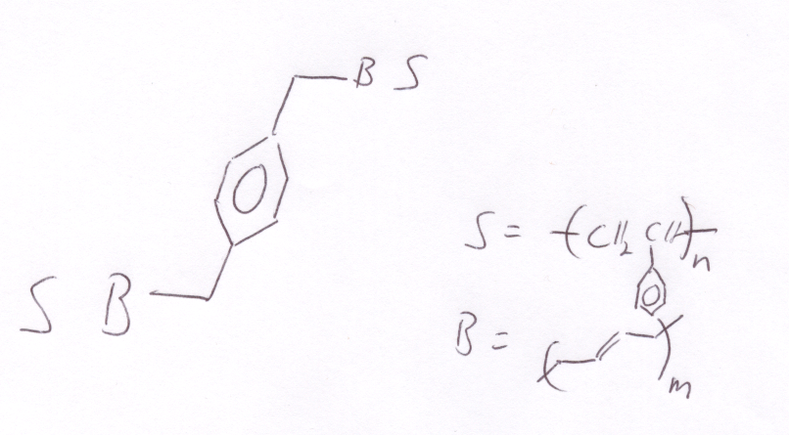
f) How would you make a 4-arm star polymer of polystyrene using a similar polymerization to part e?
ANSWERS :051129 Quiz 9 Introduction to Polymers (Chemistry)

1) a,b,c) To deionized water we added ferrous sulfate. Ferrous sulfate is a blue/green crystal so the solution became slightly blue/green. When hydrogen peroxide was added the solution immediately turned redish brown indicating the oxidation of ferrous sulfate, Fe+2 to Ferric sulfate, Fe+3 (or iron (III)). The hydrogen peroxide was reduced to produce two hydroxyl radicals and the iron (II) was oxidized to iron (III), Fe+3, or ferric sulfate. This is called a redox system because hydrogen peroxide is reduced (gains electrons) and iron is oxidized (loses electrons).
d) Polymer was separated from the viscous polyacrylamide/water solution by pouring the polymer solution in acidified propanol which is a non-solvent for the polymer but is miscible with water. The acid terminates the remaining free radicals. The polymer is then filtered out.
e) The main disadvantage is that copious amounts of solvent are produced. Usually this is a toxic solvent mixture rather than water and propanol. In this reaction 1 gram of polymer was produced using about 300 ml of solvent so a 50 kilogram bag of polymer would produce 15,000 liters of waste solvent.
f) Polyacrylamide has residual monomer (about 1%) and the monomer is a degredation byproduct in UV radiation. The monomer is a neurotoxin and a human carcinogen as well as producing sterility in men and several other nasty things. The polymer is completely non-toxic. I would say a risk assessment and consideration of comparative risk and risk/benefit analysis would be appropriate. That is, how does this toxicity compare the toxicity of moth balls for instance, pumping gasoline, nail polish remover, and hair spray. Also, are there alternatives and what is the impact on food production?

2) a)
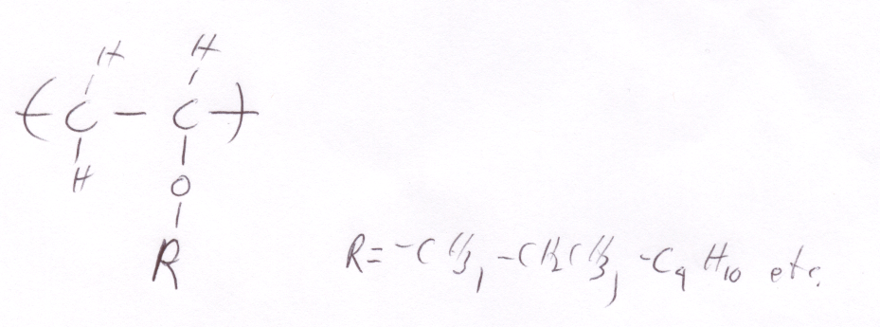
b) Boron triflouride etherate (BF₃ OCH₂CH₃)
c) A racemic diad is composed of two monomers with opposite handedness.
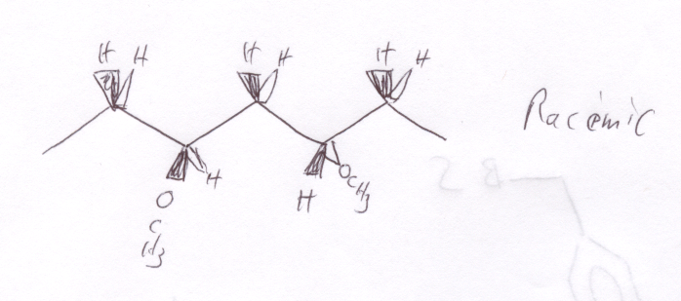
d) A pair of mm diads is an isotactic triad.
e)
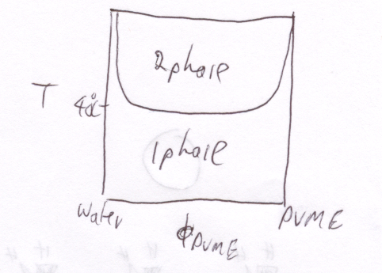
f) You would need to use cold water to clean up PVME (see phase diagram above).
3) a) The propogating species is charged and two of these groups repel each other electrostatically.
b) Living polymerization means "A chain polymerization from which chain transfer and chain termination are absent. In many cases, the rate of chain initiation is fast compared with the rate of chain propagation, so that the number of kinetic-chain carriers is essentially constant throughout the polymerization." (http://www.iupac.org/goldbook/L03597.pdf)
c) Living could be done with cationic or anionic but cationic has problems with chain transfer such as chain transfer to monomer, expulsion of the propagating ion pair (spontaneous termination), combination of the propogating cation with a counter ion, backbiting reaction, chain transfer to polymer. None of these transfer reactions exist for anions.
d) Adding water generally terminates an ionic polymerization.
e) This is produced anionically in a living polymerization that is used on an industrial scale.
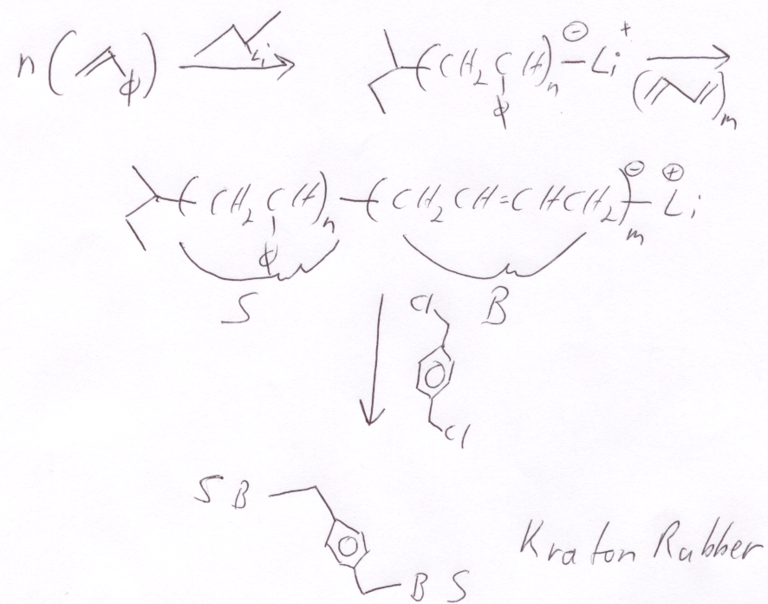
f)
