051103 Quiz 6 Introduction to Polymers (Chemistry)

1) Methane (CH₄) or hydrogen (H₂) can be burned with oxygen (O₂).
a) Write a stoichiometric reaction for each of these with water and carbon dioxide as products.
b) What "order" is each of these reactions in oxygen? (First, second, third, fourth, etc. order)
c) Write an expression for the rate of combustion using methane and using hydrogen.
d) Which reaction would be more sensitive to the concentration of oxygen? (Sketch a plot of rate versus concentration of oxygen for both reactions on the same plot.)
e) Explain what the idea of order has to do with the probability of finding an ideal gas atom per volume of a reacting system such as a flame combustion process.

2) For free radical polymerization of polystyrene using benzoyl peroxide:
a) Write a stoichiometric expression for the three reactions involved in this chain polymerization.
b) Write an expression for the rate of reaction for each of the three reactions in terms of monomer concentration, initiator concentration and free radical concentration.
c) Sketch a plot of overall rate versus time and show where steady state occurs
d) How is steady state defined in terms of the rates listed in part b?
e) Assuming that the reaction is at steady state write an expression for the overall rate of polymerization in terms of monomer and initiator concentrations.

3) The enthalpy of polymerization of styrene, ΔH, is -20 kcal per mole.
a) If the ceiling temperature is observed to be 310 °C calculate the entropy, ΔS, of polymerization.
b) Comment on the sign, + or -, of ΔS. Is the sign for polystyrene normal for polymerizations?
c) Would you think that heating the reaction mixture would enhance polymerization? Explain your answer.

4) a) Explain what the kinetic chain length is, ν. (describe this in words)
b) Give an expression for the kinetic chain length if the monomer concentration is M and the initiator concentration is I. The answer should include a function of 3 rate constants, I and M.
c) List the two main mechanisms for termination of chain growth.
d) How will the molecular weight be related to the kinetic chain length for these two conditions of termination reaction?

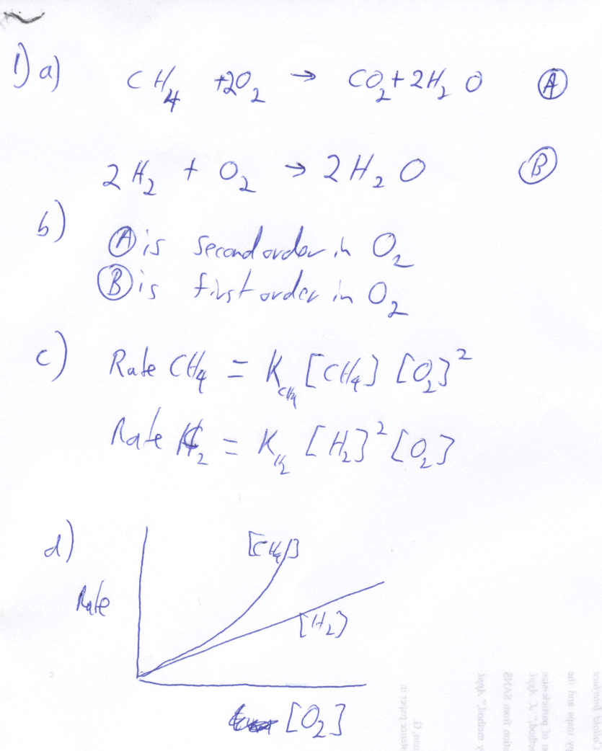
e) The probability of reacting methane involves finding two oxygen molecules. The probability to find one oxygen is proportional to the concentration of the oxygen so the probability to find two is proportional to the square of the concentration. This is then second order in oxygen concentration.

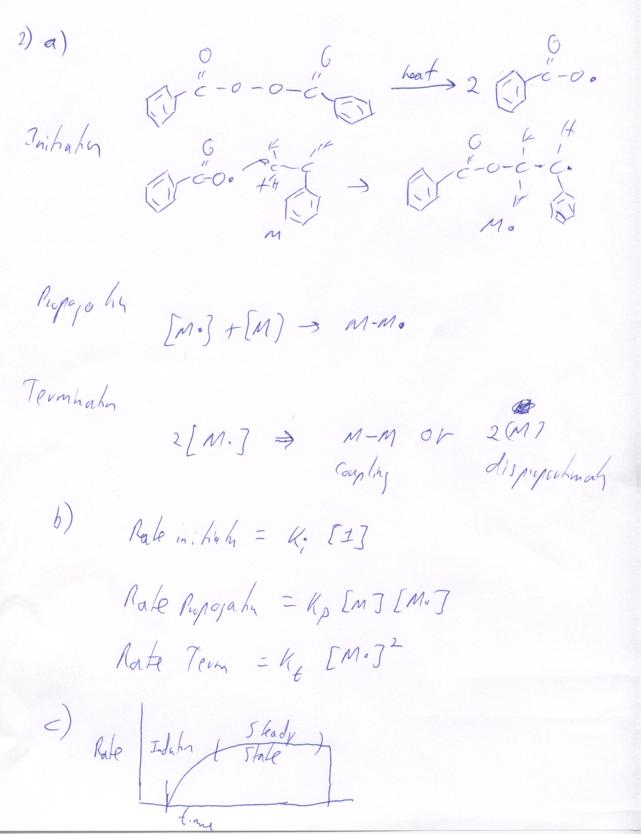
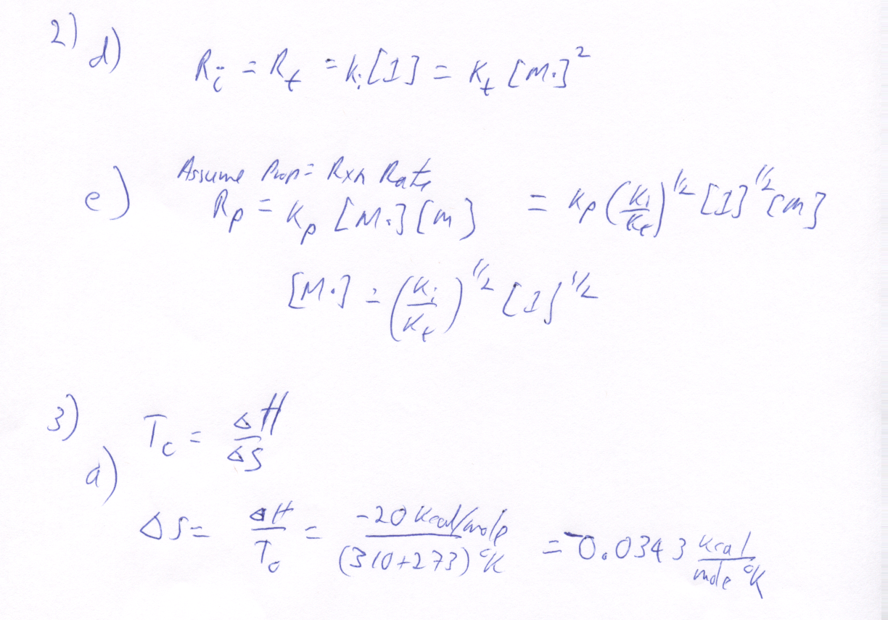
b) The entropy change is negative because the polymer is less random than the free monomer. This is the norm for polymerization.

c) Heating would not enhance polymerization since the free energy change would be lower when heated since ΔG = ΔH - T ΔS and ΔH an dΔS are negative.

4) a) The kinetic chain length is the rate of propogation divided by the rate of initiation.

b)

