051110 Quiz 7 Introduction to Polymers (Chemistry)

1) Termination of chain growth can occur by coupling/disproportionation or through a variety of chain transfer reactions.
a) What does chain transfer mean?
b) Does chain transfer affect the rate of consumption of monomers (rate of propagation)?
c) Chain transfer to initiator [I₂] involves the reaction,
P· + I₂ => PI + I· (1)
write an expression for the rate of chain transfer to initiator using the initiator concentration [I₂] and the concentration of propagating species [P·].
d) At steady state [P·] ~ [I₂]^{1/2}. Write an expression for the kinetic chain length, ν = R_{p}/R_{t}, where R_{t} includes all reactions that end chain growth.
e) Explain why 1/ν is a more useful function that ν from part d.
f) Write an equation for the rate of chain transfer to polymer and explain why this might be important to the quality of polymer product.

2) Critique the following polymerization of polystyrene (PS) that contains BHT (butylated hydroxyl toluene or t-butylcatechol): To a small amount of PS we add benzyl peroxide (DBP) and expose at room temperature to UV radiation.
a) What is BHT and why/how can it be removed?
b) Does DBP initiate when exposed to UV? How is DBP initiated?
c) When bulk polymerization of PS was successful a viscous liquid with about 60% conversion and a molecular weight of about 4000 g/mole resulted. Is this surprising? Explain the problems with bulk polymerization that can lead to this result.
d) When adding solvent to polymerization of MMA, below, the conversion versus time shows several characteristic features. Write an equation that explains the decrease in rate with increasing solvent added to the reacting system.
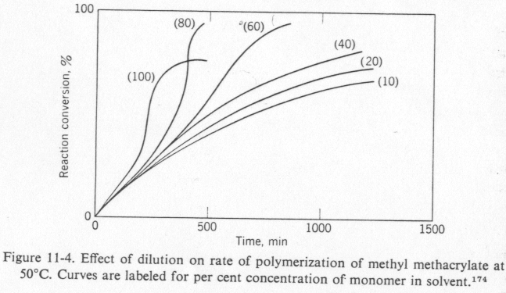 From R. W. Lenz's book.
e) Why does the plot show a change in shape of the conversion vs time curve for 80 and 100% concentrations? (A steep increase after about 1/2 of the reaction time and plateau).

3) As an alternative to bulk polymerization it is possible to run polymerization reactions in the presence of solvent and under several other unique conditions. List 7 types of chain polymerization and briefly describe how these reactions differ and what advantages and disadvantages they may have. (We haven't gone through in detail so guess advantages/disadvantages based on what you know.)
ANSWERS :051110 Quiz 7 Introduction to Polymers (Chemistry)

1) a) "Chain transfer" is the name for chemical reactions where a radical group is transferred from the propagating chain to another species in the reaction mixture such as initiator, monomer, other polymer chains, and solvent. In chain transfer the radical is not terminated and will proceed to initiate either another polymer chain or a branch on an existing polymer chain.
b) Chain transfer does not affect the rate of propagation since the radical is not consumed.
c) R_{ctI} = k_{ctI} [I₂][P·]
d) ν = R_{p}/R_{t} and R_{p} = k_{p} [P·][M] and R_{t} = k_{t} [P·]² + k_{ctI} [I₂][P·] so
ν = k_{p} [P·][M]/( k_{t} [P·]² + k_{ctI} [I₂][P·]) = k_{p} [M]/( k_{t} [P·] + k_{ctI} [I₂])
ν₀ = k_{p} [M]/( k_{t} [P·]) so
1/ν = 1/ν₀ + k_{ctI} ([I₂]/[M]) (2)
e) 1/ν is easier to consider since it separates the effects of various chain transfer mechanisms into a sum of terms.
f) R_{ctP} = k_{ctP} [P·]², which will add to equation (2) the term k_{ctP} [P·]/[M]. Chain transfer to polymer leads to long chain branched polymers.

2) a) BHT is an inhibitor that reacts with free radicals through the following reaction:
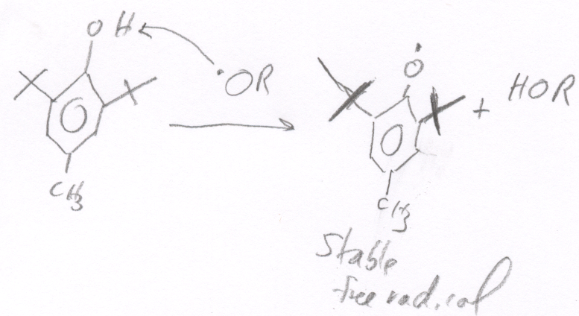
It is added to increase the shelf life of styrene monomer. It can be removed with "activated" alumina, Al₂O₅. Alumina powder is heated with a Bunsen burne extensively and then cooled. The alcohol group bonds to the activated alumina structure and is trapped when the monomer is filtered through activated alumina. Alternatively the monomer can be distilled.
b) DPB will not initiate under UV irradiation. Styrene monmer can self-initiate under UV but with a low efficiency. DPB should be initiated using heat (60 °C).
c) Problems with bulk polymerization include, over heating due to concentration of reactive monomers, high viscosity (gel) that leads to no termination and chain transfer to polymer that leads to branching, chain transfer to monomer that leads to low molecular weight. For our polymerization the gel point and chain transfer to monomer are the dominant problems that lead to low molecular weight polymer.
d) The rate polymerization follows the rate of propagation, Rp = k [M] [I]^{1/2}. Increasing the solvent content decreases [M] and also decreases [I] so the rate of reaction (slope of conversion versus time) should decrease as is seen from 10 to 40 %.
e) The change in shape is related to the Tromsdorf effect (gel effect) where the reaction displays auto-acceleration (steep curve). The gel effect is associated with a dramatic decrease in the rate of termination associated with low transport rates of chains. In the absence of strong termination the conversion becomes much faster and is self accelerating since the reaction is exothermic.

3) Bulk Polymerization: Disadvantages: Over heat/gel effect/chain transfer to polymer. Advantage is simple reaction stoichiometry and high concentrations of product. Generally higher reaction rates due to high concentrations.
Solution Polymerization: Both monomer and polymer are soluble in solvent. More controlled polymerization with lower reaction rates and temperatures. Disadvantage is the need for separation of product polymer from solvent and slow reaction kinetics. Chain transfer to solvent can be a problem in some systems.
Precipitation Polymerization: Monomer is soluble in solvent but polymer is not depending on molecular weight and temperature of the solvent. Free radical is trapped in a droplet of precipitated polymer chain. Similar to solution polymerization in terms of advantages and disadvantages except that product separation is not a problem.
Suspension Polymerization: Monomer and polymer are immiscible in solvent (water usually). Product is fine grain beads which are separated easily from water. The system does not have the problem of heat buildup that is seen in bulk polymerization. Droplets are less well defined and larger than in emulsion polymerization, typically on the order of 1 mm in size. The catalyst is dissolved in monomer and the monomer dispersed in water with the help of a dispersing agent such polyvinylalcohol, polyacrylic acid or using inorganic materials such as clay, aluminium hydroxide and phosphates.
Emulsion Polymerization: The catalyst is dissolved in the solvent phase (water) the monomer is the organic phase of a soap micelle. Catalyst diffuses to the micelle and initiates usually one chain per micelle which is on the order of 5 to 50 nm in diameter. The size of a micelle ensures that only one initiator per micelle is present and termination is not possible by combination or disporportionation so emulsion polymerization follows different kinetic equations compared to bulk and other solution polymerizations. Rate depends on number of micelles and monomer concentration but not on the initiator concentration. Advantage is controlled molecular weight and good heat removal from concentrated nanodroplets.
Gas-phase Polymerization: Monomer forms an aerosol which is a cloud of monomer droplets on the order of 1-10 micron diameter. Initiation is generally by UV light.
Solid-state Polymerization: Crystallize monomer and irradiate with UV, x-rays or electron beams to initiate. Heat transfer is an issue but there may be some advantages for some monomers.

