051020 Quiz 4 Introduction to Polymers (Chemistry)

This week we looked at synthesis of a polyester network polymer "glyptal", Carother and Flory (Macosko)'s interpretation of network formation and the swelling of a hydrogel, Sodium polyacrylate.

1) PET or PETE is a polyester. Propose a synthesis for PETE based on the synthesis of glyptal in class.
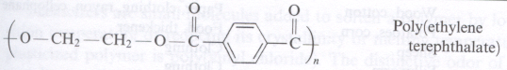
For your synthesis propose monomer(s), reaction conditions ethylene glycol, and suggest the PDI that might result from this synthesis. How might you monitor the extent of reaction, p, in this system?

2) If a network polymer was desired what monomer could be added to your PET synthesis?
What would be the average functionality for this system (write an equation)?
Using the Carothers equation what would be the critical extent of reaction based on your equation for average functionality.

3) For a reaction that results in a gel how would you measure when the system forms a gel? (define a gel)
Give three definitions of a gel based on measurable features of the system.
Percolation is a feature of many disordered complex systems which was first seriously considered by Carothers and Flory/Stockmeyer.

4)

