051020 Quiz 4 Introduction to Polymers (Chemistry)

This week we looked at synthesis of a polyester network polymer "glyptal", Carother and Flory/Stockmayer (Miller/Macosko)'s interpretation of network formation and the swelling of a hydrogel (sodium polyacrylate).

1) PET or PETE is a polyester. Propose a synthesis for PETE based on the synthesis of glyptal in class.
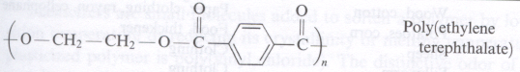
For your synthesis propose
i) monomer(s),
ii) reaction conditions (temperature etc.) and
iii) suggest the PDI that might result from this synthesis.
iv) How might you qualitatively monitor the extent of reaction, p, in this system?

2) i) If a network polymer was desired what monomer could be added to your PET synthesis?
ii) What would be the average functionality, <f_{avg}> for this system (write an equation)?
iii) Using the Carothers equation what would be the critical extent of reaction based on your equation for average functionality?

3) i) How would you measure/observe when the system forms a gel? (Define a gel) That is how did we determine the system was a gel in class?
ii) Give three definitions of a gel based on molecular weight and topology (network structure).
iii) Percolation is a feature of many disordered, complex systems. Percolation was first seriously considered in polymers by Flory and Stockmeyer. Explain in your own terms what "percolation of a network" means .

4) The hydrogel we observed in class can swell more than 100 times its volume with water. The plot below, from Flory's first book, shows the swelling behavior of an early polyacrylic acid hydrogel as a function of the degree of ionization and molecular weight between crosslinks, n.
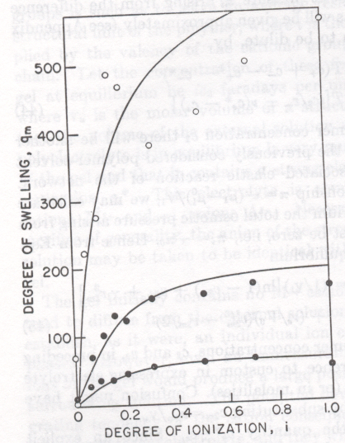
i) Explain in your own words this behavior.
ii)Guess at the reason for the plateau in swelling ratio.
iii) Why does salt make the hydrogel deswell?

ANSWERS: 051020 Quiz 4 Introduction to Polymers (Chemistry)

1) i) You would use terephthalic acid and ethylene glycol in a condensation reaction,

iii) PDI = 2 for condensation
iv) As the reaction proceeds water is produced and acid is consumed so the reaction could be monitored by the pH of the system.

