100406 Quiz 1. Introduction to Polymers

1) Polymers are different than low-molecular weight oligomers. For example an oligomeric polyethylene is wax, oligomeric polystyrene is similar to naphthalene (moth balls), oligomeric rubber is oil or grease. One way to quantify the difference between an oligomer and a polymer is through rheology.
a) Give Newton’s law for viscosity.
b) Define the shear stress.
c) Define the rate of strain.
d) Define the velocity gradient.
e) The tensile (or extensional) viscosity is used to describe the ability of a fluid to form a fiber. Explain how the tensile (or extensional) viscosity might be defined.

2) a) Sketch the behavior of viscosity as a function of velocity gradient showing how the zero-shear-rate viscosity or Newtonian-plateau viscosity are obtained.
b) Sketch the dependence of the zero-shear-rate viscosity on molecular weight.
c) How can your plot of part “b” be used to define a polymer?

3) a) Give a function that describes the probability of a chain having an end-to-end distance R if it has the molecular weight n and step length l.
b) Relate the function of part “a” to the Arrhenius function, exp(-ΔE/(kT)) to determine an expression for the energy of a polymer chain of end-to-end length R and molecular weight n.
c) Obtain an expression for the spring constant for a single polymer chain by taking the derivative of the energy with respect to R. F = k_{spr} R = dE/dR.

4) a) Sketch the modulus as a function of temperature for a polymer through the glass transition temperature to the liquid regime.
b) Show the plateau modulus and explain why this exists for a polymer but not for an oligomer.
c) Use your expression from question 3c to relate the plateau modulus to the molecular weight between entanglements.

5) In class we froze a rubber ball using liquid nitrogen and observed changes in the mechanical properties as the ball warmed up to room temperature. We also observed differences in behavior between a polybutadiene (happy) and a polynorbornene (sad) rubber ball.
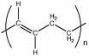 (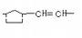)n
polybutadiene polynorbornene
a) Plot the ratio of the viscous or loss (heat) to the elastic or storage (bounce) response of the rubber ball as it warms up (tan δ).
b) Explain why there is a peak in this plot, that is, why is the ratio low at low temperature, low at high temperature and high at an intermediate temperature?
c) Explain why the happy ball is happy and why the sad ball is sad.
d) How does frequency effect this behavior and why.
e) Tires have a maximum safe velocity and a minimum use temperature. Explain why tires might have a maximum velocity and minimum use temperature while other components of a car such as the springs or axle do not.

Answers: 100406 Quiz 1. Introduction to Polymers
1)
a) Give Newton’s law for viscosity.
Shear stress is proportional to the shear strain rate with the viscosity as the scaling coefficient $t=h\overset{˙}{g}$.
b) Define the shear stress.
c) Define the rate of strain.
d) Define the velocity gradient.
A force is applied to a surface whose normal is perpendicular to the direction of the force. The ratio of the stress to the area is the shear stress, τ. The length changes in the direction of the force with a gradient normal to the force. The ratio of the length change with respect to the gap or gradient distance is the shear strain, γ. We usually consider a dynamic shear process where the gradient of the x-velocity in the y-direction is the rate of shear strain. The rate of strain is the same as the velocity gradient.

e) The tensile (or extensional) viscosity is used to describe the ability of a fluid to form a fiber. Explain how the tensile (or extensional) viscosity might be defined.
A force is applied to the surface normal to the force. The length changes in the same direction as the force. σ = F_{x}/A_{x} and ε_{xx} = ΔL_{x}/L_{x}, the elongational rate of strain is the velocity of the vertical strain so you need to pull the fluid like pulling taffy except with a continuous rate of strain.
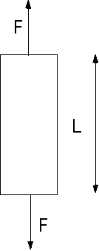

The extensional viscosity is defined as . A special experimental design is necessary to measure the extensional viscosity.
2) a) Sketch the behavior of viscosity as a function of velocity gradient showing how the zero-shear-rate viscosity or Newtonian-plateau viscosity are obtained.
b) Sketch the dependence of the zero-shear-rate viscosity on molecular weight.
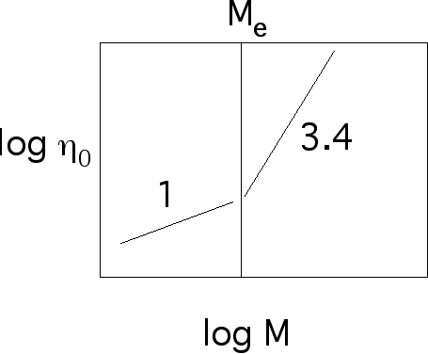
c) How can your plot of part “b” be used to define a polymer?
Above the entanglement molecular weight the material behaves like a polymer since it displays melt strength, shear thinning and other features normally associated with polymers.

3) a) Give a function that describes the probability of a chain having an end-to-end distance R if it has the molecular weight n and step length l.
b) Relate the function of part “a” to the Arrhenius function, exp(-ΔE/(kT)) to determine an expression for the energy of a polymer chain of end-to-end length R and molecular weight n.
by equating the arguments to the exponential we obtain, .
c) Obtain an expression for the spring constant for a single polymer chain by taking the derivative of the energy with respect to R. F = k_{spr} R = dE/dR.
= k_{spr} R, so .

4) a) Sketch the modulus as a function of temperature for a polymer through the glass transition temperature to the liquid regime.
b) Show the plateau modulus and explain why this exists for a polymer but not for an oligomer.
c) Use your expression from question 3c to relate the plateau modulus to the molecular weight between entanglements.
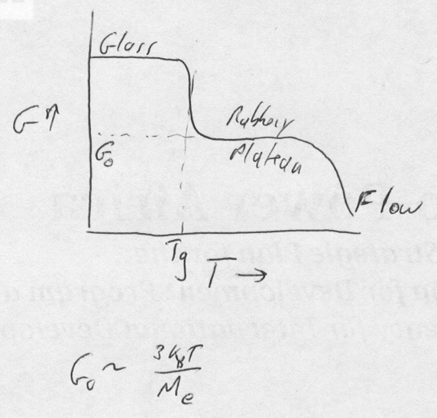

5) a)
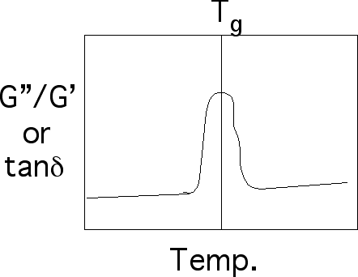
b) The polymer chain has a characteristic time, τ, that is needed for it to vibrate. This time is associated with the time for coordinated bond rotation at a local level (9 mer units). There is also a characteristic energy, E_{a}, associated with this molecular motion. In a temperature ramp the point at which the energy associated with temperature, kT, equals the energy needed to move the polymer, E_{a}, we observe close to complete conversion of mechanical energy to heat, that is the loss or G” is maximum relative to the storage G’. At temperatures (or frequencies) lower than this characteristic temperature or glass transition temperature, T_{g}, there is insufficient energy for coordinated motion of the polymer chains. At these temperatures the material is a glass. The elastic modulus is large compared to the storage modulus. At high temperatures the chains move freely and because the chains are tethered to each other through crosslink’s in a rubber we see rubber elasticity where mechanical energy is stored in chain deformation relative to the random state. The existing motion of the chains at high temperature does not allow for much of the mechanical energy added in bouncing to be converted to heat.
c) The happy ball is happy because polybutadiene has a glass transition temperature at about -60C. The sad ball is sad because polynorbornene has a glass transition at room temperature. The difference in chemical structure leads to differences in the energy required to rotate bonds. Polynorbornene has a stiffer backbone so a higher glass transition temperature, requiring more thermal energy to cause bond rotation.
d) There is a characteristic temperature at a fixed frequency of mechanical deformation (speed of ball impact). For higher frequency the material acts as if the temperature were dropped. A rubber ball will act like a glass at sufficient speed.
e) Basically the tire rubber could approach T_{g} or worse the glassy state at high frequencies or at low temperatures. Near the glass transition the tires would dissipate a lot of heat and would give bad fuel efficiency. Below T_{g} you would get a very rough ride of the tires might exploded.

