100413 Quiz 2 Introduction to Polymers

1) GPC is a common technique to determine the molecular weight of a polymer.
a) What does GPC stand for? Give two other names for this instrument.
b) Explain what each of these names has to do with the functioning of this instrument.
c) How is the polydispersity index, PDI, obtained from a GPC curve? (Explain how moments are calculated from the GPC curve in your answer.)
d) How is the PDI related to the standard deviation for the distribution curve?

2) Molecular weight can be obtained by a number of methods.
a) What molecular weight average is obtained with light scattering? Relate this molecular weight average to the moments of the distribution curve, M1, M2, M3.
b) Explain the function of a membrane osmometer in determining the molecular weight of a polymer by comparing with the ideal gas law.
c) What molecular weight average is obtained from a membrane osmometer and how is it related to the moments M1, M2, M3?
d) Explain how molecular weight can be obtained using a capillary viscometer.
e) What moment of molecular weight is obtained in a capillary viscometer?

3) There are two main mechanisms for polymerization.
a) Name these two mechanisms and give an example of a polymer made by each.
b) Describe the difference between the two mechanisms.
c) Sketch a plot of the number average molecular weight as a function of time for the two mechanisms.
d) Give a function for the number average molecular weight as a function of the extent of reaction p for one of these mechanisms.
e) Give a function for the polydispersity index as a function of the extent of reaction, p for one of these mechanisms.

4) In class we made nylon 6,10 using an interfacial polymerization following a Schotten-Baumann Reaction (http://en.wikipedia.org/wiki/Schotten-Baumann_reaction).
a) What are the monomers used to synthesize nylon 6, 10?
b) What solvents are used in the interfacial polymerization and in which solvent is each monomer dissolved?
c) How is the polymer separated from the reaction mixture in this reaction?
d) How is this reaction driven to a high extent of reaction, p => 1? (two reasons)
e) Typically a step growth polymerization, such as the reaction of epoxy glue, proceeds through a low viscosity stage (application of the glue), a viscous stage (early stages of setting/tacky glue) and finally a solid stage (cured glue). The interfacial nylon synthesis does not display these stages. Is this really a step growth polymerization? Explain your answer.

ANSWERS: 100413 Quiz 2 Introduction to Polymers
1) a) Gel permeation chromatography, Size Exclusion Chromatography (SEC) and High Pressure Liquid Chromatography (HPLC).
b) The instrument involves pumping a dilute liquid solution of a polymer under high pressure through a gel and observing the concentration of polymer in the effluent stream. The polymer permeates the gel following pathways that are large enough through the gel molecular structure to allow for passage. The molecular weights of the polymer are separated by the process of size exclusion. That is, large polymers are excluded from small pores in the gel so that these large molecules pass through the large pores quickly and elute first. Small polymers are not excluded from the gel pores and have a higher residence time in the gel structure, eluting at a later time.
c) PDI is the ratio of the weight average molecular weight, M_{w}, to the number average molecular weight, M_{n}. Mw is obtained from the ratio of the second to the first moments, M₂/M₁ = M_{w}. The moments are obtained by integration of the GPC curve, P(M) times the power of the molecular weight of interest, . M_{n} = M₁.
d)
$$\begin{aligned}s=\frac{\int_{0}^{¥}{{\left(M−M_{1}\right)}^{2}P(M)\text{dM}}}{\int_{0}^{¥}{P(M)\text{dM}}}=\frac{\int_{0}^{¥}{M^{2}P(M)\text{dM}−2\int_{0}^{¥}{{\text{MM}}_{1}P(M)\text{dM}}+M_{1}^{2}\int_{0}^{¥}{P(M)\text{dM}}}}{\int_{0}^{¥}{P(M)\text{dM}}} \\ M_{2}−M_{1}^{2}=M_{1}^{2}\left(\frac{M_{2}}{M_{1}^{2}}−1\right)=M_{1}^{2}\left(\text{PDI}−1\right) \\ M_{2}\left(1−\frac{M_{1}^{2}}{M_{2}}\right)=M_{2}\left(1−\frac{1}{\text{PDI}}\right)\end{aligned}$$

2) a) Light scattering yields the weight average molecular weight. M₂/M₁ = M_{w}.
b)
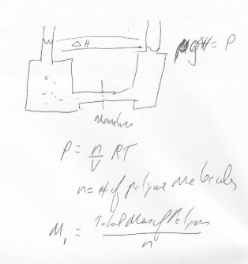
c) M₁ = M_{n} is obtained.
d), e) The intrinsic viscosity is obtained from the flow time for the solvent, t_{solv}, and the flow time of the solution t_{solution} using the Poiseuille equation.
where the second equation is the Mark-Houwink equation and the molecular weight M_{v} is the viscosity average which is between the weight and the z average in magnitude.

3) a) Step growth, polyurethane. Chain growth, polystyrene.
b) Step growth involves reaction of all monomers at once that combine to make dimers/tetramers etc. All monomers are consumed immediately when the reaction begins and the molecular weight growth is slow. You need a extent of reaction of 1 for this reaction to yield high molecular weight polymers.
Chain growth involves initiation using an initiator and propagation of the polymer as a chain with a propagating chain end. High molecular weight is achieved early on and polymer is produced even at moderate extents of reaction. There is monomer present even at the end of the reaction that must be removed from the polymer generally.
c)
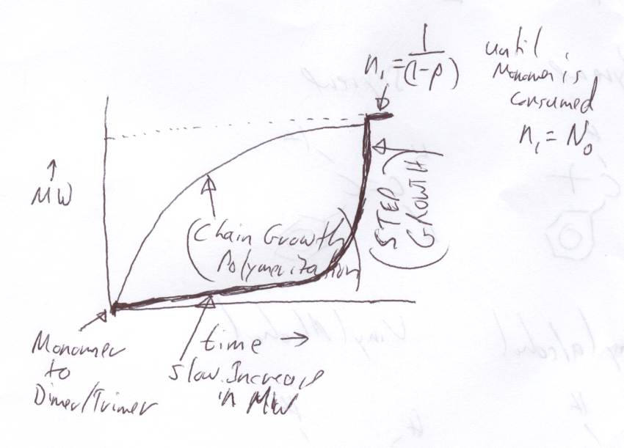
d) n₁ = n_{n} = 1/(1-p); n_{w} = (1+p)/(1-p)
e) PDI = n_{w}/n₁ = (1+p)

4) a) Hexamethyldiamine and adipic acid chloride
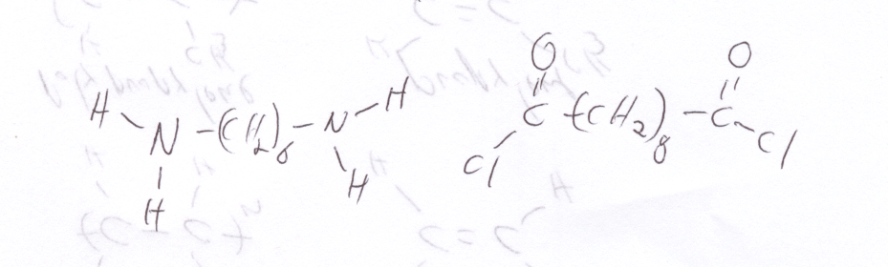
b) Hexane is used for the adipic acid chloride and water for the hexamethlydiamine.
c) The polymer precipitates at the interface of the two immiscible solvents.
d) The reaction is driven to p => 1 by removal of the polymer product and removal of the HCl byproduct by reaction with NaOH to form NaCl that dissolved in the water phase and H₂O.
e) It is really a step-growth polymerization because it proceeds through a step-growth mechanism. It does not seem to be the same kind of reaction as epoxy glue because the products are removed to drive the reaction rapidly and because the polymerization takes place in solvents which leads to a faster transport rate for reactants and an overall higher reaction rate.

