100420 Introduction to Polymers Quiz 3

1) Draw the structure or give the name of the following polymers and indicate which of the two types of polymerization could be responsible for this polymer. Indicate, where appropriate, the polyester, polyamide or polyurethane linkages.
a) polyethylene terephthalate
b)

c)

d)

e) Poly vinyl alcohol

f) List the 4 types of polyethylene that are commonly used in industry

g) Indicate the difference in chain structure between these types.

h) Describe the difference between atactic and isotactic polymers.

2) The synthesis of glyptal involves a trifunctional and a difunctional reactant in a condensation reaction.

a) Give the monomers involved in glyptal in a stoichiometric chemical reaction equation. (Draw the structure and give the number of these monomers involved in a stoichiometrically balanced reaction.)

b) What solvent is used to make glyptal?

c) Draw the structure of sodium acetate and explain why it was used in this reaction.

d) Give a sequence of events that occur chronologically in the reaction to form glyptal.

e) Give the structure of glyptal and the structure of PET (PETE) and comment on the difference in properties between these two similar polyesters based on the difference in chemical structure.

3) a) Give the structure of PMMA and the structure of the polyacrylate used in the hydrogel. Compare the two and explain the differences in properties between PMMA and polyacrylate associated with this structural difference, i.e. why isn’t PMMA a superabsorbent?

b) What would happen if uncrosslinked sodium polyacrylate were added to water? Explain this.

c) What happened when salt was added to the sodium polyacrylate. Why did this happen?

d) If you wanted a more robust gel what molecular weight between crosslink’s would you use? How would this effect the swelling of the gel?
1)

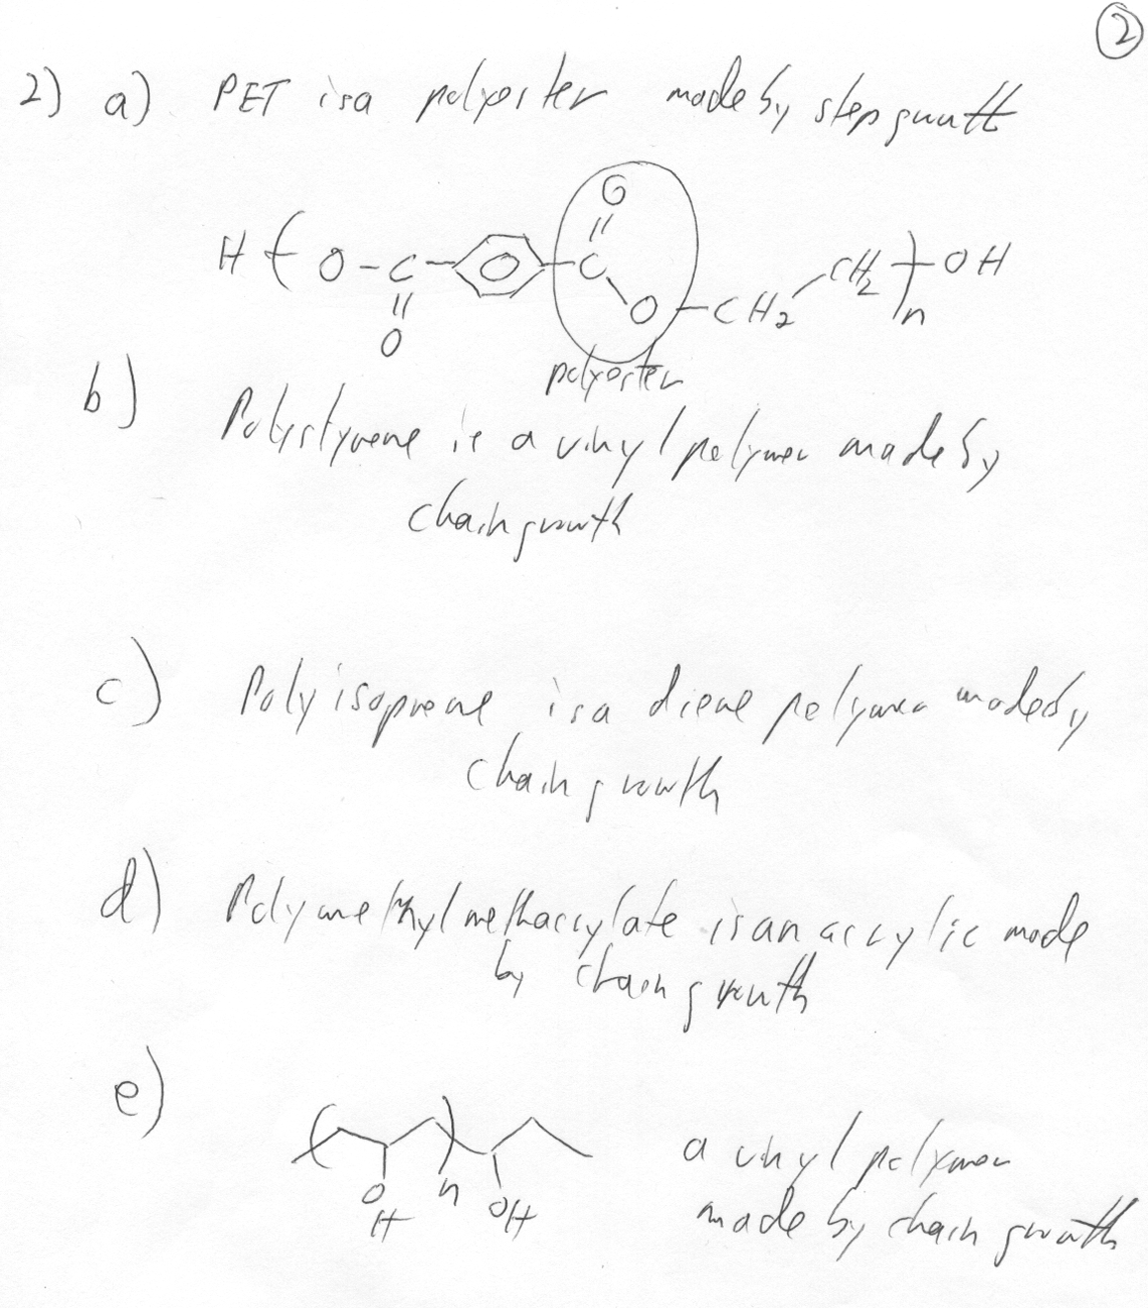
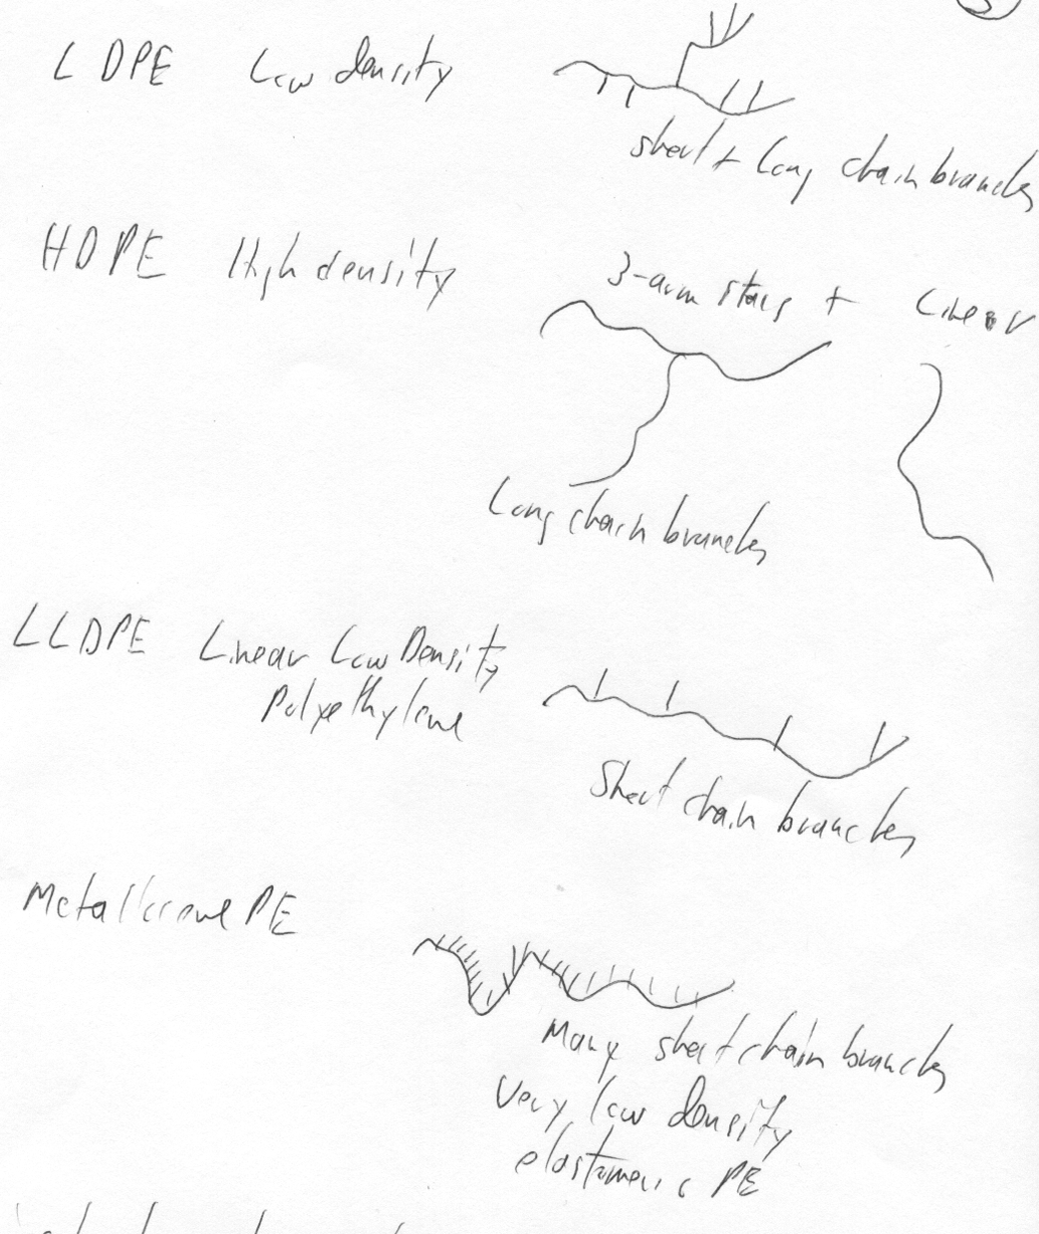
h) Isotactic polymers are composed of all meso diads, mm triads (all the same sterochemical arrangement). Atactic are composed of a random distribution of triads so 50% m and 50% r and 25% mm, 25% rr (syndiotactic) and 50% mr (heterotactic). Atactic generally refers to a polymer that will not crystallize.

2) a) 3 phthalic anhydride + 2 Glycerol
b) The reaction is run neat (no solvent).
c) The overall extent of reaction relies on the functionality of the monomers and the viscosity (kinetics) of the reacting system. If the system forms a glass too early the reaction ends since molecular mobility is needed for the reaction to occur. Sodium Acetate is used to decrease the functionality of the system to make the system less viscous during the reaction and yielding an overall higher extent of reaction.
d)
e) Glyptal PET (PETE)

Glyptal has di ortho carboxylic substutited aromatic group and PET has di para substituted aromatic group. This makes PET more flexible than glyptal. Also, the trifunctionality of glycerin versus the difunctionality of ethylene glycol leads to a network structure that is more rigid compared to PET.

3) a) PMMA Sodium Polyacrylate
PMMA doesn’t have an ioniazable group and it has a more bulky structure that allows it to form a glass. Polyacrylate has a more flexible structure and a highly ionizable group that will have a highly negative interaction parameter with water.
b) The uncrosslinked sodium polyacrylate would just dissolved in water and form a viscous solution. Crosslinked polyacrylate swelled because the network structure opposed the solvation. The network structure retains a solid form for the gel despite the polymers desire to dissolve.
c) NaCl dissociates into Na+ and Cl- ions. The Na+ ions drive the swelling hydration of the polyacrylate backwards due to le Chatelier's principle.
d) Modulus ~ kT/nl², so the lower the network molecular weight the stiffer the gel. The gel swells less for higher molecular weight. So a compromise must be reached between degree of swelling and modulus/strength.

