100429 Quiz 4 Introduction to Polymers

1) Write an expression for p for a system with an average functionality favg and show that when Mn goes to infinity, p goes to pc = 2/favg.

2) a) Give the structure of TEOS
b) Show the reaction scheme (including stoichiometry) for hydrolysis of TEOS.
c) Show the reaction stoichiometry for the condensation of tetra hydroxy silicate or titanate to silica (SiO₂) or titania (TiO₂).
d) Explain how water can act as both a catalyst and a reactant in the hydrolysis/condensation reaction of TEOS.

3) In crosslinking reactions to produce a rubber from hydroxyl terminated PDMS and TEOS or TTIP, HMDSO or HMDS (hexamethyldisiloxane) is often added to reduce the functionality of TEOS or other crosslinking agents.
a) Give the structure of HMDSO (guess if you do not know, it has two silicon atoms bonded by an oxygen).
b) Show the hydrolysis reaction scheme for HMDSO.
c) Show the condensation production of hydrolyzed HMDSO with a hydroxyl group such as on tetrahydroxyl silicate (hydrolyzed TEOS) or hydroxyl terminated PDMS.
d) How can this condensation reaction reduce the functionality of the network? (Functionality means the average number of bonds at a crosslink site.)
e) Why is PDMS rubber used as an aerospace sealant materials?

4) In class we made a silly putty from hydroxyl terminated PDMS mixed with boric acid.
a) Give the structure of boric acid.
b) Show the hydrolyzed structure of boric acid in water.
c) If boric acid (61.8 g/mole and 1.44 g/cc were used in a stoichiometric ratio with hydroxyl terminated PDMS of 20,000 g/mole 0.965 g/cc) roughly how much tetrafunctional boric acid would be needed to end link the PDMS chains? (Give a guesstimate assuming boric acid is trifunctional; PDMS is bifunctional.)
d) How does this compare with the amount of Boric acid needed to make a reasonable silly putty material?
e) Guess at the reason for the difference in amounts.

5) In class we made a novolac polymer and a resole polymer
a) What two reactants were used to make the novalac?
b) How do these reactants differ from those used to make a resole polymer?
c) For the novolac what condition is needed?
d) Outline the reaction scheme for formation of the novolac polymer.
e) Why is the novolac procedure easier to demonstrate than the resole procedure?
ANSWERS: 100429 Quiz 4 Introduction to Polymers
1)
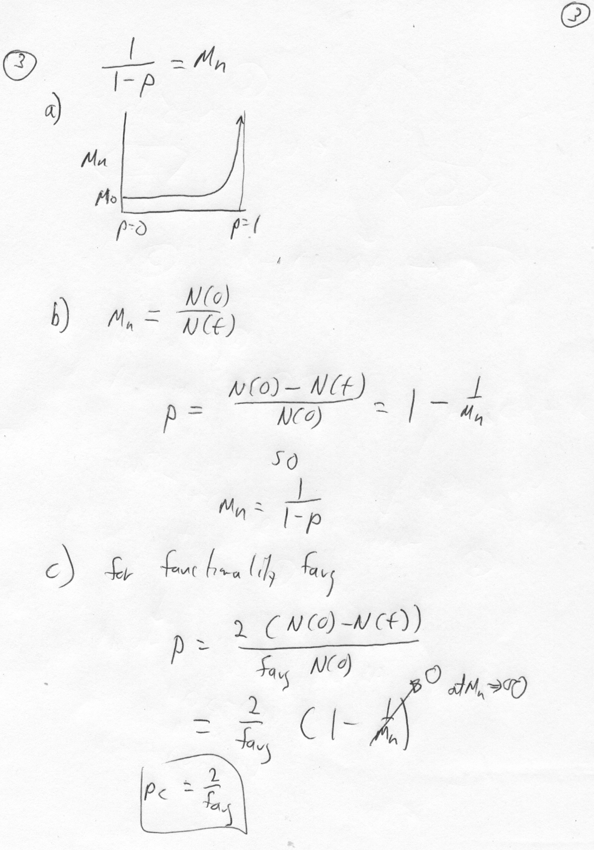
2)
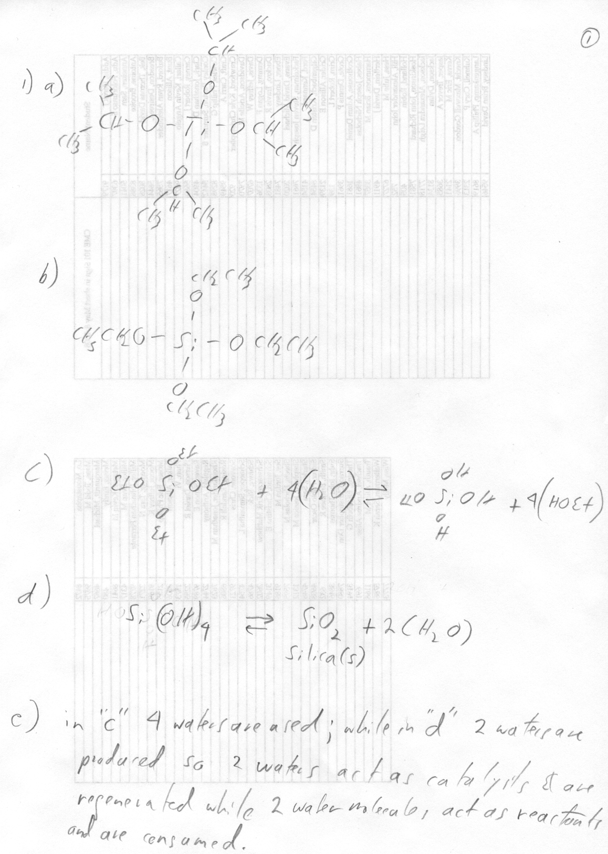
a)

b)

c)

d)

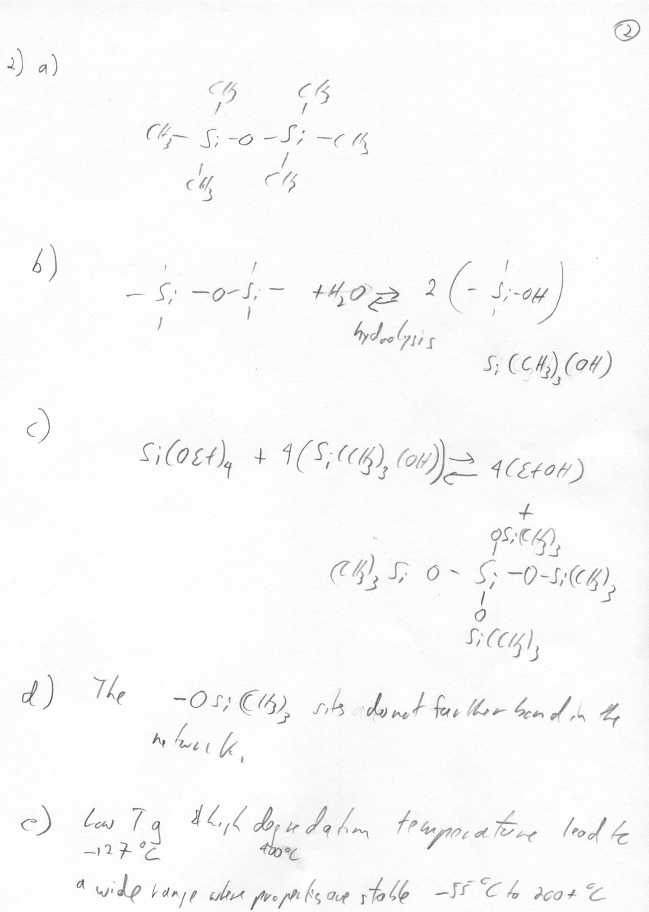
3)

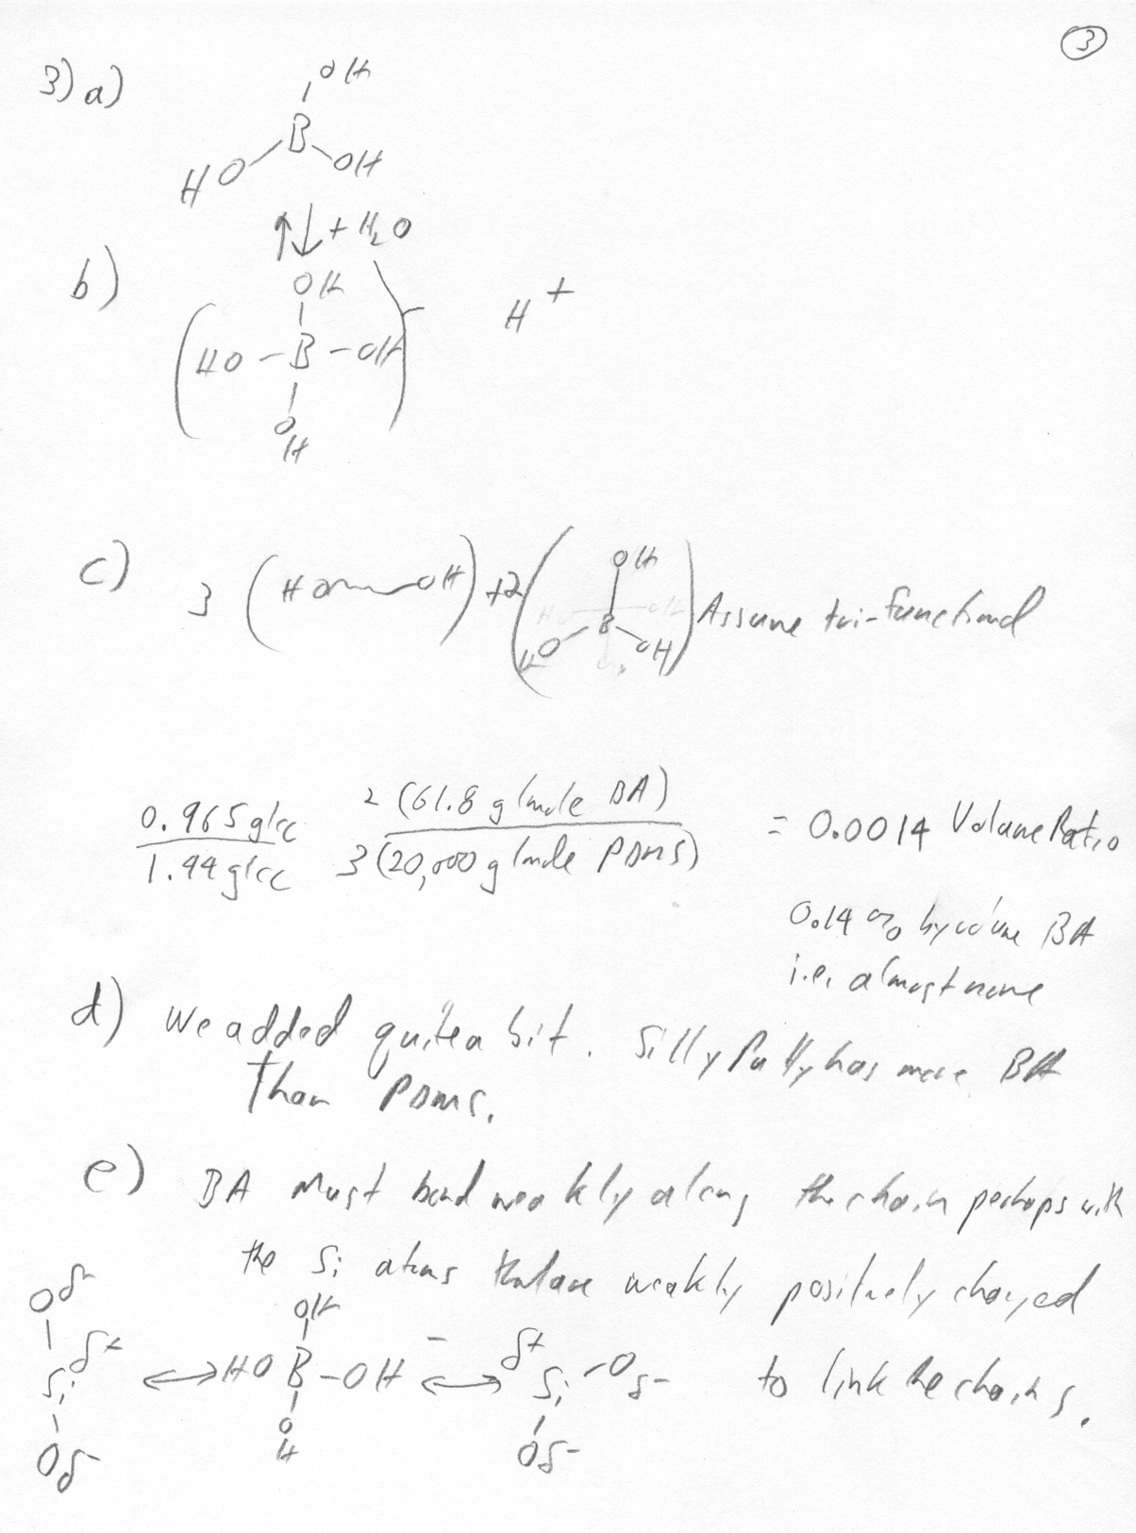
4)

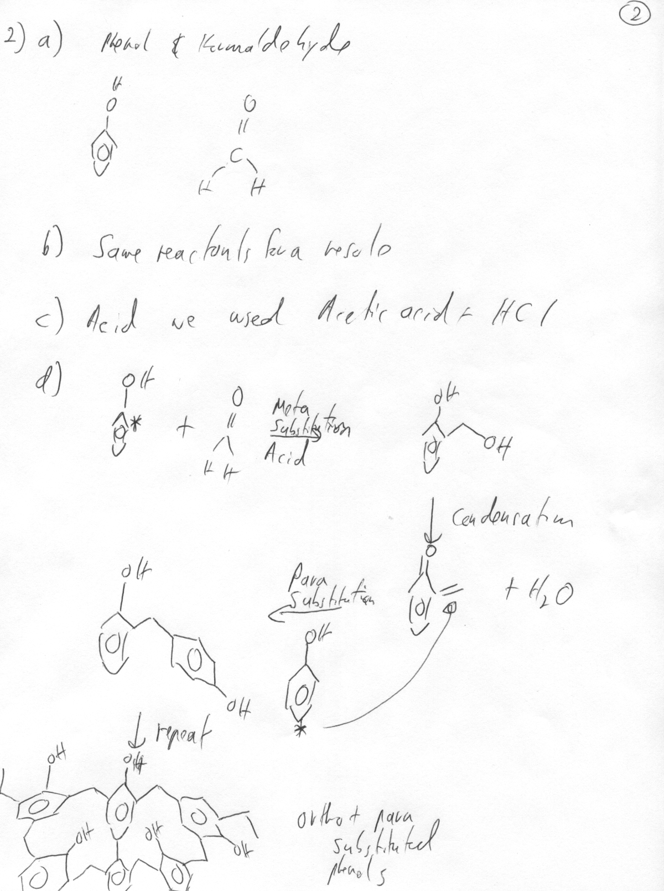
5)

e) Resole requires heating to a boil for the last step. Novolac only requires addition of acid to fully form the polymer (pink precipitate on the stir rod).

